# Financial Stability Report Summary

The Financial Policy Committee (FPC) seeks to ensure the UK financial system is prepared for, and resilient to, the wide range of risks it could face – so that the system is able to absorb rather than amplify shocks, and serve UK households and businesses, thus supporting stability and growth in the UK economy.

## The overall risk environment

Global risks associated with geopolitical tensions, global fragmentation and pressures on sovereign debt levels remain material. Uncertainty around, and risks to, the outlook have increased. As the UK is an open economy with a large financial sector, these risks are particularly relevant to UK financial stability.

Global financial markets have absorbed recent significant news in an orderly way. Government bond yields increased, but valuations across several asset classes also rose further, leaving risk premia even closer to historical lows despite the challenges facing the global risk environment. Vulnerabilities in market-based finance could amplify price corrections resulting from any crystallisation of these risks, potentially affecting the availability and cost of credit in the UK. It remains important to continue to make progress on the development and implementation of international standards for the whole financial sector, alongside using new surveillance tools such as the system-wide exploratory scenario.

Domestically, UK household and corporate borrowers are likely to remain resilient in aggregate. The UK banking system is in a strong position to support households and businesses, even if economic, financial and business conditions were to be substantially worse than expected, as demonstrated by the results of the 2024 desk-based stress test.

## Developments in financial markets

Long-term government bond yields rose following the UK budget and the results of the US election. Policymakers in advanced economies have continued to cut interest rates, and market participants expect them to continue to do so, but the market-implied path of Bank Rate is higher than it was at the time of the FPC’s Q3 meeting. Despite some volatility around events in October and November, core markets have continued to function well.

US equity prices increased further following the US election, although some of that rise has since dissipated. Risk premia across a range of markets, including equities and corporate debt, have compressed slightly further since Q3 and remain close to historical lows. **The FPC continues to judge that valuations and risk premia are vulnerable to a sharp correction, particularly in the context of risks to global growth and inflation, and uncertainty about the future path of policy rates and long-term government bond yields. Such a correction could be amplified by long-standing vulnerabilities in market-based finance and would raise the cost and reduce the availability of credit to UK households and businesses.** For further details see [**Section 1**](https://www.bankofengland.co.uk/financial-stability-report/2024/november-2024#chapter-1) of the FSR.

## Global vulnerabilities

**Global risks associated with geopolitical tensions, global fragmentation and pressures on sovereign debt levels remain material. Uncertainty around, and risks to, the outlook have increased.**

Elevated geopolitical risk, as well as structural trends such as demographics and climate change, could place further pressure on sovereign debt levels and borrowing costs. High public debt levels in major economies could have consequences for UK financial stability and interact with other risks. Specifically, a deterioration in market perceptions about the sustainability of the long-term path of public debt globally may lead to higher rates, increased term premia and market volatility. Increased debt levels and servicing costs for governments as debt is refinanced could also reduce their capacity to respond to future shocks, and increase the cost of borrowing and refinancing of debt for households and businesses. **It is important that banks and other financial firms factor these risks into their internal risk management and stress testing.**

Higher geopolitical tensions also create an environment of heightened risk of cyber-attacks, which could coincide with, and amplify, other stresses. Recognising that this is a global challenge, the FPC encourages continued industry, government, and international regulatory community focus on sharing information and building national and cross-border resilience to these threats.

**Significant refinancing challenges remain for some corporate borrowers in advanced economies, in particular for commercial real estate (CRE) borrowers, despite increases in some CRE prices.** With property market vulnerabilities continuing to crystallise and economic growth slowing, Chinese authorities have announced measures aimed at reducing macroeconomic and financial stability risks, the impact of which will become clearer over time. Given the globally interconnected nature of China’s economy, significant headwinds to it can have a material impact on global growth and financial stability. **However,** **the results of the 2024 desk-based stress test suggest that the UK banking system would be resilient to a stress including very significant declines in Chinese and other global property prices, alongside a severe global downturn.** For further details see [**Section 2**](https://www.bankofengland.co.uk/financial-stability-report/2024/november-2024#chapter-2) of the FSR.

## UK household and corporate debt vulnerabilities

The outlook for UK growth over the coming year is a little stronger than it was at the time of the FPC’s Q3 meeting. The aggregate mortgage debt-servicing ratio is expected to continue to rise modestly, but the share of households in arrears or with high debt-servicing burdens has remained relatively low and the outlook for mortgage borrower resilience has improved in line with the domestic economic outlook. Although quoted mortgage rates have risen in recent weeks, they remain slightly lower than at the time of the June FSR. While around a half of mortgagors are likely to experience greater borrowing costs over the next three years as they refinance onto higher rates, around one quarter of borrowers are expected to benefit from lower rates.

Risks remain among small and medium-sized enterprises and some highly leveraged corporate borrowers, including those backed by private equity. These businesses, many of which rely on market-based finance, are likely to face greater challenges from higher rates as they refinance. These challenges would increase if investor risk appetite deteriorated, or if interest rates remain higher for longer than markets expect. Market issuance has, however, continued to be strong since the June FSR.

**The FPC continues to judge that the UK household and corporate sectors are likely to remain resilient in aggregate.** For further details see [**Section 4**](https://www.bankofengland.co.uk/financial-stability-report/2024/november-2024#chapter-4) of the FSR.

## UK banking sector resilience and the results of the 2024 desk-based stress test

**The UK banking system is well capitalised, maintains high levels of liquidity, and asset quality remains strong. The FPC continues to judge that the UK banking system has the capacity to support households and businesses even if economic, financial and business conditions were to be substantially worse than expected.**

**This judgement is supported by the results of the 2024 desk-based stress test of the UK banking system. The test suggests that banks’ aggregate capital ratio would remain above the hurdle rate in both a severe supply shock scenario, in which a global shock drives higher inflation and interest rates, and a severe demand shock scenario, in which there is a sharp fall in global activity that results in lower inflation and interest rates.**

There were further indications of easing credit conditions in Q3. Mortgage demand has increased and there was also improving sentiment among larger businesses consistent with the observed increase in aggregate credit growth to corporates in Q3. Intelligence from lenders and the Bank’s agents indicates banks are increasing the provision of credit to meet those increases in demand.

Adjustment by banks to the normalisation of central bank balance sheets is continuing as the extraordinary measures put in place following the global financial crisis and Covid pandemic are unwound. Banks have mostly replaced reserves with government bonds in their highquality liquid assets as the volume of reserves in the system has reduced. Term Funding scheme with additional incentives for Small and Medium-sized Enterprises (TFSME) repayment has continued, and usage of the Bank’s repo facilities has increased as expected.

For further details see [**Sections 5**](https://www.bankofengland.co.uk/financial-stability-report/2024/november-2024#chapter-5) and [**6**](https://www.bankofengland.co.uk/financial-stability-report/2024/november-2024#chapter-6) of the FSR.

## The Bank of England’s approach to stress testing the UK banking system

**Under the guidance of the FPC and the Prudential Regulation Committee, the Bank has updated its approach to stress testing the UK banking system.** **As part of that, the Bank will move from an annual to a biennial frequency for its main bank capital stress test, in which banks participate by submitting stressed projections. This will yield considerable efficiency gains for firms as well as the Bank.**

In the intervening years, as appropriate, the Bank expects to assess the resilience of the UK banking system to cyclical risks in a less burdensome way, including through desk-based stress tests conducted by Bank staff. The Bank expects to continue to use exploratory exercises to assess other risks, including structural and emerging risks that are not linked to the financial cycle.

This change in approach should reduce the burden on banks and create space to assess and address a wider range of risks, while preserving predictability through biennial capital stress tests for the purposes of informing individual banks’ capital buffers.

As part of the updated approach, the Bank will in 2025 undertake its next bank capital stress test – in which banks participate – to inform the setting of system-wide and bank-specific capital buffers.

## The UK countercyclical capital bu er rate decision

**The FPC is maintaining the UK countercyclical capital buffer (CCyB) rate at its neutral setting of 2%.**

This decision is supported by evidence from the 2024 desk-based stress test, which suggests that the UK banking system could continue to meet the credit demand of creditworthy households and businesses in two different stress scenarios, without needing more capital.

The FPC will continue to monitor developments closely and stands ready to vary the UK CCyB rate, in either direction, in line with the evolution of economic and financial conditions, underlying vulnerabilities, and the overall risk environment. The Committee will continue to use the Bank’s stress tests to help assess the potential impact of any build-up in risks on the ability of banks to continue lending to UK households and businesses.

## The resilience of market-based finance

**Important vulnerabilities in market-based finance that the FPC has previously identified remain.** In particular, leveraged positions continue to increase among hedge funds, and this has been accompanied by rapid growth in prime brokerage lending. If a market shock were to cause deleveraging in highly leveraged positions such as the US Treasury cash-futures basis, this could significantly amplify the initial shock. **The FPC continues to support the Financial Stability Board’s international work programme on leverage in non-bank financial institutions. For further details see** [**Section 7**](https://www.bankofengland.co.uk/financial-stability-report/2024/november-2024#chapter-7) **of the FSR.**

## The results of the system-wide exploratory scenario exercise

**The Bank has published the conclusions of its system-wide exploratory scenario (SWES). The exercise, which is the first of its kind, has improved the FPC’s understanding of the behaviours of banks and non-bank financial institutions during stressed financial market conditions in core UK markets, and revealed a number of mismatches in expectations among market participants. The headline results illustrate that actions taken by authorities and market participants following recent stresses, for example on LDI funds, have helped to increase gilt market resilience. They also highlight a number of remaining risks and vulnerabilities that will be important to address, including the importance of the resilience of the repo and corporate bond markets.**

System-wide stress testing has proved to be an effective tool for improving the understanding by the Bank and participating firms of system-level vulnerabilities in core UK markets. The FPC welcomes the Bank’s commitment, alongside the Financial Conduct Authority (FCA), to continue to invest in their capabilities in this area for surveillance and risk assessment, and to update periodically these findings, in a proportionate way with market participants, as the financial system and risk-taking change. The FPC supports staff plans to explore how further SWES-style exercises could be used to explore risks in different markets.

**It is important for all financial market participants to factor system-wide dynamics and the lessons from the SWES exercise into their internal risk management and stress testing.** There are also potential benefits to the broader international regulatory community and financial sector of running such system-wide exercises. For further details see [**Box A in**](https://www.bankofengland.co.uk/financial-stability-report/2024/november-2024#chapter-8)

[**Section 7**](https://www.bankofengland.co.uk/financial-stability-report/2024/november-2024#chapter-8) of the FSR.

## Emerging vulnerabilities at the intersection of the private equity and life insurance sectors

**The rapid growth in the global private equity (PE) sector, which plays a significant role in financing UK businesses, has been accompanied by the acquisition of insurance liabilities as a low-cost source of long-dated funding for lending activities.** This business model, which is established in the US and growing elsewhere, involves the acquisition of insurance companies, including reinsurance companies that offer funded reinsurance (FundedRe). Complexity and lack of transparency in these arrangements mean they have the potential to increase the fragility of parts of the global insurance sector and to pose systemic risks if the underlying vulnerabilities are not addressed.

This activity is currently only a small share of the UK insurance sector’s balance sheet, but if it continues to grow rapidly these risks could be a threat to UK financial stability. **The FPC supports the regulatory actions taken by the Prudential Regulation Authority (PRA) to mitigate risks to UK life insurers from FundedRe. The FPC also supports international work to address the build-up of these risks more broadly, given the indirect risks posed by the growth of this activity.** For further details see [**Section 8**](https://www.bankofengland.co.uk/financial-stability-report/2024/november-2024#chapter-9) of the FSR.

At the FPC’s meeting on 15 November, the Committee also:

Welcomed the publication of **the Bank's third public supervisory stress test of UK central counterparties.**

Welcomed the publication of **the UK regulators' final policy and rules for critical third parties (CTPs), as well as information on how the regulators will approach CTP oversight.**

Welcomed the **FCA's policy statement on improving transparency for bond and derivatives markets** and judged that the transparency regime would support UK financial stability.

Reviewed the **current thresholds for other systemically important institutions (O-SII) buffer rates** and decided it would consult on a proposal to index the thresholds based on the growth in nominal GDP since the Committee last updated the thresholds in 2019. The FPC proposed to assess the thresholds as part of its future regular reviews of the framework, and to update them in line with nominal GDP growth, where appropriate.

Considered developments in the macroeconomy and the mortgage market in the context of **the FPC’s loan to income (LTI) flow limit recommendation**. The FPC recommended to the PRA and FCA to index the de minimis threshold of the flow limit based on the growth in nominal GDP since 2014. This change would mean the LTI flow limit would only apply to lenders who extend residential mortgages above £150 million per annum, rather than £100 million.

Agreed to publish further detail on **the Committee's approach to evaluating the impacts of climate change on financial stability** in the FSR (see [**Section 3**](https://www.bankofengland.co.uk/financial-stability-report/2024/november-2024#chapter-3)).

**Received a Remit letter from the Chancellor setting out the economic policy of His Majesty's Government and Treasury's Recommendations under Sections 9D–9E of the Bank of England Act 1998.** The FPC noted the strong emphasis on economic growth, and agreed to publish its response in due course.

# 1: Developments in financial markets

## Key developments since the June 2024 FSR

Financial markets have absorbed recent significant news in an orderly way, following a short-lived period of volatility in August. Long-term government bond yields rose following the UK budget and the results of the US election, and are now back at broadly similar levels to the June FSR.

Valuations across several risky asset classes, particularly in the US, have increased further, leaving risk premia even closer to historical lows despite the challenges facing the global risk environment.

Core markets have continued to function well since the June FSR despite shortlived periods of elevated volatility.

Corporate credit spreads to government borrowing rates have also continued to tighten materially since the June FSR, with spreads falling across most types of corporate lending in the UK, US and euro area.

The FPC continues to judge that risk premia and asset valuations remain vulnerable to a shift in risk appetite. An adjustment could be triggered by factors including a further deterioration in geopolitical conditions, a weakening of growth prospects, or more persistent inflation.

Should these downside risks materialise, a change in sentiment could lead to a sharp correction in market prices, adversely affecting the cost and availability of finance to the real economy in a number of ways, including by interacting with longstanding vulnerabilities in market-based finance (Section 7).

**Financial markets have absorbed recent significant news in an orderly way.**

Markets responded in an orderly way to the UK budget and the US election result as market participants processed the potential economic impacts. Following the US election, US equities rose, with the S&P and Nasdaq indices reaching all-time highs, although some of that rise has since dissipated. European equities fell. The US dollar strengthened against other currencies and yields on US Treasuries rose, pushing up global government borrowing costs. Prior to that, UK gilt yields had risen following the UK budget announcement, but core sterling markets have continued to function effectively.

**Markets expect advanced economy central banks to continue cutting policy rates, but longer-term government bond yields have risen since Q3 in the US and UK, and are now back at broadly similar levels to the June FSR.**

Central banks in advanced economies have continued to cut policy rates since the June FSR and are expected to continue to do so. However, markets now expect fewer cuts to Bank Rate and the US federal funds rate over the next year than they did at the time of the FPC’s Q3 meeting. This has reversed most of the fall in the market-implied path for Bank Rate observed during Q3, leaving the market-implied path only slightly lower than at the time of the June FSR, based on data to 10 June.

Broadly consistent with these changes in the market-implied path for monetary policy, UK, US and most euro-area government debt yields initially fell in Q3. But they have since retraced to differing degrees (Chart 1.1). Yields on UK and US 10-year government debt rose by around 60 and 70 basis points respectively relative to the time of the FPC’s Q3 meeting. The 10-year rate on UK gilts is now around 15 basis points above levels at the time of the June FSR at around 4.5%, while yields on US Treasuries are now at similar levels to the June FSR at just over 4.4%. By contrast euro-area long-term bond yields have not retraced to the same extent. Ten-year German bund yields are now around 30 basis points below their level at the time of the June FSR at just over 2.3%. French 10-year government debt yields have traded at a higher spread to bunds since the French parliamentary elections, which ended in early July, and the spread now sits at just over 70 basis points, around 20 basis points above the spread at the time of the June FSR.

**Chart 1.1: Longer-term government borrowing costs have fluctuated and are now at**

**broadly similar levels to the time of the June FSR in the UK and US**

US, UK, French and German 10-year government bond yields

(

**a**

)

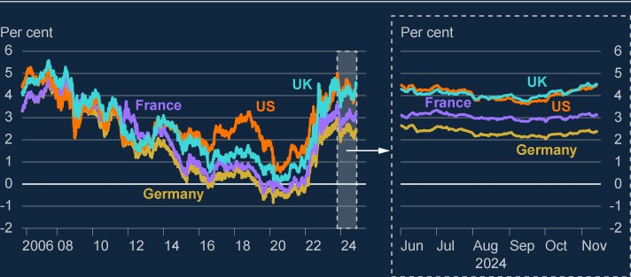

Source: Bloomberg Finance L.P.

(a) Data as at 14 November 2024. The FPC’s Q3 policy meeting was informed by data as at 19 September. The June FSR was informed by data as at 10 June.

**Core markets have continued to function well despite short-lived periods of elevated volatility.**

Markets had been particularly sensitive to economic news in Q3, in a context of heightened uncertainty over policy rates. The Merrill Lynch Option Volatility Estimate (MOVE) index, which tracks implied volatility in US Treasury markets, remained high by historical standards throughout Q3 (Chart 1.2).

This sensitivity to news was highlighted by a significant spike in volatility across financial markets in August, triggered by the release of weaker than expected US jobs data. Shifting interest rate differentials between the US and Japan led to some unwinding of the yen carry trade (participants borrowing cheaply in yen to purchase other assets in higher-yielding currencies). Volatility in bond markets rose and implied equity volatility (measured by the VIX) also spiked significantly (Chart 1.2). The deleveraging of these and other common trades, including short volatility positions, exacerbated the moves.[1] While most market moves during the August volatility were short-lived, this was partly due to subsequent positive macroeconomic news.[2]

The VIX and MOVE have fallen since the US election. Market intelligence suggests this reflects immediate clarity around the election outcome and investors’ initial optimism over the outlook for the US economy, despite what remains a challenging global risk environment.

**Chart 1.2: Implied volatility in financial markets was elevated for short periods in**

**August and leading up to the November US election, but has now returned to similar**

**levels as at the time of the June FSR**

Five-day average of Merrill Lynch Option Volatility Estimate for interest rates (MOVE index)

(

**a**

)

and

Cboe Volatility index (VIX index)

(

**b**

)

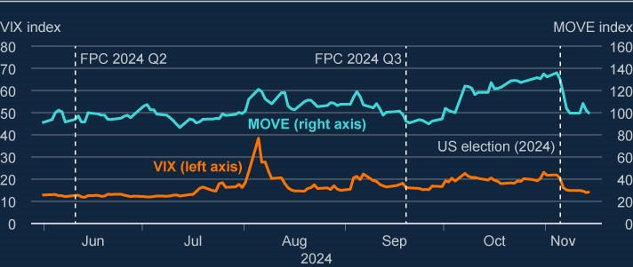

Sources: Bloomberg Finance L.P., Cboe Global Indices, ICE BofAML and Bank calculations.

(a) The MOVE index is a yield curve weighted index of the normalised implied volatility on one-month US Treasury options. (b) The VIX is an index of US equity market volatility derived from the prices of S&P 500 index options expiring inside 30 days.

Core markets have continued to function well through volatility associated with recent news events. UK gilt market liquidity conditions have largely remained stable and realised volatility has generally been limited. While there was a marginal widening in bid-ask spreads following the UK budget announcement in October, measures of market liquidity have generally been better than historical averages. Sterling money markets also continued to function well, with both secured and unsecured markets generally trading close to Bank Rate. Trading volumes in both gilt futures and repo markets remain consistent with historical norms.

**Risk premia across a range of markets have compressed further and are very low by historical standards.**

Valuations across a range of different asset classes continue to appear stretched, including equities and corporate debt, with measures of risk premia compressed relative to historical levels (Chart 1.3). While there were significant falls in equity indices across global financial markets during the August period of volatility, many moves retraced quickly, with most equity indices and corporate bond spreads returning to, or close to, their initial levels. Measures of risk premia across several assets have compressed further, particularly in the US, following the US election result.

**Chart 1.3: Risk premia across many asset classes are very compressed relative to**

**their historical distributions, with some falling further since the June FSR**

Current level of selected risk premia metrics as a percentile of their historical distribution, compared

to levels at the 2024 Q2 FPC policy meeting

(

**a**

)

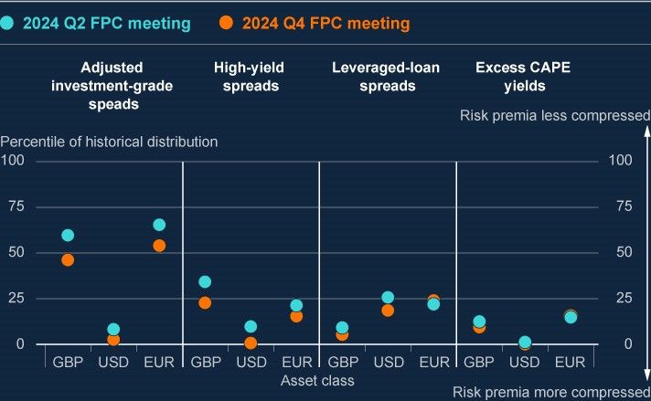

Sources: Bloomberg Finance L.P., Datastream from LSEG, ICE BofAML, PitchBook Data, Inc. and Bank calculations.

(a) Risk premia data are a percentile of five-day rolling average (except for leveraged-loan (LL) spreads). Percentiles are calculated from 1998 for investment-grade spreads and high-yield bond spreads, 2008 for LL spreads and 2006 for excess cyclically adjusted price-to-earnings (CAPE) yields. Data updated to 14 November 2024, except for LL spreads which are updated to 8 November. Investment-grade spreads are adjusted for changes in credit quality and duration. All data are daily except for LL spreads which are weekly.

US equity valuations have been rising strongly for an extended period. This partly reflects the fact that the US economy has outperformed other advanced economies since the pandemic, as well as investor optimism over the potential impact of artificial intelligence and other technological developments on productivity and earnings. US equities rose further following the US election, with market intelligence contacts suggesting that markets expect government policy to boost corporate profits, although they have since retraced somewhat. The excess cyclically adjusted price-to-earnings ratio (CAPE) yield – a measure of the excess return that investors expect from equities relative to government bond yields – indicates risk premia have compressed further across equity markets in the US and UK since the June FSR and are below the levels reached in early 2000s. This suggests that by this measure, equity valuations are stretched relative to historical earnings. While forward-looking option-implied measures suggest US equity risk premia are closer to historical averages, this is predicated on the assumption that market expectations of strong future returns actually materialise and are not overly optimistic.

Corporate credit spreads to government borrowing rates have also continued to tighten materially since the June FSR, with spreads falling across most types of corporate lending in the UK, US and euro area. This is particularly evident in the US and UK, where corporate spreads are now at levels last seen prior to the global financial crisis. Spreads on high-yield bonds and leveraged lending also appear compressed across jurisdictions, with spreads within the bottom quartile of their historical distribution in the UK, US and euro area (Chart 1.3). While overall borrowing costs are lower in high-yield markets, investment-grade bond yields in the US and UK remain at broadly similar levels as at the time of the June FSR.

Consistent with the tightening of corporate credit spreads, there were further signs of strengthening investor risk appetite, as seen, for example, in lower credit default swap spreads. Increasing investor appetite has supported strong primary corporate debt issuance (which has significantly outstripped 2023 levels and recent historical averages across almost all markets). Leveraged lending and high-yield bond issuance has also increased notably from its subdued levels in recent years and activity in private credit markets remains robust. This increased volume is partly a function of significant refinancing needs.

**Given continuing widespread compression of risk premia, the risk of a sharp repricing across asset markets remains. Such a correction could impact financial stability via a number of channels.**

Although financial market asset valuations have so far been robust in a challenging global risk environment, the FPC judges that risk premia and valuations remain particularly vulnerable to a shift in risk appetite. An adjustment could be triggered by a weakening of growth prospects or more persistent inflation, which could be prompted by a further deterioration in geopolitical conditions, for example (Section 2).

Should these downside risks materialise, a change in sentiment could lead to a sharp correction in market prices. This was seen in the significant short-lived spike in volatility across financial markets in August, as well as the volatility in Chinese equity markets in September. This in turn has the potential to affect financing to the real economy adversely via two main channels:

first, it would make it more costly and difficult for corporates to refinance maturing debt, including by reducing the value of collateral. However, given increased issuance in leveraged lending and high-yield bonds since the start of 2024, a smaller portion of the stock of outstanding market-based corporate debt in these higher-risk markets is due to refinance by the end of 2025. Refinancing challenges are likely to be most significant for the tail of more vulnerable or highly leveraged corporates, including those backed by private equity (Section 4). Some shocks, such as those involving the crystallisation of certain global risks, could increase corporate bond spreads as well as increasing government bond yields, which would further add to corporate refinancing challenges; and second, it could interact with vulnerabilities in market-based finance, which may amplify the correction. In August the unwinding of popular leveraged trading positions, such as short volatility and the yen carry trade, exacerbated market moves. While a broader spillover to core market functioning did not materialise on that occasion, had subsequent macroeconomic news been less positive, further deleveraging could have occurred as market-based finance vulnerabilities (eg fund liquidity mismatches and hedge fund leverage, including net short positioning in US Treasuries futures) remained elevated (Section 7).

# 2: Global vulnerabilities

## Key developments since the June 2024 FSR

Global risks associated with geopolitical tensions, global fragmentation and pressures on sovereign debt levels remain material. And while election-related uncertainty globally has reduced since the June FSR, policy uncertainty remains. The central outlook is for global growth to remain steady but uncertainty around, and risks to, the outlook have increased. As the UK is an open economy with a large financial sector, these risks are particularly relevant to UK financial stability.

Events in the Middle East, Russia’s continued war in Ukraine, and US-China relations remain sources of material geopolitical risk. Geopolitical risks can affect the financial system in a number of ways, including by worsening existing pressures on sovereign debt and interacting with risks around global fragmentation with respect to trade, financial markets and international policy co-operation. Higher geopolitical tensions also create an environment of heightened risk of cyber attacks, which could coincide with, and amplify, other stresses.

Public debt-to-GDP ratios have risen globally since the Covid pandemic and are forecast to continue increasing, in part because of both short and longer-term trends, such as defence spending pressures, demographics and climate change. A deterioration in market perceptions about the sustainability of the long-term path of public debt globally may lead to higher rates, increased term premia and market volatility, which could interact with vulnerabilities in market-based finance (MBF) to increase the cost and reduce the availability of credit for households and businesses.

It is important that banks and other financial firms factor these risks into their internal risk management and stress testing.

Significant refinancing challenges remain for some corporate borrowers in advanced economies, in particular for commercial real estate (CRE) borrowers, despite increases in some CRE prices. Mainland Chinese property market vulnerabilities have continued to crystallise, while Hong Kong property prices have also fallen further since the June FSR.

The results of the 2024 desk-based stress test suggest that the UK banking system would be resilient to a stress including very significant declines in Chinese and other global property prices, alongside a severe global downturn.

## 2.1: The global economic outlook

**The central outlook is for global growth to remain steady but uncertainty around, and risks to, the outlook have increased.**

The global macroeconomy can affect financial stability, for example through its impact on borrower resilience. And uncertainty around the global outlook for growth and inflation can lead to more volatile financial markets, potentially amplifying vulnerabilities in MBF.

Global GDP continues to grow steadily at rates a little below pre-Covid pandemic averages. Headline and core consumer price inflation have fallen back from their 2022 peaks in the US and the euro area. In line with continued falls in inflation, several advanced economy central banks have continued to reduce policy rates, and market-implied paths are consistent with further reductions in policy rates in the coming quarters (see Section 1 for further discussion of global interest rates).

Key sources of downside risk to the outlook for UK-weighted global growth include demand weakness in the euro area and consumer spending and property sector weakness in China. Following elections in many countries, a range of macroeconomic and financial policies may change under newly elected governments. This could in turn increase the uncertainty around the global economic outlook, including by interacting with sovereign debt pressures, existing geopolitical tensions and risks around global fragmentation.

## 2.2: Geopolitical and global fragmentation risks

**Heightened geopolitical tensions pose a significant risk to financial stability…**

In the Bank’s [**Systemic Risk Survey Results – 2024 H2**](https://www.bankofengland.co.uk/systemic-risk-survey/2024/2024-h2), which covers a range of banks and

non-bank financial institutions (NBFIs), geopolitical risks and cyber-attacks remained the most frequently cited risks to the UK financial system, with the proportion of those citing geopolitical risks reaching its highest level recorded in the survey.

Respondents to the Systemic Risk Survey also selected these two risks as the most challenging to manage, should they materialise. Market intelligence confirms that many market participants find it difficult to hedge against geopolitical risks, owing to the hedging cost, and the breadth of potential adverse ‘tail’ scenarios.

Events in the Middle East, Russia’s continued war in Ukraine, and US-China relations all continue to represent sources of material geopolitical risk. Geopolitical developments can affect financial stability through a number of channels. For example, they could:

disrupt global trade and supply chains. This could lead to sharp changes in asset prices, including commodities, which could in turn generate rapid increases in liquidity demand in the system of MBF (Section 7). It could also cause inflationary pressures, putting upward pressure on interest rates and increasing challenges for households and businesses; worsen existing pressures on sovereign debt, which could increase risks including via market volatility (Section 2.3); and

exacerbate the risks of global fragmentation with respect to trade, financial markets and international policy co-operation.

**…including through cyber-attacks.**

Higher geopolitical tensions also create an environment of heightened risk of cyber-attacks, which could coincide with, and amplify, other stresses. The FPC’s approach to assessing cyber risks, alongside other sources of operational risk, was set out in the March 2024 [**Financial Stability in Focus: The FPC’s macroprudential approach to operational resilience**.](https://www.bankofengland.co.uk/financial-stability-in-focus/2024/march-2024) Cyber stress testing is a key tool used by the FPC to assess the financial system’s ability to absorb and restore functioning following a significant operational incident.[3] And collaboration between the UK authorities and the financial sector, though fora such as the Cross Market Operational Resilience Group, contributes to enhancing system-wide operational resilience, including to cyber threats.

Recognising that this is a global challenge, the FPC encourages continued industry, government and international regulatory community focus on sharing information and best practices, and building national and cross-border resilience to these threats.

**The global financial and economic impacts of the conflict in the Middle East have so far been contained, but the risk of spillovers remains.**

Following recent events in the Middle East, the implied volatility of oil prices increased, although it is still considerably below the levels seen following the Russian invasion of Ukraine (Chart 2.1). Bank staff analysis suggests that perceptions of risks to global oil supply have pushed upwards on oil prices, while other factors, including downside risks to the outlook for global demand, have had the opposite effect, with an overall decline in prices seen over recent months. Nonetheless, a further escalation of tensions in the Middle East could lead to higher oil and gas prices, and potentially wider disruption to supply chains. This could affect risky asset prices, for example as part of a ‘flight to safety’ dynamic.

**Chart 2.1: Oil price volatility has risen over recent months, but is below levels seen**

**immediately after the Russian invasion of Ukraine**

Implied volatility of Brent three-month forward price (index)

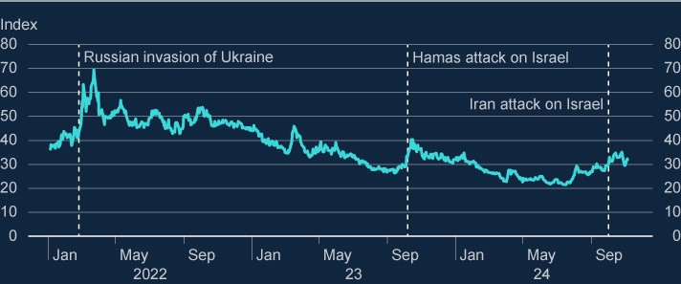

Sources: Bloomberg and Bank calculations.

**The potential for increased global fragmentation also poses risks to UK financial stability.**

Global fragmentation, namely a reduction in the degree of international trade and policy cooperation, could have several consequences. For the macroeconomy, it could weigh on growth and increase the uncertainty of economic outcomes including around inflation, which could in turn feed into volatility in financial markets. The financial system could also be directly affected via disruptions to cross-border capital flows and the reduced ability to diversify risk across borders.

A reduction in the degree of international policy co-operation could hinder progress by authorities in improving the resilience of the financial system and its ability to absorb future shocks. In addition, less international policy co-operation would make it harder to achieve an orderly transition to net-zero greenhouse gas emissions, needed to limit the impacts of climate change on financial stability and long-term growth.

## 2.3: Global sovereign debt vulnerabilities

**Public debt-to-GDP ratios have risen globally since the pandemic and are forecast to continue increasing.**

There has been a long-term upward trajectory in public debt-to-GDP ratios across major economies in recent decades, with further increases projected (Chart 2.2). International Monetary Fund (IMF) projections are for average global public debt to approach 100% of GDP by 2030, with China and the United States largely driving the increase. The IMF projection for the debt-to-GDP ratio in the euro area is broadly flat. Although debt is projected to stabilise or decline by 2029 in about two thirds of the world’s economies, it is forecast to remain higher than before the Covid pandemic. Moreover, the IMF has highlighted that debt forecasts have historically had an optimism bias, with outturns on average being materially higher than three year ahead projections.[4]

**Chart 2.2: Average global debt-to-GDP has risen over recent decades, and further**

**increases are projected**

Sovereign debt (percentage of GDP)

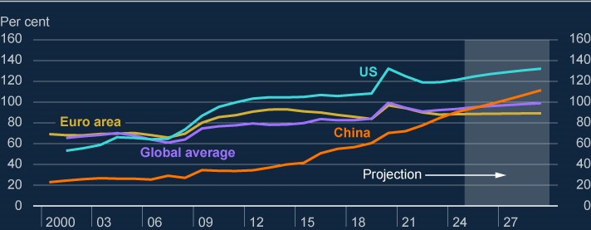

Sources: IMF and Workspace from LSEG.

Projected increases in public debt-to-GDP ratios in the coming years are driven by expected primary budget deficits (that is, before interest payments) as well as by the higher level of growth-adjusted interest rates (that is, the difference between nominal interest rates and expected GDP growth rates). There are a number of both short and longer-term trends which combine to increase the pressure on government finances. These include defence spending pressures, demographics and the physical impacts of climate change and the transition to net zero (Section 3). The crystallisation of geopolitical risks could place further pressures on public debt-to-GDP ratios, including by lowering the outlook for global growth.

Alongside higher indebtedness levels, higher interest rates globally increase the costs of servicing government debt as governments refinance.

**High public debt levels in major economies could interact with other vulnerabilities and have consequences for UK financial stability.**

There are a number of risk channels through which pressures on sovereign debt globally could affect UK financial stability, including:

a deterioration in market perceptions around the sustainability of the long-term path of public debt globally may lead to higher rates, increased term premia and market volatility.

More pronounced volatility in government bond prices could interact with vulnerabilities in MBF, which can amplify shocks, such as large leveraged positions in sovereign debt markets, or expose vulnerabilities associated with interlinkages between banks and sovereigns. This interlinkage was most recently highlighted by the March 2023 stress in the US banking system, in part prompted by the exposure of certain banks to sharp falls in the value of government bonds, driven by higher interest rates. Shocks pushing down on government bond prices (and so up on bond yields) tend to tighten credit conditions for households and businesses as interest rates on sovereign debt influence borrowing costs to the real economy;

increased debt levels and servicing costs could reduce the capacity of governments to respond to future shocks, such as the crystallisation of geopolitical, climate change or pandemic risks, leaving households and businesses more exposed to their impact; and concerns among non-resident investors about the sustainability of government debt could prompt capital outflows, with some jurisdictions, such as emerging market economies, more exposed to this risk than others. This could lead to increased volatility in exchange rates and other financial markets, with the potential to generate losses for financial market participants, including banks.

It is important that banks and other financial firms factor these risks into their internal risk management and stress testing. The FPC will continue to monitor risks arising from sovereign debt globally, taking into account the potential for them to interact with other financial vulnerabilities and amplify shocks. Analytical tools, such as system-wide stress testing, can help market participants and authorities globally better understand the channels through which shocks to government bond prices can spill over.

## 2.4: Global household and corporate debt vulnerabilities

**Globally, corporate and household balance sheets have remained resilient in aggregate, despite continued pressures from higher debt-servicing costs.**

While short-term interest rates have begun to decline from recent peaks, and corporate debt issuance has outstripped recent historical averages across almost all markets, many businesses globally still need to refinance their long-term debt at higher rates. Higher debtservicing burdens can put pressure on corporate balance sheets, especially for smaller, highly leveraged, or less profitable firms. Across advanced economies, the rate of corporate bankruptcies has risen over the last two years, although, in aggregate, the rate of corporate bond defaults globally has remained relatively low by historical standards.

**Significant refinancing challenges remain for advanced economy CRE borrowers, despite increases in some CRE prices.**

US CRE real estate investment trust (REIT) prices have increased by 14% since the June FSR. This follows significant price falls over the last two years, driven by higher interest rates and structural changes such as the rise in remote working. REIT prices can act as a leading indicator of transaction prices, which appear to be bottoming out. But significant refinancing challenges remain for CRE loans, with US$1 trillion (or 17%) of US CRE debt due to be refinanced in the remainder of 2024 and 2025. This could lead to further sales of CRE assets if investors are unable to roll over or secure new financing, potentially amplifying falls in CRE prices. Developments in euro area and UK CRE markets are broadly consistent with those in the US, with tentative signs that CRE prices are stabilising (see Section 4 for further discussion of UK CRE developments).

A number of small and mid-sized banks in jurisdictions such as the US, Germany and Japan have significant domestic and cross-border CRE exposures. The share prices of some banks fell sharply after announcing losses or provisions on CRE portfolios earlier this year, illustrating this potential vulnerability. Stresses in overseas banks could affect the UK financial system through macroeconomic spillovers and contagion to funding conditions for UK banks.

A significant share of global CRE debt is held outside the banking sector. There is less visibility on CRE debt held by NBFIs globally, but correlated exposures to CRE markets for some groups of NBFIs could lead to concentrated losses in a stress, which could interact with other vulnerabilities in the system of MBF (Section 7).

**Mainland Chinese property market vulnerabilities have continued to crystallise…**

Since the June FSR, new and existing home prices in mainland China have continued to fall. They are around 7% and 14% below their peaks, respectively (both in 2021 Q3), and the wider macroeconomic environment remains subdued.

The People’s Bank of China and other Chinese authorities have announced a package of monetary stimulus, and support for the property and stock markets, while steps have also been taken to support local government finances, with an immediate transfer of funds, and a longer-term plan to bring some local government hidden debts on balance sheet. The impact of these measures will become clearer over time and the potential for stresses in mainland Chinese markets to affect the UK remains. Financial stability risk transmission channels include the potential for adverse impacts on global economic growth and financial markets (given the size and globally interconnected nature of the Chinese economy), UK banks’ direct exposures and spillovers to their Hong Kong exposures.

**…while Hong Kong property prices have also fallen further since the June FSR.**

Hong Kong CRE and residential real estate prices are, according to the latest available data, 40% and 28% below their peaks (in 2018 Q4 and 2021 Q3), respectively. There are direct factors affecting Hong Kong property, including the rise in interest rates resulting from the Hong Kong dollar’s peg to the US dollar. More broadly the rise in interest rates is likely to put upward pressure on debt-servicing costs for businesses in Hong Kong. Weaker growth in mainland China is also likely to have an adverse impact on the Hong Kong property sector, and any financial stresses in the mainland could spill over.

**The results of the 2024 desk-based stress test suggest the UK banking system would be resilient to very significant declines in global property prices alongside a severe global downturn.**

The UK banking system has some direct cross-border property market exposures. The scenarios for the 2024 desk-based stress test included peak-to-trough falls in CRE prices of 49% in the UK, the US and the euro area, Hong Kong CRE price falls of 60%, and Hong Kong and mainland Chinese residential real estate price falls of 46% and 38% respectively, alongside a severe global recession. The results suggest that the UK banking system would be resilient to losses associated with such shocks.

## 2.5: The normalisation of monetary policy globally

**The August financial market volatility, which was connected with monetary policy normalisation in Japan, underscored the potential for normalisation across jurisdictions to interact with other risks and vulnerabilities.**

Central banks globally continue to unwind the extraordinary monetary policy measures implemented following the global financial crisis and the Covid pandemic. The specific dynamics and potential risks posed vary across jurisdictions. But funding markets used by global banks are highly interconnected, and a liquidity strain arising in one market could spill over into others. For example, the IMF has highlighted that in the US greater government bond issuance in the context of quantitative tightening has increased the share of debt held by primary dealers, which could put pressure on dealers’ intermediation capacity in the event of a market stress.[5]

The episode of financial market volatility in August underscored the importance of considering risks along the path of monetary policy normalisation. In July, the Bank of Japan, continuing on its path of normalisation after a prolonged period of near-zero interest rates and unconventional monetary policy, decided to increase its key policy rate and to taper its monthly purchases of Japanese government bonds. Although these changes were clearly signalled, this was one of several factors behind an appreciation of the yen against the US dollar, which caused leveraged investors to unwind carry trades, amplifying market volatility (see Section 1 for a discussion of risks around such sharp asset repricing). In addition to causing more unwinding of leveraged yen carry trades, further sharp moves in Japanese asset prices could have wider impacts through other channels, for example if they led to substantial reallocations of portfolio holdings across jurisdictions, or via spillovers from losses for Japanese banks and other financial institutions. Financial institutions should incorporate potential system-wide risks like these into their internal risk management and stress testing.

# 3: In focus – The impacts on financial stability of climate change and the transition to net zero

## Summary

Climate-related risks are relevant to the FPC’s primary financial stability objective of protecting and enhancing the resilience of the UK financial system, and the FPC has developed a framework to help identify and assess them.

Climate-related risks could impact the financial system through a wide variety of channels, including via financial asset prices as they adjust to changing expectations of potential physical and transition risks. And in the longer term, the rising physical impacts of climate change in the UK, such as flooding, could pose increasing risks to financial stability, including via the potential loss of insurance services for some customers.

There is significant uncertainty around the magnitude of future climate-related financial losses and how soon they could crystallise. The FPC will remain vigilant in case risks are bigger or crystallise sooner than expected.

The FPC will continue to assess the potential build-up of systemic risks related to climate change. Scenario analysis, including stress testing, is an important part of the FPC’s toolkit.

UK authorities’ work to ensure awareness of these risks by financial firms, and the co-ordinated development of a transition finance infrastructure, should enhance the resilience of the financial system to climate-related risks over time.

## 3.1: Physical and transition risks from climate change

**Climate-related risks are relevant to the FPC’s financial stability objective of protecting and enhancing the resilience of the UK financial system.**

Climate change poses risks to the financial system, both directly and via impacts on households and businesses, as well as through potential pressures on public finances.

Climate-related risks are therefore relevant to the FPC’s financial stability objective.

The financial risks from climate change can be understood as falling into one of two categories. First, physical risks, which can arise from climate-related weather events, such as droughts, floods, and storms, and ‘chronic’ impacts, such as temperature rise and precipitation changes (which may affect labour, capital and land in specific areas). Second, transition risks connected to the adjustment towards a net-zero economy (‘the transition’), which could arise from developments in climate policy, disruptive new technology, impacts on supply chains for transition-related materials and shifting investor sentiment.

The FPC continues to build on the insights from the Bank’s [**Climate Biennial Exploratory**](https://www.bankofengland.co.uk/stress-testing/2022/results-of-the-2021-climate-biennial-exploratory-scenario)

[**Scenario**](https://www.bankofengland.co.uk/stress-testing/2022/results-of-the-2021-climate-biennial-exploratory-scenario) (CBES), published in 2022, which assessed climate-related risks facing the largest

UK banks and insurers. The CBES concluded that climate change and the transition create risks to households and businesses globally, and so for the financial system. It suggested that overall costs to the financial system would be lowest with timely, well-managed action to reduce greenhouse gas emissions and so limit climate change.

The Bank’s regular stress tests of the UK banking and insurance sectors are based on severe but plausible scenarios. For future stress tests, the Bank will consider how scenarios could start to incorporate specific risks that are expected to be caused or exacerbated by climate change.

**Climate is an inherently international issue.**

[**The UN Global Stocktake**](https://unfccc.int/topics/global-stocktake/components-of-the-gst/consideration-of-outputs-or-political-component-of-the-global-stocktake) showed that physical risks are rising globally. And national transition policies can have wider global economic impacts, including for the UK.

Risks crystallising in other jurisdictions, for example those in regions most exposed to an increase in the intensity and severity of physical hazards, could impact the UK. The UK financial system, including banks and insurers, has significant direct overseas exposures, including to transition-exposed sectors. And the crystallisation of financial disruption elsewhere could spill over to the UK due to the interconnections across the global financial system.

**The physical risks from climate change are crystallising and are expected to increase in severity over time.**

Recent analysis indicates that globally, physical risks are rising faster than previously expected. The [**IPCC Sixth Assessment Report**](https://www.ipcc.ch/assessment-report/ar6/) (AR6) indicated that warming had reached

1.1°C above 1850–1900 levels between 2011 and 2020 and that there is a greater than 50% chance of 1.5°C of global warming between 2030 and 2052. Indeed, the [**UN Emissions Gap**](https://www.unep.org/resources/emissions-gap-report-2024)

[**Report 2024**](https://www.unep.org/resources/emissions-gap-report-2024) estimates that a continuation of the mitigation efforts implied by current policies

will limit global warming to a maximum of 3.1°C over the course of the century. Higher temperate pathways, for example those that overshoot 1.5°C, run a greater risk of passing through ‘tipping points’, causing large, accelerating and potentially irreversible impacts.

The rise in temperatures has already increased the frequency and intensity of extreme weather events. According to the IPCC’s AR6, heavy precipitation is becoming more frequent and more intense globally. And, according to the [**World Weather Attribution study**,](https://spiral.imperial.ac.uk/handle/10044/1/111577) in the UK

intense storm rainfall, like that seen in 2023–24 is now expected to occur one in every five years (instead of one in every 50 years under a pre-industrial climate). And under a 2°C global warming pathway, this could occur one in every three years. The study also indicates that climate change has so far increased the intensity of storm rainfall by around 20%.

The occurrence of unprecedented extreme weather events will continue to rise with increasing temperatures. Even at current levels of global warming, the IPCC’s AR6 indicates that some of these impacts are already ‘locked in’ for the coming decades, regardless of future emissions pathways.

**Financial and economic losses related to physical risks are already rising and are also projected to continue to increase in the coming decades, although the magnitude and timing of losses are very uncertain.**

According to the [**Swiss Re Institute**,](https://www.swissre.com/dam/jcr%3A3a23765e-8aab-460a-a975-fb8bc1f30f9b/2024-03-sr-sigma-1-facts-sheet.pdf) annual insured losses for natural catastrophes have

been growing by 5%–7% on average for the last three decades, and this trend is anticipated to continue over the long term. Their [**projections**](https://www.swissre.com/risk-knowledge/building-societal-resilience/growing-risk-insurance-industry-crucial-role.html)for damage from physical impacts

associated with climate change also indicate that insured property catastrophe losses in key global markets (including China, France, Germany and the UK) will rise by as much as 120% over the next 20 years.

Poorer macroeconomic outturns associated with greater physical risks can have an impact on financial stability by eroding household and business borrower resilience, as well by putting pressure on public finances (Section 2). The global macroeconomic effects of the physical impacts of climate change are expected to rise as severe weather events intensify and become more frequent. According to Network for Greening the Financial System (NGFS) modelling of economic losses from acute physical risks, under a ‘current policies’ scenario, losses could amount to around 4% of world GDP relative to the baseline without climate change by 2030 and 8% by 2050, at the 90th damage percentile (Chart 3.1).[6] The latter is equivalent to twice the estimated GDP impact of a scenario with 1.5°C warming, at the 90th damage percentile. Droughts and heatwaves account for the largest share of losses globally, but large regional differences exist. The physical effects of extreme weather are more acute for jurisdictions where climate-related risk is crystalising more rapidly.

**Chart 3.1: Economic losses from physical hazards are projected to rise**

Estimated GDP losses by acute hazard, under a ‘current policies’ scenario (percentage difference

versus a baseline scenario with no climate change; 2017 purchasing power parity (PPP); local

currency/year)

(

**a**

)

(

**b**

)

(

**c**

)

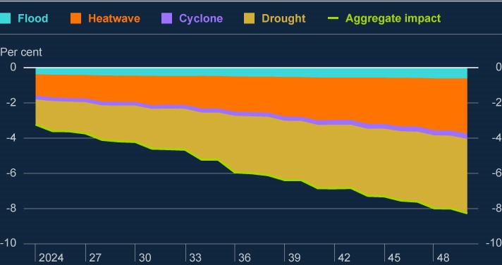

Source: NGFS.

1. ‘Current policies’ scenario assumes that only currently implemented policies are preserved.
2. PPPs are the rates of currency conversion that try to equalise the purchasing power of different currencies, by eliminatingthe differences in price levels between countries.
3. GDP losses shown correspond to the 90th damage percentile (that is, there is a 10% chance of damages being at leastthat high) for droughts, heatwaves, and cyclones. Floods are represented by a point estimate.

As well as acute risks, there are also slower-moving chronic risks, such as average temperature increases and precipitation. These may affect labour, capital and land and have material adverse impacts on output. Median damages for these chronic impacts are estimated by the NGFS based on recent modelling to amount to around 15% of world GDP by 2050.[7] And a lack of economy-wide adaptation to physical risks would, other things equal, increase the financial and economic losses arising from them.

**Transition risks are rising but there is also uncertainty about when and where they will crystallise.**

The UK’s Climate Change Committee noted that the UK has met all of its emissions reductions targets so far, but that reductions across most sectors will need to speed up significantly to be on track to meet the UK’s climate budgets and 2030 Nationally Determined Contribution to the Paris Agreement.[8] [9]

The Bank’s CBES illustrated that a timely and orderly transition helps mitigate financial stability risks. For example, projected bank losses would be lower in a scenario in which earlier and more gradual action is taken to limit global warming to 1.5°C, compared to a scenario where action is taken later, which would need to be faster and more significant if the same end point is to be achieved. More significant and faster policy action increases the likelihood that affected assets become too costly to use or ‘stranded’ in short order, which would cause losses to be larger and more concentrated, also causing greater market volatility.

## 3.2: The FPC’s approach to identifying and assessing climaterelated financial stability risks

**The FPC has developed a framework to consider how climate risks could affect the financial system through a number of channels.**

The FPC’s framework aids understanding of how climate-related risks could impact the financial system and the real economy (Figure 3.1). It illustrates how, despite the specific characteristics of climate-related risks, they will likely impact financial stability through wellknown transmission channels. For example:

Some corporates will be exposed to physical risks arising from climate change, such as more frequent and severe flooding. The extent of their exposure is likely to depend on their location and the nature of their physical operations. Corporates can also be exposed to transition risks, with those sectors most associated with the fossil fuel economy, such as certain energy and transport companies, at potentially greater risk of losses as a result of the transition. The crystallisation of both physical and transition risks is likely to worsen the macroeconomic outlook.

Impacts on corporates can flow through to the financial system if their ability to service debt is impaired, or the value of their collateral is reduced. This is relevant both for bank lending and market-based lending, such as bonds.

Insurers face increased claims as the physical impacts of climate change progress, but the ultimate impact is likely to fall predominantly on their customers through the reduced supply and higher costs of insurance. As such, households are potentially affected via a reduction in the availability of property insurance, and reductions in the value of their assets as result (this channel is discussed in more detail below).

Financial markets could be directly impacted in a number of ways. The value of corporate credit assets (eg corporate bonds and private credit assets) can be affected by changes in the default probability of borrower firms (this channel is also discussed in more detail below), creating potential losses for banks and non-bank financial institutions (NBFIs). And commodity prices, including energy and transition critical minerals, could be impacted by sudden changes to transition policies or relevant technologies. Sharp swings in financial market pricing can, in certain circumstances, lead to spikes in liquidity demand, which could lead to deleveraging that might amplify the impact of shocks (Section 7). The financial system could also be directly affected by operational disruption related to the impacts of climate change, for example if there was an outage at a major firm or critical third party owing to an extreme weather event.

The crystallisation of litigation risks, whereby companies or governments are subject to legal challenge in respect of their climate change mitigation and adaptation measures, could affect financial firms both directly and indirectly, via the impacts on corporates.

The nature of climate change means there are also potential longer-term feedback loops, for example if there is disruption so that the financial system makes an orderly and effective transition harder to achieve and physical risks are increased.

**Figure 3.1: Framework showing how climate-related risks could impact the financial**

**system and the real economy**

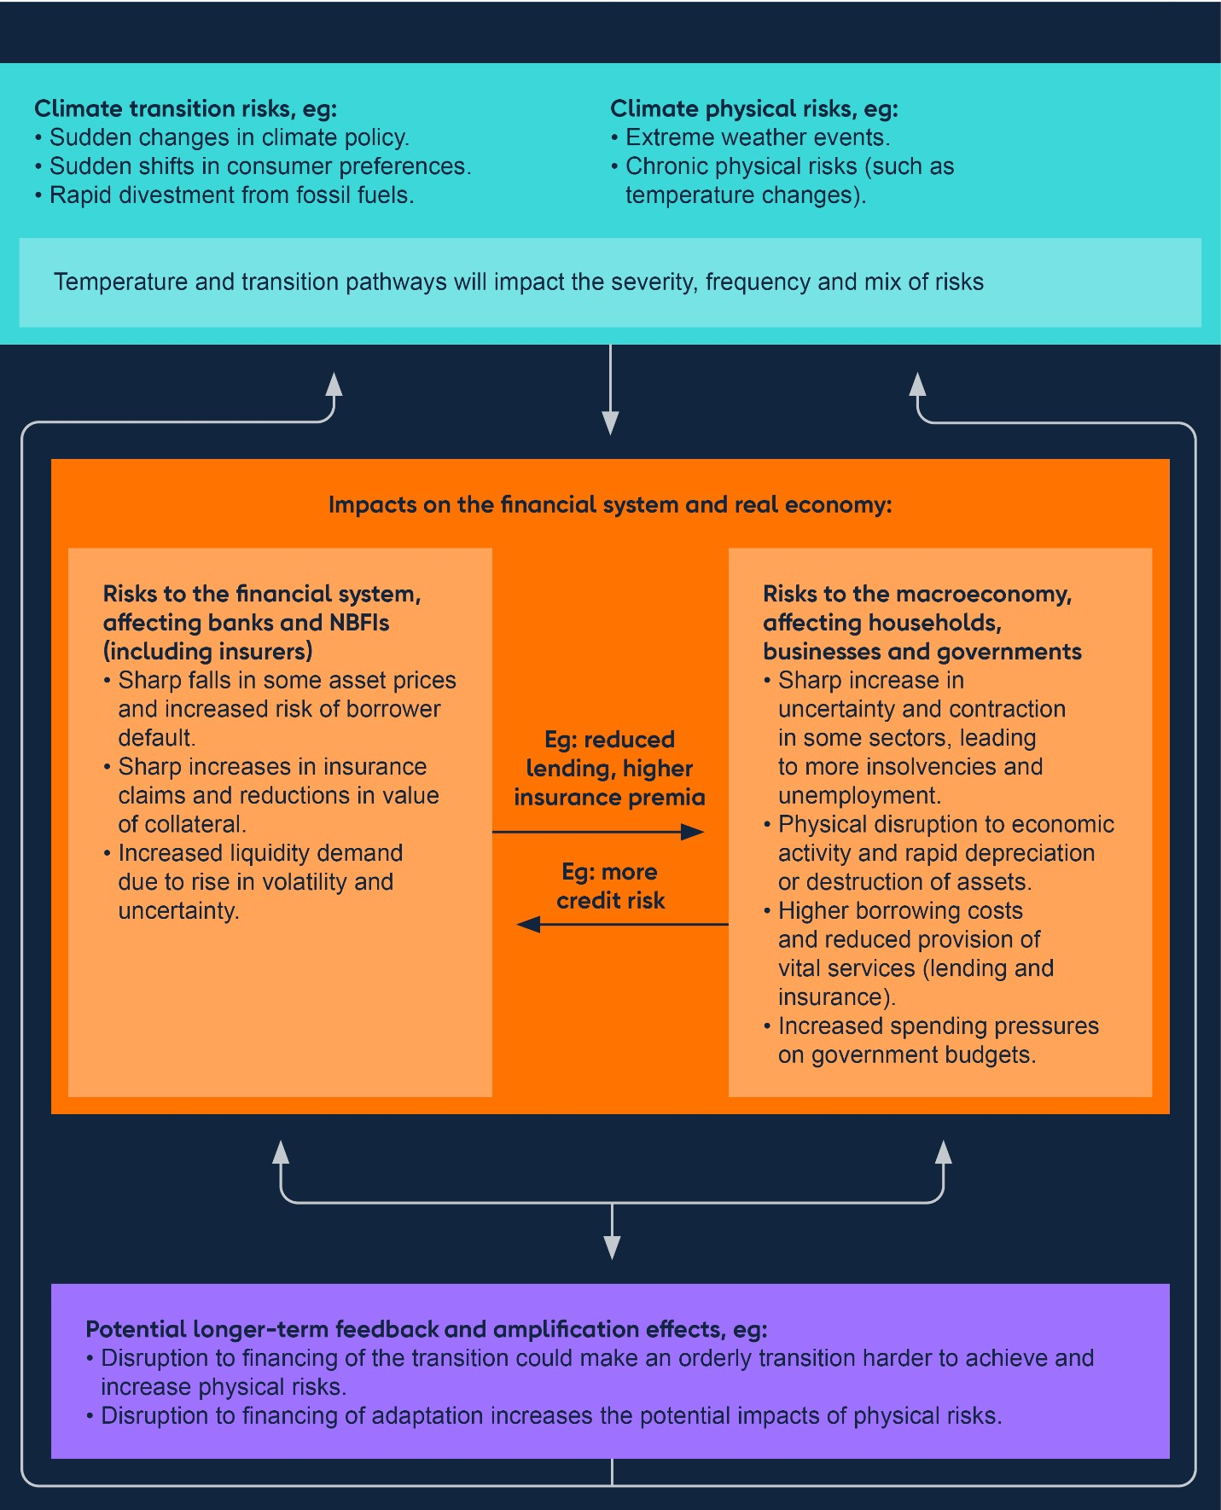

There is significant uncertainty around the magnitude of future climate-related financial losses and how soon they could crystallise. Limitations of available data and methodology in relation to firms’ exposures to physical and transition risks also make any conclusions about the potential financial stability impacts of climate-related risks tentative and approximate.[10] This uncertainty means that the FPC will remain vigilant in case risks are bigger or likely to crystallise sooner than expected.

**Climate-related risks could impact financial stability through financial asset prices.**

Using the above framework, the FPC has identified various specific ways in which climaterelated financial impacts could affect financial stability (Figure 3.2).

**Figure 3.2: Selected climate-related financial impacts and examples of how they could**

**impact financial stability**

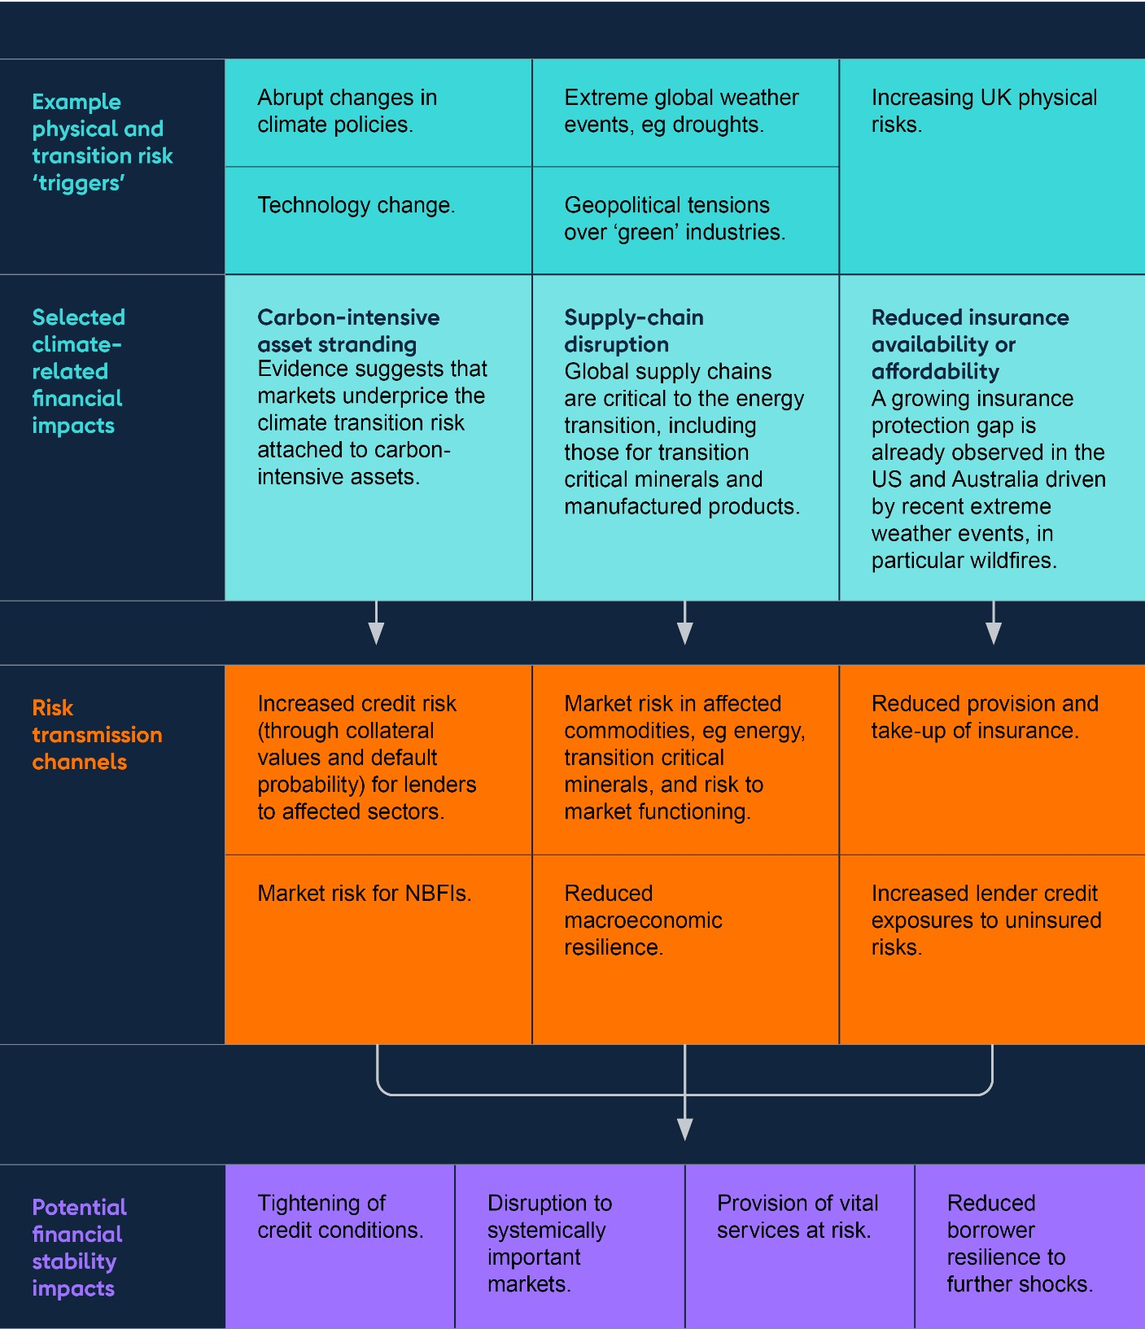

Bank analysis suggests that some credit markets underprice the risks to corporate borrowers’ financial resilience posed by climate transition risks, exposing them to sudden adjustments. The size of the potential vulnerability depends on the average maturity of the assets concerned.[11] When looking at high-yield bonds with a maturity greater than eight years, for example, only around 50% of transition risks expected to crystalise in an orderly transition scenario (as a result of cash-flow impacts and consequent increased default probability) are priced into spreads across most corporate sectors.[12] [13] This ratio would fall further when accounting for the additional risks that creditors would be exposed to in a disorderly transition. Underpricing of transition risks is estimated to be especially pronounced in longer-dated bonds. Bank staff estimates suggest that in the energy sector, even under an orderly transition scenario, less than 35% of transition risk impact is priced in.

This implies significant potential asset price corrections if investors were to start fully pricing in these potential impacts. Sudden movements in asset prices could in turn affect the resilience of systemic firms exposed to those assets or crystalise a number of existing vulnerabilities in market-based finance (Section 7).

Market expectations around future emissions pathways are key to the pricing of this risk, and there are various potential developments that could trigger a change in market perceptions that might cause a repricing. These could include breakthroughs in the deployment of green technologies and the sudden and disorderly implementation of more significant transition policies globally.

**Longer term, the rising physical impacts of climate change in the UK, such as flooding, will further affect potential risks to financial stability…**

In the UK, a key impact of climate change will be an increase in the frequency and magnitude of flooding. Around six million people in the UK currently live in flood prone areas, with that figure set to increase steeply by 2050. According to a UK Health Security Agency report on the impact of climate change, by 2050 the number of people at risk of flooding could rise by around 60% under a 2°C warming scenario, and by around 120% in a 4°C warming scenario.

[14]

**…via the potential loss of insurance services.**

The shorter-term financial impact of flooding on households is likely to be limited, as around 90% of residential properties are insured. This is in part due to the existence of Flood Re, a joint reinsurance initiative between the Government and the insurance industry, which promotes the affordability and availability of insurance for households at high risk of flooding. [15] Flood Re is due to end in 2039 and has a statutory objective to manage the insurance market’s transition to a post-Flood Re pricing model. As physical climate-related risks increase over the longer term, and the Flood Re scheme ends, financial stability risks could develop. In the Bank’s CBES, under the ‘No Additional Action’ scenario, insurers projected that insurance for around 7% of (or approximately two million) UK households would become unaffordable or unavailable.

**Reduced insurance availability and increased costs could pose further potential challenges to financial stability, by putting downwards pressure on house prices and exposing households and lenders to greater losses.**

As flood risks intensify and become more proximate, prospective homebuyers in flood prone areas may start to anticipate reduced insurance availability and substantially higher insurance premia. Prospective buyers may therefore seek property price discounts to compensate for both of these factors.

This dynamic could reduce the market value of affected properties. Bank analysis, based on the net present value of all future increases in insurance premia combined with a potential reduction in insurance coverage, has generated estimated falls in house prices due to this effect, other things equal. In the most pessimistic climate scenarios, the 1% of properties most exposed to increases in flood risk could lose around 20% of their value. And, more widely, the potential fall in house prices for the 10% most exposed areas is, on average, 6.5 times larger than in areas with a median level of risk.

Mortgage lenders’ exposures are sensitive to house prices: other things equal, a price fall would increase the loss given default on a property. And if more properties were uninsured, this would also increase potential losses faced by lenders in the event of damage caused by flooding.

In addition, since most mortgage providers require buildings insurance as a condition of the loan, any change in insurance affordability or availability in flood prone areas could trigger changes in mortgage lending criteria or availability, resulting in some existing mortgage holders being unable to refinance over time.

Furthermore, Flood Re currently only covers residential properties built before 2009 and excludes commercial real estate. As such, even if most flood insurance premia are unlikely to materially change ahead of 2039, some insurance gaps could materialise before then. Commercial properties can also be at high risk of flooding and the impact on affected businesses of flooding events can be severe. The need for businesses to self-insure could, other things equal, put downward pressure on their investment expenditure.

## 3.3: Mitigating and monitoring climate-related financial stability risks

**UK authorities’ work to ensure awareness of climate-related risks by financial firms, and the co-ordinated development of transition finance infrastructure, should continue to enhance resilience in the system over time.**

An important mitigant to potential climate-related financial stability risks is the appropriate management by individual firms of their own risk exposures. This should include the application of scenario analysis to inform the assessment of climate-related risks. The PRA’s work on climate-related risks is helping to build resilience in the UK banking and insurance sectors, including through its supervisory expectations in relation to firms’ effective management of financial risks from climate change (PRA supervisory statement 3/19 – [**Enhancing banks’ and insurers’ approaches to managing the financial risks from climate change**](https://www.bankofengland.co.uk/-/media/boe/files/prudential-regulation/supervisory-statement/2019/ss319)). The PRA is currently updating its supervisory statement which will, among other things, incorporate effective practice.

A further key mitigant alongside these initiatives is the work of UK authorities on building out the ‘transition finance infrastructure’, to support higher emitting companies and activities to decarbonise over time. The Government has announced its intention to consult on economically significant companies disclosing information using future UK Sustainability Reporting Standards, which will be based on the internationally interoperable International Sustainability Standards Board Reporting Standards. It will also consult on how to take forward its work on transition plans. Such disclosures aim to help investors make wellinformed decisions, and thus support better allocation of capital and build confidence in the market for transition climate finance. Such disclosures also aim to help corporates, including those that are exposed to transition risks, for example via their supply chains, to manage the risks and seize the opportunities presented by the transition.

Environmental, Social and Governance (ESG)-labelled assets, which often include, but are not limited to, transition-related investments, have grown over recent years. This highlights a potential risk around so-called ‘greenwashing’, whereby products are marketed as more sustainable than they are in practice, and which could lead to market volatility were market perceptions suddenly to shift. To help address this risk, the FCA has introduced rules into its [**ESG sourcebook**,](https://www.handbook.fca.org.uk/handbook/ESG.pdf) including sustainability disclosure requirements, investment labels and an

anti-‘greenwashing’ Rule, increasing transparency in sustainable investment markets. The requirements are being introduced on a phased timeline, which commenced in May 2024.

**The FPC will continue to assess the potential build-up of systemic risks related to climate change through further monitoring.**

The FPC will continue to monitor climate-related risks that could pose risks to UK financial stability and further develop its understanding of the channels through which these risks can build in the system. This is particularly important given the uncertainty around pathways, models, and data, relevant to climate risk analysis. Understanding the impacts of different potential emissions pathways, and the associated mix of physical and transition risks, is central to this.

The FPC is also considering a range of potential metrics to help monitor climate-related risks to the financial system systematically over time. This includes proxies that provide indicators of the likelihood, severity and potential drivers of transition and physical risks. For example, the timing and trajectory of emission pathways to achieve legislated climate goals are proxies for transition risk and could be driven by changes in government policy, regulation, consumer sentiment and technology. Metrics for physical risk can, for example, capture potential economic losses from natural hazards.

**Scenario analysis, including in the context of stress testing, is important in assisting the FPC’s assessment of climate-related risks.**

As highlighted in the April 2024 Quarterly Bulletin article [**Measuring climate-related financial**](https://www.bankofengland.co.uk/quarterly-bulletin/2024/2024/measuring-climate-related-financial-risks-using-scenario-analysis)

[**risks using scenario analysis**](https://www.bankofengland.co.uk/quarterly-bulletin/2024/2024/measuring-climate-related-financial-risks-using-scenario-analysis), and building on the CBES, climate scenario analysis is an

important tool to enable the integration of climate factors into financial firms’ decision-making and risk management. The Bank considers climate scenario analysis a key part of the risk assessment toolkit for supervised firms, and the PRA expects firms to make further progress on climate scenario analysis to enhance their assessment of the impact of climate change on their businesses.[16] To support the advancement of firms’ risk management capabilities, the Bank continues to encourage the development and deployment of leading practice, including through the work of the [**Climate Financial Risk Forum**](https://www.bankofengland.co.uk/climate-change/climate-financial-risk-forum) and the International Association of

Insurance Supervisors.

Climate macrofinancial scenarios are a key source of forward-looking climate-related risk assessments for central banks and supervisors. For example, the [**updated NGFS scenarios**](https://www.ngfs.net/en/ngfs-climate-scenarios-phase-v-2024)

incorporate the latest economic and climate data, policy commitments and an improved methodology to assess the economic losses from physical risks. This more comprehensive understanding of how climate-related risks change under varying assumptions, including about future climate paths, can help central banks understand the potential implications for the financial system as a whole. It can also assist the FPC in assessing the materiality and proximity of climate-related risks under varying emission pathways.

Climate scenario analysisis a developing field and, to support the FPC, the Bank is investing in its own capabilities and exploring how climate-related risks interact with traditional financial risk drivers, including how they could do so in the future. This includes considering how scenarios in future bank and insurance stress tests could start to incorporate specific risks that are expected to be caused or exacerbated by climate change. This would enable the Bank to explore the impacts of rising physical risks or forthcoming transition-related policy on the potential scale of losses in a stress.

# 4: UK household and corporate debt vulnerabilities

## Key developments since the June 2024 FSR

Overall, UK household and corporate borrowers have been resilient to higher interest rates. But many households and businesses remain under pressure from the higher cost of living and higher interest rates.

The share of households in arrears or with high debt-servicing burdens has remained relatively low. And the outlook for mortgage borrower resilience has improved in line with the domestic economic outlook. While around half of mortgagors are likely to experience greater borrowing costs over the next three years as they refinance onto higher rates, around a quarter of borrowers are expected to benefit from lower rates.

Consumer credit growth has continued to pick up from pandemic lows and is slightly above 2016–19 averages. But pressures on renters and lower-income households continue. Savings buffers have decreased for lower-income households, and the share of renters who have fallen behind on payments has risen slightly.

Risks remain among SMEs and some highly leveraged corporate borrowers, including those backed by private equity. Many businesses that rely on marketbased finance are likely to face greater challenges from higher rates as they refinance. These would increase if investor risk appetite deteriorated, or if interest rates remain higher for longer than markets expect. Market issuance has, however, continued to be strong since the June FSR.

The FPC continues to judge that the UK household and corporate sectors are likely to remain resilient in aggregate.

**Household and corporate indebtedness can impact UK financial stability through two key channels.**

The FPC previously identified two main channels through which high levels of household and corporate debt can pose risks to the UK financial system:

1. Lender resilience: If highly indebted households and businesses get into difficulties makingdebt repayments and default, this can lead to losses for lenders and test their resilience.
2. Borrower resilience: Highly indebted households and businesses may cut back sharply onconsumption, investment, or employment to make debt repayments, and hence amplify macroeconomic downturns and losses for lenders.

By stress testing banks to ensure they have sufficient capital to absorb significant losses on their household and corporate loans while continuing to lend, and by limiting the supply of high loan to income (LTI) mortgages, the FPC aims to reduce risks to financial stability from household and corporate lending, and so support economic growth.

## 4.1: Overview of UK economic developments

**The outlook for UK growth over the coming year is a little stronger than it was at the time of the June FSR, and mortgage market activity has increased.**

In the November Monetary Policy Report, annual real UK GDP growth was projected to average around 1.4% over the three-year forecast period, higher than the 1.2% average growth rate expected at the time of the May MPR. Consistent with that, UK unemployment was projected to remain low by historical standards, remaining below 4.5% through to 2027 Q4. Twelve-month CPI inflation was at the MPC’s 2% target in 2024 Q3 and markets expect the MPC to cut Bank Rate further. Market pricing implies that Bank Rate is expected to be around 3.6% in three years’ time, around 0.2% lower than at the time of the [**June FSR**](https://www.bankofengland.co.uk/financial-stability-report/2024/june-2024)

(Section 1).

Household nominal income growth slowed a little in 2024 H1 but remains robust in real terms. With inflation falling, aggregate real incomes and the household saving ratio continued to recover, although not all households will have experienced those increases. Corporate earnings were broadly flat in 2024 H1, remaining close to 2023 levels.

In line with decreasing interest rate expectations, housing market activity has picked up. In October, quoted mortgage rates fell to their lowest values since September 2022. And although quoted mortgage rates have risen in recent weeks, they remain slightly lower than at the time of the June FSR. Two-year and five-year fixed rate 75% loan to value (LTV) mortgages are now around 4.4% and 4.2% respectively. Accordingly, mortgage approvals have increased towards pre-pandemic levels and secured net lending to households is 0.9% higher than a year ago (Section 5). UK house prices have also continued to rise since the June FSR.

## 4.2: UK household debt vulnerabilities

**Household debt as a share of income has fallen further since the June FSR.**

Aggregate measures of UK household indebtedness have continued to fall since the June FSR, as nominal income growth has outpaced the increase in debt in the latest available data. The aggregate household debt to income ratio fell by around two percentage points to 130% from 2023 Q4 to 2024 Q2, having fallen every quarter since 2022 Q3.

**And the outlook for mortgage borrower resilience has improved in line with the domestic economic outlook.**

Increasing incomes and decreases in actual and expected interest rates mean that, in aggregate, the share of household income spent on mortgage repayments is expected to increase by less than previously forecast. The aggregate mortgage debt-servicing ratio (DSR) fell slightly to 7.2% in June 2024, but is expected to rise modestly to around 8.0% by the end of 2026. This is lower than the 8.4% projected in the June FSR. The aggregate mortgage DSR is still projected to remain well below levels experienced in the global financial crisis (GFC) and the early 1990s recession.

The share of households in arrears or with high debt-servicing burdens has remained relatively low. The proportion of all households with high mortgage cost of living adjusted DSRs (defined as COLA-DSRs over 70%) remained broadly flat at 1.2% in 2024 Q3 (Chart 4.1). This share is expected to remain well below its pre-GFC peak and slightly below projections at the time of the June FSR. Further, NMG household survey evidence suggests borrowers have slightly increased their savings buffers in aggregate in 2024, making them more resilient to potential shocks. Consistent with this, mortgage arrears have remained low since the June FSR at 1.1% in 2024 Q3, and are expected to remain well below their early 1990s and post-GFC peaks.

**Chart 4.1: The proportion of households with the highest mortgage repayments**

**relative to their incomes is projected to stay broadly flat from end-2024 to end-2026**

The share of households with high COLA-DSRs

(

**a**

)

(

**b**

)

(

**c**

)

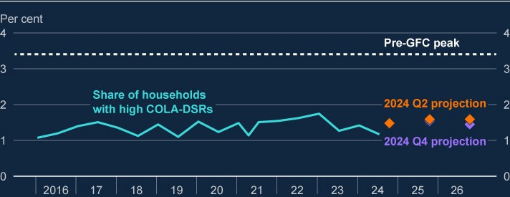

Sources: Bank of England, Bloomberg Finance L.P., British Household Panel Survey/Understanding Society (BHPS/US), NMG Consulting survey, ONS and Bank calculations.(a) High COLA-DSRs are defined as those over 70%. The threshold is estimated by taking the threshold at which households become much more likely to experience repayment difficulties for gross DSRs (40%) and adjusting it to reflect the share of income spent on taxes and essentials (excluding housing costs) by households with mortgages. For more information on the gross threshold, see the [**August 2020 FSR**](https://www.bankofengland.co.uk/-/media/boe/files/financial-stability-report/2020/august-2020.pdf).

1. The impact of inflation is estimated by assuming the prices of essential goods rise in line with the November 2024 MPRoverall CPI inflation projection, and that households do not substitute away from this consumption. Interest rate projections are applied based on overnight index swap (OIS) rates as at 12 November 2024.
2. The 2024 Q2 projection of the share of households with high COLA-DSRs (orange diamonds) was not published in theJune FSR.

**While around half of mortgagors are likely to experience greater borrowing costs over the next three years as they refinance onto higher rates, around a quarter of borrowers are expected to benefit from lower rates, based on market pricing.**

37% of fixed rate mortgage accounts have not yet re-fixed since rates started to rise in 2021 H2, so the full impact of higher interest rates has not yet passed through to all mortgagors. Between December 2024 and 2027 Q4, around 50% of mortgage accounts (4.4 million) are expected to refinance onto higher rates (orange squares in Chart 4.2). Of these, 2.7 million (31% of all mortgages) are expected to refinance onto a rate above 3% for the first time and roughly 420,000 (5% of all mortgages) will see payments increase by more than £500 per month.

For other borrowers, previous and expected falls in Bank Rate will lead to decreasing mortgage payments. 27% (2.4 million) of mortgage accounts are expected to see monthly payments decrease between December 2024 and 2027 Q4 (aqua squares in Chart 4.2). 1.7 million (19% of all mortgages) of these are on variable rates, while the remaining 800,000 are currently fixed above prevailing rates.

On balance, for the typical owner-occupier mortgagor rolling off a fixed rate in the next two years, their monthly mortgage repayments are projected to increase by around £146 (22%), compared to £180 (28%) at the time of the June FSR. An increasing proportion of households are choosing to borrow over longer terms, which reduces monthly capital repayments in the near term but means they will have more debt to service further out.[17] A continuation of this trend would reduce the average expected increase in mortgage repayments.

**Chart 4.2: Around half of mortgages are expected to see payment increases by 2027**

**Q4**

Proportion of owner-occupier mortgages by estimated change in monthly mortgage costs, from

December 2024 to 2027 Q4

(

**a**

)

(

**b**

)

(

**c**

)

(

**d**

)

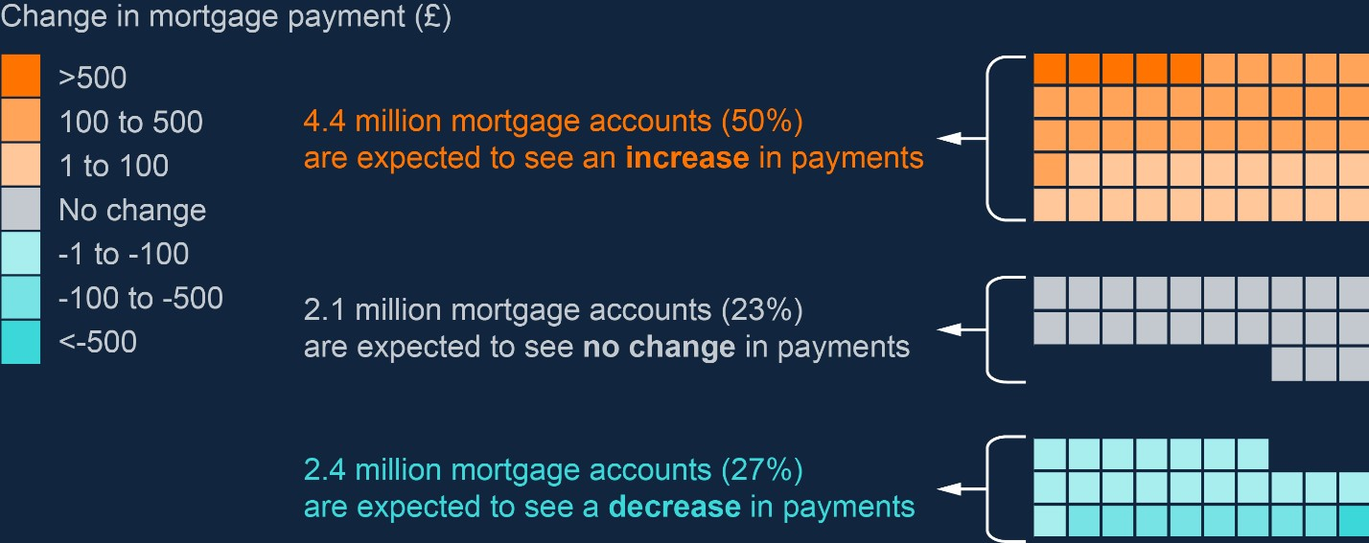

Sources: Bloomberg Finance L.P., FCA Product Sales Data and Bank calculations.

1. There are around 8,834,000 mortgages in the UK. There are 100 squares, each representing 1% of the total current stockof UK mortgages (around 88,340 mortgages), rounded to the nearest 1%.
2. The projection uses the overnight index swap (OIS) curve as at 12 November 2024 and the latest available data (2024 Q2) on the stock of outstanding mortgages.
3. Changes in payments on variable-rate mortgages are calculated using the implied change in the OIS curve, and changesin payment on fixed-rate mortgages are calculated by assuming that mortgagors refinance onto a typical fixed rate implied by the OIS curve at the point that their fixed-rate contract ends.
4. Mortgages with less than £1,000 outstanding are excluded. These data do not include buy-to-let mortgages or mortgagesthat are off balance sheet of authorised lenders, such as securitised loans or loan books sold to third parties.

**The FPC continues to judge that the LTI flow limit has not significantly reduced mortgage access for first-time buyers.**

To provide insurance against a marked and unsustainable loosening in underwriting standards and a further significant increase in the number of very highly indebted households, the FPC introduced mortgage market measures in 2014. These measures included a 15% flow limit on new lending to borrowers with high LTI ratios (at or greater than 4.5).

The aggregate share of lending at high LTI ratios has picked up to 7% in 2024 Q3 (Section 5), this remains well below the FPC’s flow limit of 15%. Banks therefore continue to have capacity for new high LTI lending, and evidence suggests accumulating a sufficient deposit continues to be a key challenge for first-time buyers, as first set out in the FPC’s 2021 [**housing review**](https://www.bankofengland.co.uk/-/media/boe/files/financial-stability-report/2021/december-2021.pdf). The share of new mortgages for house purchase extended to first-time

buyers reached 52% in 2024 Q3, up from 44% in 2013 and near its highest point since at least 2005 (Chart 4.3). The total number of approved mortgages for house purchase per quarter is broadly similar to 2013.

**Chart 4.3: The share of new mortgages extended to first-time buyers is near its**

**highest point since at least 2005**

First-time buyer mortgages as a share of all mortgages for house purchase

(

**a**

)

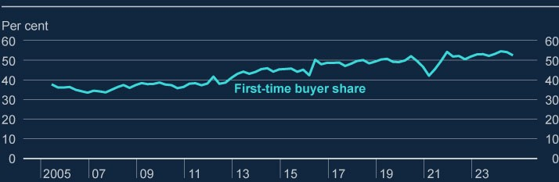

Sources: FCA Product Sales Data and Bank calculations.

(a) Number of first-time buyer mortgage completions as a proportion of all owner-occupied mortgage completions for house purchase (ie first-time buyers and home-movers). This excludes remortgages, further advances, second charge mortgages and lifetime mortgages. Data available from 2005 Q2.

In addition to the FPC’s LTI flow limit, the FCA also has Responsible Lending rules ([**Mortgage**](https://www.handbook.fca.org.uk/handbook/MCOB/11/?view=chapter)

[**Conduct of Business 11**](https://www.handbook.fca.org.uk/handbook/MCOB/11/?view=chapter)) to protect consumers from unaffordable mortgage debt. FPC

measures and FCA rules have helped keep arrears low; more than half of the UK mortgages currently in arrears were originated prior to the GFC. Similarly, repossession rates, which are currently at around 0.04%, remain well below their 2009 rate of 0.2% and their 1990s peak of

0.7%.

**Consumer credit growth has continued to pick up from pandemic lows and is slightly above 2016–19 averages. But pressures on renters and lower-income households continue.**

Consumer credit use grew 6.6% from June 2023 to June 2024, slightly above the 2016–19 average of around 6%.[18] Households use unsecured borrowing to manage their expenditures, including those associated with increased living costs, or to borrow to smooth spending on large outlays such as car purchases or home renovations.

The resilience of typical consumer credit borrowers has improved since the pandemic and the

GFC. Consumer credit debt balances are now 15% of income, well below pre-GFC peaks of 25% and 2017–19 levels of 18% (Chart 4.4). Relatedly, aggregate consumer credit DSRs remain low and are currently around half pre-GFC levels. Interest rates on consumer credit are less directly related to Bank Rate than mortgage rates, meaning payments have not increased by as much in relative terms since rates began to rise in 2021.

However, pressures on renters and lower-income households continue. On average, savings buffers for renters have increased in the six months to 2024 Q3 but have decreased for lowerincome households. NMG survey evidence suggests the share of renters who have fallen behind on payments has continued to rise as rents have risen substantially alongside the increase in mortgage borrowing costs. The NMG survey also suggests some renters and lower-income households intend to run down their savings in the next year to deal with the increased cost of living, making these groups less financially resilient. The challenges faced by renters and lower-income households are also borne out by intelligence from the Bank’s agency network.

**Chart 4.4: Consumer credit balances are significantly smaller than mortgage balances**

**and a similar share of debt repayments**

Outstanding consumer credit and mortgage balances as a share of income (left panel) and

consumer credit and mortgage DSRs (right panel)

(

**a**

)

(

**b**

)

(

**c**

)

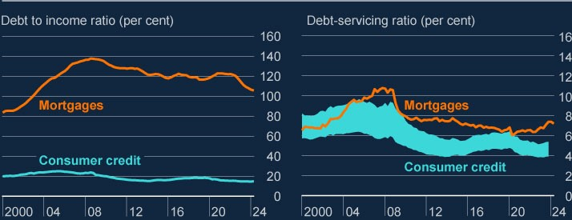

Sources: Bank of England, Finance and Leasing Association, ONS, UK Finance and Bank calculations.

1. Debt to income calculated as consumer credit and mortgage gross debt outstanding as a proportion of nominal householdpost-tax income. Debt-servicing ratios calculated as interest payments plus principal repayments, as a proportion of nominal household post-tax income. Household income is defined as disposable (post-tax) income adjusted for changes in pension entitlements, which is adjusted to exclude gross operating surplus and the effects of financial intermediation services indirectly measured, and to add back in interest paid. Mortgage interest payments before 2000 are adjusted for the effect of mortgage interest relief at source.
2. There are uncertainties in the exact level of the aggregate consumer credit DSR, where a plausible range is illustrated inthe swathe. This range is constructed using different assumptions regarding the amount of principal that is repaid on credit cards and personal loans, and regarding the calculation of interest payments. (c) Consumer credit DSR data are available to 2023 Q4, all other data to 2024 Q2.

Direct financial stability risks from consumer credit are likely to remain limited given the current economic outlook. Arrears on UK banks’ consumer credit lending were 1.3% in 2024

Q2, broadly flat since 2024 Q1, which was the latest data available at the time of the June FSR, and remain low by historical standards. And annualised write-off rates on banks’ consumer credit exposures are around 2%, below the GFC peak of 7%. These low levels of distress are supported by low current and expected unemployment rates.

However, if unemployment were to increase significantly, loss rates on consumer credit would also increase. For example, write-offs on banks’ UK consumer credit exposures totalled around £35 billion when unemployment reached 8.5% during the GFC, more than ten times higher than on mortgages.

**The FPC judges that, in aggregate, households should remain resilient. And that the UK banking system has the capacity to continue supporting the economy even if unemployment were to increase significantly.**

In the 2024 desk-based stress test, the resilience of the UK banking system was tested under two severe macroeconomic scenarios (Section 6). These both included increases in UK unemployment to 8.5%, which would put pressure on the ability of many households to service their debts. The results of the test indicated that banks would have the capacity to continue supporting the economy, despite a high level of impairments on consumer credit and mortgage lending in the scenarios.

## 4.3: UK corporate debt vulnerabilities

**Measures of indebtedness suggest corporate resilience remains strong in aggregate. And although the share of vulnerable corporates has increased slightly, it is projected to continue to remain well below past peaks.**

Corporate net debt to earnings were broadly unchanged from end-2023 to 2024 Q2, having fallen by 11 percentage points from end-2021 to end-2023. They are now low by historical standards at around 125%, well below pandemic highs of 172% and post-GFC highs of 235%. This reduces the risk that indebted corporates would materially amplify a shock. However, earnings, cash reserves and debt holdings are not evenly distributed among firms, so this aggregate picture can mask vulnerabilities within particular firms and sectors.

The share of firms which are considered vulnerable also remains low by historical standards. The debt-weighted proportion of corporates with low interest coverage ratios (ICRs) – ICRs below 2.5 – is currently estimated to be 44% and is expected to increase by around one percentage point by the end of 2025 (Chart 4.5). This projection is slightly lower than projected at the time of the June FSR. This is consistent with the Bank’s broader corporate debt at risk measure based on data up to end-2023. This measures the share of debt held by firms that cross three thresholds with the highest predictive power for default: low ICRs; low liquidity; and negative return on assets. These firms are considered to be at higher risk of default, and more likely to take defensive actions such as significantly cutting investment and employment, creating risks through the borrower resilience channel. The estimated share of corporate debt at risk has ticked up slightly in 2023, but remains below 10%, suggesting that the volume of vulnerable corporates remains well below the GFC and early 2000s peaks.

**Chart 4.5: Measures of corporate vulnerability are well below past peaks and are**

**expected to remain low**

Debt-weighted share of UK corporates with ICRs below 2.5 and share of UK corporates at higher

risk of default

(

**a**

)

(

**b**

)

(

**c**

)

(

**d**

)

(

**e**

)

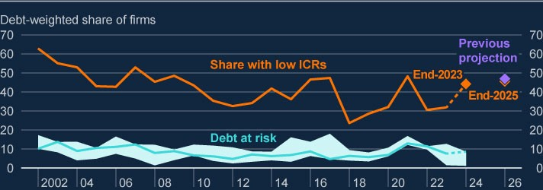

Sources: Moody’s: Bureau van Dijk, S&P Capital IQ and Bank calculations.

1. These data refer to UK private non-financial corporations only.
2. The ICR projection conservatively assumes full pass-through of the Bank Rate path to the stock of floating and maturingfixed rate corporate debt over 2023 and 2025. Not all firms have submitted end-2023 balance sheets, so the partial coverage beyond 2022 is represented as a dotted line for the debt-at-risk measure.
3. The aqua line represents the debt-weighted share of UK corporates that simultaneously breach the three thresholdsassociated with the highest likelihood of firm failure: whether a company’s interest coverage ratio, calculated by dividing its earnings before interest and tax, is below 1.5; whether its liquidity ratio (current ratio) is below 1.1; and whether its return on assets is negative.
4. Alternative projections of debt at risk within the aqua swathe capture firms that breach any three thresholds within sixfactors (the three set out in (c), as well as turnover growth less than -5%, leverage growth greater than 5% and leverage less than 1) and breach the thresholds with the highest marginal effects. See [**Stressed or in distress? How best to measure**](https://bankunderground.co.uk/2024/02/21/stressed-or-in-distress-how-best-to-measure-corporate-vulnerability/)

[**corporate vulnerability**](https://bankunderground.co.uk/2024/02/21/stressed-or-in-distress-how-best-to-measure-corporate-vulnerability/) for further details.

1. Previous projections are as published in the June FSR.

Likewise, corporate insolvency rates have been broadly flat since the June FSR. Insolvencies were around 55 per 10,000 firms in the 12 months to September 2024, broadly unchanged on the prior 12 months and well below their long-term average level of around 100 per 10,000 firms. Insolvencies continue to be driven by very small firms with limited debt and share of employment, with firms formed since the start of the pandemic making up a significant proportion of recent firm exits. The current rate of insolvencies is unlikely to pose borrower or lender resilience challenges. But a significant further increase in insolvencies to levels beyond historical averages could pose an indirect risk to the ability of households to service their debts as SMEs comprise around 60% of UK employment.

**SMEs are generally under more pressure than larger corporates, and arrears have risen slightly in 2024.**

The majority of lending to SMEs is advanced by banks on floating rates, so decreases in Bank Rate will have relieved repayment pressures slightly, as evidenced by a dip in the aggregate share of SME current account inflows spent on debt-servicing in 2024. Nevertheless, arrears for commercial loans to SMEs increased slightly from 1.2% in January 2024 to 1.4% in July 2024, and around 10% of SMEs are currently using their overdrafts. This is higher than the 6% seen during the pandemic and close to pre-pandemic averages. SME lending has limited lender resilience implications because bank exposures are relatively small, and a large share of lending is government-guaranteed.

**But refinancing challenges remain for larger corporates, particularly for firms using riskier forms of market-based finance, such as leveraged loans and high-yield bonds.**

Given that most corporate debt is on floating interest rates (eg variable rate bank loans) that have already increased in line with Bank Rate, some of the debt-servicing pressure associated with past interest rate rises has already passed through to corporates in aggregate. And further expected decreases in Bank Rate should relieve some of this pressure.

But a subset of corporates, largely those relying on market-based finance (or with interest rate hedges in place), have not yet felt the full impact of higher interest rates. Bonds, which comprise 25% of UK corporate debt, are fixed for 10 years on average meaning issuers are likely to face interest rate increases as they refinance.

Most publicly issued corporate bonds are investment grade, and their issuers are typically resilient to refinancing risks because of low leverage, strong balance sheets and choice over sources of finance. However, the 21% of public UK corporate bonds (ie 7% of total UK corporate debt) that are high yield are typically shorter term, and subject to greater refinancing risk. Around 20% of high-yield corporate bonds are due to mature in the next two years (Chart 4.6), and Bank Rate is now around 4.25 percentage points higher than when many of these bonds were issued. Around 25% of firms that need to refinance high-yield bonds over the coming years are private equity backed ([**Section 6 of the June FSR**](https://www.bankofengland.co.uk/financial-stability-report/2024/june-2024)).

Since the June FSR, the share of firms due to refinance has remained broadly flat, and strong issuance in corporate debt markets and lower interest rate expectations have supported refinancing. However, risk premia across a range of markets have compressed further and are very low by historical standards (Section 1). If market conditions were to tighten before high-yield bonds were refinanced, issuers might have to re-finance onto even higher rates or turn to alternative sources of finance such as private credit. Businesses facing higher debtservicing costs after refinancing, or difficulties in sourcing finance, may take defensive action by cutting back on investment and employment and may be more likely to default. Because firms using riskier forms of market-based finance comprise at least 12% of UK employment, stress in these markets could pose borrower and lender resilience challenges.

**Chart 4.6: A large proportion of higher-risk market-based debt used by UK firms is**

**due to be refinanced in the coming years, but market issuance has continued to be**

**strong**

Stock of debt maturing within one or two years (four-quarter rolling average) and quarterly issuance

in UK high-yield markets, as a percentage of the outstanding stock of high-yield bonds

(

**a**

)

(

**b**

)

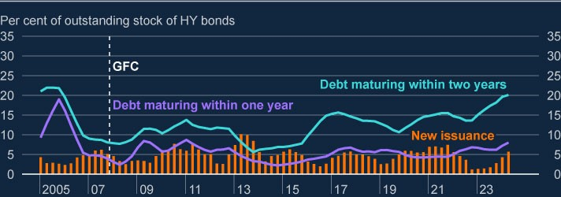

Sources: LSEG and Bank calculations.

1. The total UK PNFC high-yield bonds shown in this chart excludes non-rated and withdrawn bonds.
2. All UK issued bonds in all currencies converted to sterling.

The headwinds continuing to face some parts of the UK commercial real estate (CRE) market also make refinancing challenging, in part due to the lower value of collateral. Office and retail CRE have been particularly impacted by factors including the post-pandemic shift to more remote working and the continuing shift from physical to online shopping. Cyclical pressures and the transition to net zero are also expected to continue to weigh on prices. Although UK CRE prices have fallen over 20% from their 2022 peaks, they have stabilised in recent quarters. There are tentative signs that US and euro area CRE prices are also stabilising (Section 2). The desk-based stress test indicated that the major UK banks would be resilient to a much larger fall in UK CRE prices than already observed.

**The FPC judges that, in aggregate, the UK corporate sector will remain broadly resilient. And the UK banking system is well capitalised to withstand increases in corporate distress.**

The UK banking system is well capitalised and could continue to support businesses even if macroeconomic conditions turned out materially worse than expected. The results of the 2024 desk-based stress test (Section 6) indicate the UK banking system would have the capacity to continue supporting the economy in the severe economic scenarios it tested, despite higher impairments on their UK corporate and CRE lending portfolios, including on riskier forms of lending such as leveraged loans. The desk-based stress test indicated that the major UK banks would be resilient to a much larger fall in UK CRE prices than already observed.

# 5: UK banking sector resilience

## Key developments since the June 2024 FSR

The UK banking system is well capitalised and has high levels of liquidity. Major UK banks’ asset quality remains strong, and forward-looking indicators of asset quality have improved.

The results of the 2024 desk-based stress test suggest that the UK banking system is in a strong position to support households and businesses even if economic, financial and business conditions turned out to be substantially worse than expected (Section 6).

Net interest margins are anticipated to remain broadly stable, with widespread use of hedging practices likely to reduce banks’ sensitivity to expected falls in interest rates. UK banks’ aggregate price to tangible book (PtTB) ratio is now nearer to one.

Adjustment by banks to the normalisation of central bank balance sheets is underway as the extraordinary measures put in place following the global financial crisis (GFC) and Covid pandemic are unwound. Banks should continue to factor these trends into their liquidity management and planning.

Aggregate credit conditions have continued to ease. Both credit demand and availability have increased, albeit from subdued levels in recent years and to varying degrees in different market segments. The FPC judges that, overall, credit conditions continue to reflect the macroeconomic outlook.

The FPC has maintained the UK countercyclical capital buffer (CCyB) rate at its neutral setting of 2%.

Interlinkages between UK banks and non-bank financial institutions (NBFIs) are significant, including through their provision of repo financing and other prime broking activity. The FPC explored these interlinkages as part of its system-wide exploratory scenario exercise and will continue to monitor them in future (Section 7, Box A).

## 5.1: Recent developments in UK banks’ resilience

**The UK banking system continues to be well capitalised and has high levels of liquidity.**

Major UK banks and building societies (‘major UK banks’) remain well capitalised, with an aggregate Common Equity Tier 1 (CET1) capital ratio of 14.8% in 2024 Q2. This level is broadly unchanged since the June 2024 FSR. Small and medium-sized UK banks and building societies (‘small and medium-sized UK banks’) have also maintained robust capital positions in aggregate with an overall CET1 ratio of 18.1% in 2024 Q2.[19]

The PRA announced that the Basel 3.1 capital standards will come into effect for UK banks on 1 January 2026, with transitional arrangements in place until the end of 2029. The PRA’s near-final policy statement gives further clarity to firms on their future UK capital requirements. Implementation of Basel 3.1 delivers a better balanced and risk-sensitive approach to calculating regulatory capital, and supports the UK’s growth and competitiveness, the resilience of the banking system, and alignment with global standards.[20]

The UK banking system also maintains high levels of liquidity. Major UK banks’ aggregate three-month moving average Liquidity Coverage Ratio (LCR) is broadly unchanged since the June FSR, standing at 151% in September, and these banks maintained total high-quality liquid assets (HQLA) of around £1.34 trillion. The aggregate three-month moving average LCR for small and medium-sized UK banks rose slightly to 269% in September, and they had £165 billion of HQLA. Banks have continued to adjust the composition of their liquid assets, replacing reserves with gilts and other forms of HQLA, as the volume of reserves in the system has declined with the normalisation of the Bank of England’s balance sheet (see below in this section for further details).

**Major UK banks’ asset quality has continued to improve. Overall, the UK banking system is resilient to the current economic outlook and has the capacity to support households and businesses, even if economic, financial and business conditions were to be substantially worse than expected.**

Major UK banks reported further improvements in asset quality since the June FSR, and their forward-looking indicators of asset quality have continued to improve steadily. The share of loans for which there has been a significant increase in credit risk since origination

(International Financial Reporting Standard (IFRS) 9 ‘stage 2’ loans) fell from 10.2% in 2024 Q2 to 9.5% in 2024 Q3. Reflecting this, major UK banks’ aggregate provisions against loans fell to their lowest point as a share of lending since the Covid pandemic, while provision coverage remains close to 1% of loans, which is around its pre-Covid value.

There was also no overall deterioration in asset quality within riskier credit portfolios. Despite a further decline in Hong Kong property prices (Section 2), UK bank losses were limited by lenders having previously made provisions, reduced the size of their portfolios and the fact that initial lending was largely at relatively low loan to value ratios. While global leveraged loan defaults continued to be high, they remained stable, and ultimate loss rates still appear low.

The results of the 2024 desk-based stress test indicate the UK banking system would be resilient to severe economic scenarios that significantly impact credit portfolios, including increased losses within riskier credit portfolios (Section 6). The test suggests that banks’ aggregate capital ratio would remain above its hurdle rate in both a severe supply shock scenario, in which a global shock drives higher inflation and interest rates, and a severe demand shock scenario, in which there is a sharp fall in global activity that results in lower inflation and interest rates.

**UK banks have continued to deliver robust earnings growth, supporting increased valuations. Looking ahead, hedging practices are expected to temper the adverse impact of falling interest rates on net interest margins.**

Major UK banks continued to report robust earnings in 2024 Q3, with underlying returns on tangible equity at 14.0%, around estimates of their cost of equity (the compensation investors require for the perceived riskiness of those returns). Pre-provision profits rose to £16.2 billion on the quarter.[21] This was largely driven by increased net interest income, which was in turn supported by stronger lending growth in the context of an improving macroeconomic environment. Banks with investment banking divisions reported particularly strong performance, largely driven by increased mergers and acquisitions activity and trading revenues, including through the period of elevated market volatility in August (Section 1).

Major UK banks’ earnings are expected to remain around their current levels in aggregate. Lending volumes are expected to increase in line with an improving economic outlook. Net interest margins (NIMs) are expected to remain at a level close to their long-run average; somewhat higher than in recent years when Bank Rate was close to zero (Chart 5.1). This reflects the expected benefit from banks’ previously established hedging practices that reduce the sensitivity of their income to interest rates (Section 6 for further details in the context of the desk-based stress test results).[22] This includes the ‘structural hedge’, which should dampen the impact on NIMs of the falls in central bank policy rates expected by markets, just as it dampened the benefit to NIMs as interest rates were rising.

**Chart 5.1: Major UK banks’ average loan margins are expected to remain close to their**

**long-run average**

Average margin on major UK banks’ lending since 2000

(

**a**

)

(

**b**

)

(

**c**

)

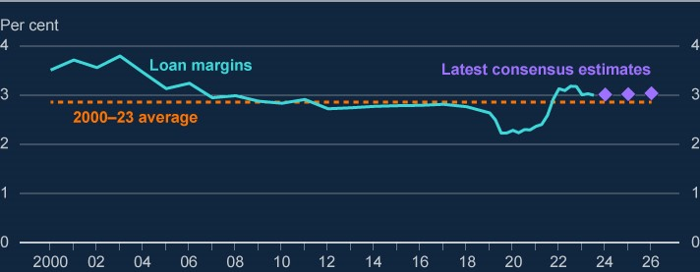

Sources: Refinitiv Eikon from LSEG, published accounts and Bank calculations.

1. Loan margin is calculated as net interest income divided by total lending. Loan margins in this chart are calculated acrossall currencies. Net interest income is interest income minus interest expense.
2. Figures between 2000 and 2019 exclude Virgin Money UK, and figures before 2006 exclude Standard Chartered.(c) Consensus estimates are scaled based on analysts’ expectations of loan margins for Barclays, HSBC, Lloyds Banking Group, NatWest Group and Standard Chartered. Purple diamonds are the forecasts for 2024, 2025 and 2026.

The strong results and improving macroeconomic outlook were reflected in an increase in UK banks’ valuations and PtTB ratios. The FTSE 350 bank index has increased by around 11% since the June FSR. Major UK banks’ PtTB ratio, an indicator of investor confidence in the risk-adjusted outlook for bank profitability, continued to increase and is now nearer to one.[23]

Some lenders face uncertainty over the potential for redress payments associated with certain historic commission payments. In January 2024, the FCA [**announced**](https://www.fca.org.uk/news/statements/fca-undertake-work-motor-finance-market) a review into whether

motor finance customers had been overcharged because of the past use of discretionary commission arrangements. In October, the Court of Appeal declared it was unlawful for car dealers to receive commission from motor finance lenders unless it had been appropriately disclosed to the customer and they had subsequently given informed consent. Having previously [**announced**](https://www.fca.org.uk/news/statements/extension-motor-finance-complaint-handling-pause-confirmed) that it was extending a pause to the deadline for motor finance firms to

respond to customer complaints regarding discretionary commission arrangements, in November the FCA [**announced**](https://www.fca.org.uk/news/statements/fca-consult-extending-time-motor-finance-firms-handle-commission-complaints) that it would consult on extending the timeframes for

complaints about motor finance where a non-discretionary commission was involved. Equity prices for some potentially exposed banks declined following the Court of Appeal ruling, reflecting market perceptions that the potential for higher redress payments could weigh on future profitability.

**UK banks have continued to adjust to the normalisation of central bank balance sheets.**

The normalisation of central bank balance sheets has continued as the extraordinary measures put in place following the GFC and Covid pandemic have been unwound further.[24] The Bank of England, in accordance with the approach decided by the MPC, has continued to unwind holdings in its Asset Purchase Facility (APF), with another £100 billion planned over the 12-month period from October 2024 to September 2025.[25] The Term Funding Scheme with additional incentives for Small and Medium-sized Enterprises (TFSME) is also winding down.[26] As a result, aggregate Bank of England reserves have declined by around £250 billion since their peak in early 2022, around £40 billion of which has been since the June FSR.

UK banks have maintained their liquid assets well above minimum levels as this process of normalisation has continued, using the range of options and liquidity management tools available to them.[27] Banks have continued to adjust the composition of their liquid assets, replacing reserves with other forms of HQLA as the volume of reserves in the system has declined. The share of government bonds in major UK banks’ HQLA has increased from 21% in September 2023 to 29% in September 2024, while the share of central bank reserves has decreased from 60% to 50% in the same period. LCRs have remained broadly unchanged throughout this period of adjustment.

Use of the [**Bank of England’s facilities**,](https://www.bankofengland.co.uk/markets/bank-of-england-market-operations-guide/our-tools) including the Short-Term Repo (STR) and Indexed

Long-Term Repo (ILTR) facilities, has also increased as intended. The STR allows participants to borrow central bank reserves for a one-week period in exchange for high quality, highly-liquid assets. This has enabled banks to manage their short-term liquidity needs as they adjust to the decline in the volume of system-wide reserves.[28] Use of the STR has stabilised at around £40–£50 billion, up from around £30 billion at the end of July and £5 billion at the end of 2024 Q1. This is consistent with its intended purpose of ensuring interest rate control as the MPC unwinds its asset purchases (Chart 5.2).

The ILTR allows participants to borrow central bank reserves for a six-month period against the full range of Sterling Monetary Framework eligible collateral (including less liquid assets). As set out in [**Victoria Saporta’s**](https://www.bankofengland.co.uk/speech/2024/july/victoria-saporta-speech-at-afme-seminar) speech, the ILTR is intended to complement the STR,

providing participants with a longer-term facility to supply the potentially large stock of reserves the system may demand in steady state. In future, as the level of reserves declines, the ILTR is expected to play a greater role in both supplying the reserves necessary for interest rate control and supporting financial stability. Consistent with this, the stock of ILTR use has begun to increase, reaching around £5.5 billion, its highest level since 2020 Q4.

The Bank continues to welcome banks’ willingness to use its facilities and encourages lenders to prepare operationally for increased usage of both short term and long-term repo operations as the Bank’s balance sheet continues to transition towards a steady state. This includes engaging with a forthcoming discussion paper (DP) on the Bank’s transition to a demanddriven, repo-led framework for supplying reserves. The DP will include more detail on the Bank’s plans for ensuring the ILTR is appropriately calibrated to supply the stock of reserves moving forward.

**Chart 5.2: Banks’ use of the Bank of England’s short-term repo and indexed long-term**

**repo facilities has continued to increase as intended**

**(**

**a)**

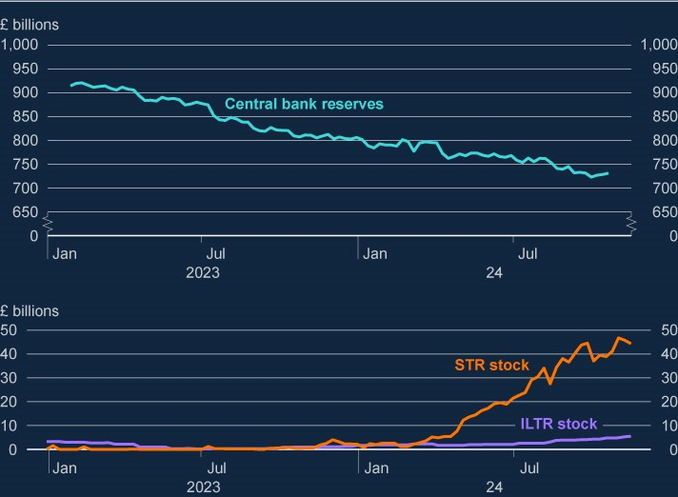

Sources: Bank of England facilities’ results and usage data.

(a) Central bank reserves are aggregate system-wide reserves. STR and ILTR stock represent the cumulative stock of outstanding drawings under the respective facilities calculated on a weekly basis.

UK banks have also continued to repay TFSME funding, around two fifths of which has now been repaid. This repayment has been supported by growth in aggregate deposits, consistent with increased bank lending (Section 5.2), and favourable wholesale funding market issuance conditions. The PRA continues to monitor progress against TFSME repayment plans.

Banks should continue to factor system-wide trends likely to affect bank funding and liquidity, including the normalisation of central bank balance sheets, into their liquidity management and planning. The FPC will continue to monitor the implications of these trends for financial stability.

## 5.2: UK banks’ provision of credit to UK households and businesses

**There have been further signs of easing credit conditions since the June FSR.**

UK banks’ gross and net lending volumes have continued to rise since 2024 Q1. Total net lending is at its highest level since 2022 Q3, but remains below its 2015–19 average, even in nominal terms (Chart 4.3). Intelligence from lenders and the Bank’s agents indicates banks are increasing the provision of credit to meet a growing demand from households and some businesses, which is recovering consistent with an improved domestic macroeconomic outlook.

**Chart 5.3: Bank lending volumes have continued to increase but remain below 2015–**

**19**

**averages**

UK monetary financial institutions’ net lending to UK households and businesses, seasonally

adjusted

(

**a**

)

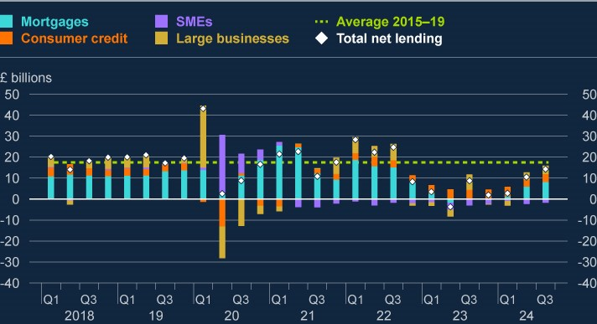

Sources: Bank of England and Bank calculations.

(a) SMEs are defined as businesses with annual debit account turnover on the main business account up to £25 million.

Large businesses are those with annual debit account turnover on the main business account of over £25 million.

Mortgage lending has been a key driver of the overall increase in credit growth. Approvals reached a two-year high in September and have been increasing for four consecutive months. This reflected increased borrower demand as quoted rates had fallen in line with the outlook for Bank Rate. Strong mortgage market competition has meant that lending spreads to Bank Rate have remained relatively low. While aggregate mortgage lending has risen back towards

2015–19 averages, it remains well below past peaks. While the 2024 Q3 [**Credit Conditions**](https://www.bankofengland.co.uk/credit-conditions-survey/2024/2024-q3)

[**Survey**](https://www.bankofengland.co.uk/credit-conditions-survey/2024/2024-q3) (CCS) indicates that credit provision to households is expected to continue to

increase in the coming months, this comes from a relatively low base.

There were some initial signs of growing lender risk appetite. The flow of lending at higher loan to value (LTV ≥90%) and loan to income (LTI ≥4.5) ratios increased by around 1 percentage point in Q3 but still remains slightly below 2019 levels.

Gross lending volumes to corporates have also continued to grow since the June FSR, driven primarily by lending to large businesses. This is consistent with evidence from the Q3 CCS indicating a slight improvement in credit availability for these firms. Major UK bank CROs indicated the main constraint to credit growth over Q3 was corporate borrower demand rather than lender risk appetite. Indeed, there were also signs of growing appetite for lending to riskier corporate segments at the largest banks, with 12-month global leverage loan issuance increasing to US$688 billion in September, compared to US$369 billion in September 2023.

Credit conditions for SMEs, however, remain subdued. While gross lending to SMEs remains broadly unchanged at around its 2015–19 average volumes, net lending remained negative as Covid guaranteed loans continue to be paid down. While the CCS indicated credit availability for medium-sized firms slightly increased in Q3, availability for small firms was unchanged and intelligence from the Bank’s agency network suggests SMEs still face tighter conditions than they would consider normal.

**The FPC judges that, overall, credit conditions continue to reflect the macroeconomic outlook.**

In its assessment of what has driven changes in credit conditions, the FPC considers a range of factors. These include the quantity, quality and price of credit available; indicators of the macroeconomic environment; and indicators of demand including from the CCS. The FPC also considers the resilience of the UK banking system, which remains well capitalised with headroom over regulatory requirements and buffers.[29]

**The FPC has maintained the UK CCyB rate at its neutral setting of 2%.**

The FPC sets the UK CCyB rate to help ensure that the UK banking system is better able to absorb shocks without an unwarranted restriction in essential services, such as the supply of credit, to the UK real economy (see [**CCyB policy statement**](https://www.bankofengland.co.uk/paper/2023/ps/the-financial-policy-committees-approach-to-setting-the-countercyclical-capital-buffer) for further details on the FPC’s

approach). The FPC has decided this quarter to maintain the UK CCyB rate at its neutral setting of 2%.

The results of the Bank’s 2024 desk-based stress test (Section 6) suggest that the UK banking system has the capacity to continue to support households and businesses even if economic, financial and business conditions turned out to be substantively worse than expected. Maintaining a neutral setting of the UK CCyB in the region of 2% should help to ensure that banks continue to have capacity to absorb unexpected future shocks without restricting lending in a counterproductive way.

The FPC will continue to monitor developments closely in what remains an uncertain environment and stands ready to vary the UK CCyB rate, in either direction, in line with the evolution of economic and financial conditions, underlying vulnerabilities, and the overall risk environment. The Committee will continue to use the Bank’s stress tests to help assess the potential impact of any build-up in risks on the ability of banks to continue lending to UK households and businesses.

## 5.3: Interlinkages with non-bank finance

**Interlinkages between UK banks and non-bank finance are significant and continue to grow.**

The UK banking system supports the provision of market-based finance (MBF) through investment banking activities that supply finance and liquidity to NBFIs. Understanding and monitoring interlinkages between major UK banks’ and NBFIs is an important part of [**the**](https://www.bankofengland.co.uk/financial-stability-in-focus/2023/october-2023)

[**FPC’s approach to assessing risks in market-based finance**.](https://www.bankofengland.co.uk/financial-stability-in-focus/2023/october-2023)

Those interlinkages have the potential to transmit shocks in the system of MBF to banks, and mean that banks’ responses can amplify stress in markets. For example, banks may have significant counterparty credit exposures, including to leveraged counterparties such as private equity firms and hedge funds via prime-broking activities. Indeed, banks are the major providers of lending to their non-bank clients, notably as hedge funds seek to build and maintain leveraged positions, including in core markets. In addition, a decline in NBFI appetite for riskier credit assets (eg leveraged loans) could result in mark-to-market losses on banks’ origination, underwriting and syndicating activities. In the other direction, if banks constrain their supply of financing to NBFIs in a stress – as the results of the system-wide exploratory scenario (SWES) (Section 7, Box A) suggests could be possible in gilt repo markets – this has the potential to amplify the effect of shocks in markets.

UK banks’ prime brokerage balances have increased in aggregate since the June FSR. Many hedge funds’ assets under management and gross portfolio exposures increase as equity indices and other asset prices rise. This increases their demand for the prime brokerage services, which broker-dealer investment banks provide alongside other activities, including cash management, repo, and derivative transactions (Section 7). The PRA and FCA previously set out their expectations on required risk management enhancements related to prime brokerage in a [**joint letter**](https://www.bankofengland.co.uk/prudential-regulation/publication/2021/december/supervisory-review-global-equity-finance-businesses) to banks operating in the UK following a supervisory review

of global equity finance businesses and in a second [**joint letter**](https://www.bankofengland.co.uk/prudential-regulation/letter/2023/fixed-income-financing-thematic-review) following a supervisory review

of fixed-income financing.

The global banking system also continues to have significant exposure to private equity activity.[30] Such exposures could lead to credit losses for banks. As noted in the PRA’s [**Dear**](https://www.bankofengland.co.uk/prudential-regulation/letter/2024/private-equity-related-financing-activities)

[**CRO letter**,](https://www.bankofengland.co.uk/prudential-regulation/letter/2024/private-equity-related-financing-activities) the potential impact of losses on these exposures could in part reflect

weaknesses in banks’ risk management practices. For example, the PRA identified a need to employ better group-wide risk data aggregation tools, stress-testing capabilities and consolidated management information reporting processes, in order to fully understand credit risk to the sector as a whole.

UK banks must ensure appropriate risk management of their growing counterparty credit exposures to hedge funds, trading houses, private equity firms and other leveraged NBFIs exposures, which the PRA and FPC will continue to monitor.

# 6: In focus – The results of the 2024 desk-based stress test of the UK banking system

## Summary

To support the FPC’s and Prudential Regulation Committee’s (PRC’s) monitoring and assessment of the resilience of the UK banking system to potential downside risks, the Bank has carried out a desk-based stress test of the UK banking system.

The exercise has tested the resilience of the banking system to two hypothetical adverse macroeconomic scenarios, both of which include a severe but plausible combination of adverse shocks. One of the scenarios features a negative global aggregate supply shock, with higher-than-expected inflation leading to an increase in interest rates. The other scenario features a negative global aggregate demand shock, with falling inflation leading to a decline in interest rates. Both scenarios feature a severe fall in economic output and asset prices, along with increases in unemployment, both domestically and globally.

The results of the stress test indicate that the UK banking system would have the capacity to continue supporting households and businesses even if economic, financial and business conditions turned out materially worse than expected. The aggregate capital ratio remains above the hurdle rate in both scenarios after taking into account the Bank’s estimates and underlying assumptions about the impact of the macroeconomic and financial shocks on credit impairments, net interest income (NII) and other components of banks’ balance sheets.

The overall capital drawdown is higher in the supply shock scenario relative to the demand shock scenario. This reflects the impact of higher credit impairments in that scenario, predominantly driven by differences in affordability and profitability pressures due to higher inflation and interest rates.

It is assumed in the stress scenarios that banks pass through increases in Bank Rate to depositors in full, while decreases in Bank Rate lead to a compression in the deposit spreads that banks earn. It is also assumed that reductions in Bank Rate are passed through to borrowers, with lending spreads increasing by only an amount necessary to reflect higher expected credit losses on new loans, while lending volumes are held fixed. As a result, NII is relatively flat in the first two years of the supply shock scenario, and falls in the first two years of the demand shock scenario. NII increases in the later part of both scenarios as banks’ income from structural hedge reinvestments increases.

|  |
| --- |
| The results are sensitive to different assumptions regarding scenario severity and banks’ behavioural responses. Sensitivity analysis suggests that greater declines in house prices would have a non-linear impact on impairments. Separately, if banks were to pass on more than the increase in Bank Rate to depositors in the supply shock scenario, for example reflecting greater competition for deposits, or if interest rates were to remain low for longer in the demand shock scenario, this could motivate banks to increase lending spreads to offset lower NII.  The FPC has used the results of the stress test, along with other relevant information, to help inform the setting of the UK countercyclical capital buffer rate.  The results of the test will also continue to be used to support the Prudential Regulation Authority’s (PRA’s) ongoing supervisory work.  As a desk-based stress test, the focus of the exercise is on the aggregate-level results, based on balance sheet data as at the end of 2023. As part of the Bank’s updated [**approach to stress testing the banking system**](https://www.bankofengland.co.uk/stress-testing/2024/boes-approach-to-stress-testing-the-uk-banking-system), published alongside the  Financial Stability Report*,* in 2025 the Bank intends to carry out a Bank Capital Stress Test which will include submissions of stressed projections from participating banks. |

## 6.1: Key features of the 2024 desk-based stress test

**To support the FPC’s and Prudential Regulation Committee’s (PRC’s) monitoring and assessment of the resilience of the UK banking system to potential downside risks, the Bank has carried out a desk-based stress test.**

The 2024 desk-based stress test has assessed the capital resilience of the UK banking system – as represented by the major UK banks and building societies that account for around 75% of the sector’s lending to the UK real economy – against cyclical risks. A key benefit of a desk-based exercise is that it allows the resilience of the UK banking system to be tested to multiple hypothetical adverse macroeconomic scenarios. The test has also explored the sensitivity of the results to different assumptions.

As a desk-based exercise, the test has not involved banks submitting their own stressed projections. Instead, the Bank has relied on a range of modelling approaches and judgements to inform its estimates of the impact of the stress scenarios on the resilience of the banking system. In doing so, the Bank has developed its toolkit in some areas for modelling and monitoring risks in the UK banking system. Nevertheless, the exercise has not benefitted from the depth of analysis that would come with participating banks providing their own estimates of the impact of the stress on their balance sheets, as well as scenario-specific management actions, to be considered alongside the Bank’s estimates. As such, the focus of the exercise is on the aggregate results, although within that, different banks would be affected to a greater or lesser degree depending on their business models and other factors.

**The exercise has tested the resilience of the banking system to two hypothetical adverse macroeconomic scenarios, that each include a severe but plausible combination of adverse shocks.**

In June 2024, the Bank published the scenarios[31] for the desk-based stress test, which had been calibrated based on the FPC’s assessment of the underlying vulnerabilities in the UK and global economies and financial markets, taking a countercyclical approach. The scenarios begin in the first quarter of 2024, meaning that the starting point for banks’ balance sheets is that at the end of 2023.

As shown in Figure 6.1, one of the scenarios features a severe negative **global aggregate supply shock** from an increase in geopolitical tensions, rising global commodity prices and supply-chain disruptions. This leads to higher-than-expected inflation across advanced economies. Global policymakers increase interest rates to bring inflation back to target. Bank Rate rises to 9% and stays there for a year, falling thereafter. The other scenario features a severe negative **global aggregate demand shock** and global recession resulting in falling inflation. This prompts global policymakers to lower interest rates to support the recovery and return inflation to target. Bank Rate falls rapidly to 0.1% and remains below 0.5% for two years, rising thereafter.

Each scenario is severe in a historical context, with deep and simultaneous recessions in the UK and global economies, and sharp falls in asset prices. UK GDP falls by 5%, unemployment rises to 8.5% and house prices fall by 28% in both scenarios. There are assumed to be further falls in world GDP, UK and global commercial real estate (CRE) prices, equity prices, and government bond term premia rise, while corporate bond spreads widen.

As was set out in the publication of the scenarios, in addition to the impact of the macroeconomic and financial scenarios, the test also incorporates a stressed level of misconduct costs.

The desk-based stress test scenarios are hypothetical rather than forecasts of macroeconomic and financial conditions in the UK or abroad. They represent coherent ‘tailrisk’ scenarios designed to be severe but plausible and broad enough to assess the resilience of the UK banking system to a range of adverse shocks to the UK and global economies.

They are more severe in many respects than the 2007–08 global financial crisis (GFC).

**Figure 6.1: Summary of the scenarios for the desk-based stress test**

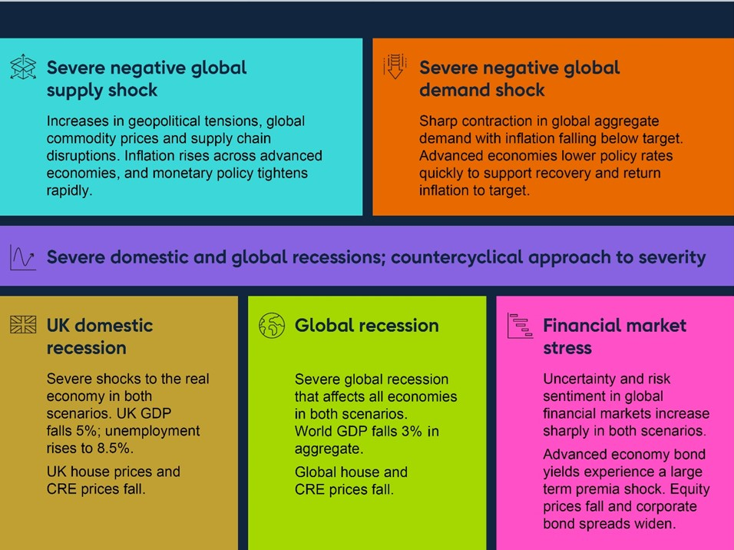

## 6.2: Headline results of the desk-based stress test

**The stress affects capital positions through several channels, notably credit impairments and net interest income.**

As set out in Table 6.A, credit impairments arising from the adverse macroeconomic environment are a key driver of capital depletion in the stress scenarios. This reflects the impact of higher unemployment, lower corporate profits and lower property prices. In the supply shock scenario, impairments are also driven by affordability and profitability pressures arising from higher inflation and the impact of subsequently higher interest rates. Section 6.3 describes the impact of the scenarios on credit impairments, and includes additional sensitivity analysis.

Banks continue to earn NII over the two scenarios. However, reflecting the assumptions set out in Section 6.4, NII remains relatively flat in the early years of the supply shock scenario despite the increase in policy rates, and it declines in the early years of the demand shock scenario.

Other drivers of the capital results (set out in Section 6.5) include traded risk losses, particularly in the supply shock scenario, as higher interest rates cause the fair value of bonds in banks’ banking books to decline. Some of banks’ income is also absorbed by operating expenses, which are affected by the profile for inflation in both stress scenarios. Misconduct costs also reduce capital resources. Other factors that drive the results include changes in risk-weighted assets (RWAs), other profit and loss (P&L) statement items and assumptions about strategic management actions.

**Starting from a strong capital position, the UK banking system’s aggregate capital ratio remains well above its hurdle rate in both stress scenarios.**

The aggregate capital ratio of the UK banking system is assessed against an aggregate ‘hurdle rate’ for the risk-weighted Common Equity Tier 1 (CET1) capital ratio and Tier 1 leverage ratio.[32] [33] The projected capital ratios in the test reflect internationally agreed transitional arrangements for the IFRS 9 accounting standard. Consistent with the approach to stress testing taken by the Bank in recent years[34], the hurdle rate is the sum of banks’ aggregate minimum capital requirements and systemic buffers, and adjusted to take into account the impact of the IFRS 9 accounting standard relative to the previous accounting standard.

The aggregate capital ratio of the banking system remains well above its hurdle rate in both stress scenarios (Table 6.A). The aggregate CET1 ratio starts at 14.7%, and in the supply shock scenario it falls to a low point of 10.4% in the second year of the stress, which equates to an aggregate capital drawdown of 4.3 percentage points. It remains above the hurdle rate of 6.8%. In the demand shock scenario, the aggregate CET1 ratio falls to a low point of 11.3% in the second year of the stress, which equates to an aggregate capital drawdown of 3.4 percentage points. It remains above the hurdle rate of 7.0%. The CET1 ratio impact is illustrated in Chart 6.1.

The aggregate Tier 1 leverage ratio starts at 5.4%. It falls to a low point of 4.6% in the first year of the supply shock scenario, compared to an aggregate hurdle rate of 3.4%. The aggregate Tier 1 leverage ratio falls to a low point of 4.9% in the second year of the demand shock scenario, set against an aggregate hurdle rate of 3.5%.

At the low point, the aggregate headroom over hurdle rates is a minimum of £66 billion in the supply shock scenario and £75 billion in the demand shock scenario.

**The results indicate that the UK banking system could continue to support households and businesses even if economic, financial and business conditions turned out materially worse than expected.**

The desk-based stress test results suggest that the UK banking system would be resilient to both the supply shock scenario and the demand shock scenario. In the exercise, the banking system continues to meet the credit demand of creditworthy households and businesses in both scenarios, and passes through increases in Bank Rate to depositors and reductions in Bank Rate to borrowers, with lending spreads to risk-free references rates increasing by only an amount that reflects higher expected losses on new lending.

**Table 6.A: Contributions to the cumulative change in the aggregate CET1 ratio by Year**

**2 of the stress scenarios (a) (b) (c) (d) (e)**

|  |  |  |
| --- | --- | --- |
|  | **Supply shock scenario** | **Demand shock scenario** |
| **Start point (Year 0)** | **14.7%** | **14.7%** |
| Credit impairments | -5.6pp | -4.5pp |
| Net interest income | +9.7pp | +8.9pp |
| Traded risk losses | -0.9pp | -0.4pp |
| Operating expenses | -5.8pp | -5.6pp |
| Misconduct costs | -0.6pp | -0.6pp |
| Other | -1.1pp | -1.2pp |
| **Low point (Year 2)** | **10.4%** | **11.3%** |
| **Drawdown** | **-4.3pp** | **-3.4pp** |
| **Hurdle rate** | **6.8%** | **7.0%** |

1. The CET1 capital ratio is defined as CET1 capital expressed as a percentage of the total risk exposure amount (riskweighted assets or RWAs), where CET1 capital and RWAs are determined in accordance with the Capital Requirements Regulation (CRR).
2. Start points are on an IFRS 9 transitional basis. By Year 2 of the stress scenarios, the IFRS 9 transitional relief period willhave come to an end, such that CET1 ratios do not include any IFRS 9 transitional relief by this point. Consistent with the approach taken by the Bank in recent years, the hurdle rate is adjusted to take into account the impact of the IFRS 9 accounting standard relative to the previous accounting standard.
3. Traded risk losses include investment banking (IB) revenues, the IB component of net fee and commission income, IBcost deductions, market risk and counterparty credit risk losses, fair value through other comprehensive income, and Prudential Valuation Adjustment change.
4. ‘Other’ comprises net fee and commission income, other P&L items, distributions, other capital items, changes in RWAs,IFRS 9 transitional relief and strategic management actions.
5. The difference in hurdle rates between the two scenarios is due to the difference in the IFRS 9 hurdle rate adjustment,and the impact of Pillar 2A changes over the stress period.

**Chart 6.1: The UK banking system starts the stress test with a strong aggregate**

**capital position, which remains well above the aggregate hurdle rate at the low point**

**of both scenarios**

Aggregate CET1 capital ratio and impact of the 2024 desk-based stress test scenarios

(

**a**

)

(

**b**

)

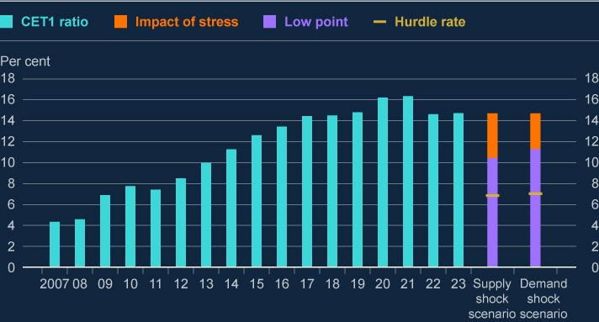

Sources: Stress Test Data Framework (STDF), PRA regulatory returns, published accounts, Bank analysis and calculations.

1. The CET1 capital ratio is defined as CET1 capital expressed as a percentage of the total risk exposure amount (RWAs),where CET1 capital and RWAs are determined in accordance with the CRR.
2. The difference in hurdle rates between the two scenarios is due to the difference in the IFRS9 hurdle rate adjustment, andthe impact of Pillar 2A changes over the stress period.

## 6.3: Credit impairments

**The starting level of asset quality in the desk-based stress test was strong relative to historical levels.**

Arrears across some UK banks’ loan portfolios had increased in the run-up to the end of 2023, but they remained low by historical standards. For example, in retail credit, mortgage arrears had been broadly flat and well below their historical peaks. Households and businesses in the UK and overseas were continuing to adjust to higher interest rates with associated higher debt-servicing costs and downward pressure on property prices.

Residential and commercial property prices had fallen in mainland China and Hong Kong, but banks had reduced their exposures to these markets over 2023 and had already increased provisions at the start of the stress test. In wholesale credit, business insolvencies had risen slightly but remained well below their long-term average level. Global defaults on leveraged loans had also risen, although performance on UK banks’ portfolios remained relatively strong.

That said, the starting level of asset quality was somewhat weaker than at the start of the [**2022/23 Annual Cyclical Scenario (ACS)**](https://www.bankofengland.co.uk/stress-testing/2023/bank-of-england-stress-testing-results) – the Bank’s most recent stress test in which

banks submitted their own estimates of the impact of the stress – reflecting a number of factors. In banks’ retail portfolios, UK house price growth had been weaker than historical averages, affecting the loan to value (LTV) ratios of their stock of lending as mortgages mature and are replaced. And there had been some weakening in non-UK retail lending asset quality, driven in part by falling global property prices and higher interest rates. In banks’ corporate portfolios, UK asset quality was broadly unchanged at the start of the desk-based stress test compared to the 2022/23 ACS. While there had been a worsening of UK CRE asset quality, in part due to recent CRE price falls, this had been offset by improvements to other, larger UK corporate exposures.

**Credit impairments are a key source of capital depletion.**

Across both scenarios, impairments increase as the macroeconomic environment deteriorates. Higher unemployment and lower corporate profits reduce households’ and corporates’ ability to repay their loans, and lower property prices affect underlying residential and commercial property collateral value. CET1 capital ratios are further impacted by credit risk weights, which increase in line with the higher likelihood of default.

**Impairments are higher in the supply shock scenario than the demand shock scenario, driven by affordability and profitability pressures due to higher inflation and interest rates in the supply shock scenario.**

Banks’ total five-year credit impairments amount to £133 billion in the supply shock scenario and £104 billion in the demand shock scenario (Table 6.B). At the two-year low point, the level of impairments reduces the CET1 capital ratio by 5.6 percentage points in the supply shock scenario and 4.5 percentage points in the demand shock scenario.

Most key drivers of impairments such as unemployment rates and property prices are the same across the two scenarios, but higher inflation and subsequently higher interest rates lead to greater impairments in the supply shock scenario (Chart 6.2). The combination of reduced affordability and higher repayment costs increases impairment rates across mortgage and consumer credit lending. Impairments are also higher in corporate sectors that are particularly vulnerable to rising costs and higher interest rates. The Bank has taken a similar approach to estimating the impact of these pressures on impairments as that used in the 2022/23 ACS, which is based on affordability analysis of households and sectoral analysis of corporate vulnerabilities. These pressures are not present in the demand shock scenario, in which a contraction in demand sees inflation fall and policymakers reduce interest rates to return it to target.

**Chart 6.2: Banks incur higher credit losses in the supply shock due to the effect of**

**inflation on affordability and profitability and associated higher interest rates**

Total five-year impairment charges in the desk-based stress test scenarios

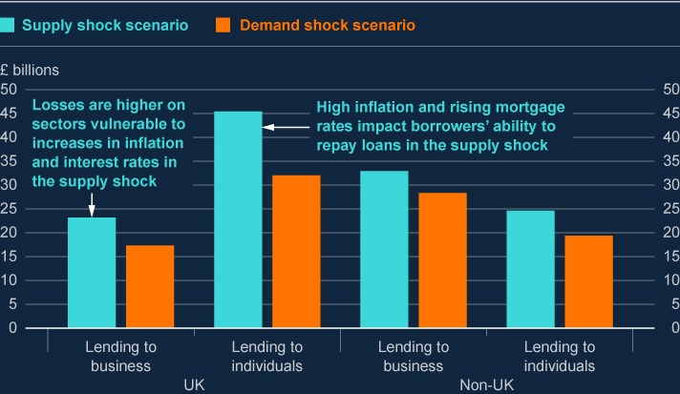

Sources: STDF, Bank analysis and calculations.

**Table 6.B: Aggregate cumulative impairment charges and rates over the five years of the stress (a) (b)**

|  |  |  |  |  |
| --- | --- | --- | --- | --- |
| **Lending portfolio** | **Supply shock scenario** | | **Demand shock scenario** | |
|  | Impairment charge  (£ billion) | Impairment rate (Per cent) | Impairment charge  (£ billion) | Impairment rate (Per cent) |
| UK: lending to individuals | 45.4 | 3.4 | 32.0 | 2.4 |
| of which, UK consumer credit | 31.3 | 29.6 | 23.4 | 22.1 |
| of which, UK Mortgages | 14.1 | 1.1 | 8.6 | 0.7 |
| UK: lending to business | 23.2 | 8.6 | 17.3 | 6.4 |
| UK: Other wholesale lending | 1.4 | 0.9 | 1.4 | 0.9 |
| **Total UK** | **70.0** | **4.0** | **50.7** | **2.9** |
| Non-UK: lending to individuals | 24.6 | 6.5 | 19.4 | 5.1 |
| of which, non-UK consumer credit | 21.8 | 23.3 | 17.6 | 18.7 |
| of which, Non-UK Mortgages | 2.8 | 1.0 | 1.8 | 0.6 |
| Non-UK: lending to business | 32.9 | 6.7 | 28.3 | 5.7 |
| Non-UK: Other wholesale lending | 5.2 | 0.7 | 5.2 | 0.7 |
| **Total non-UK** | **62.8** | **3.9** | **52.9** | **3.3** |

Sources: STDF, Bank analysis and calculations.

1. Cumulative impairment charge rates are calculated as the five-year total impairment charge divided by average gross onbalance sheet exposures.
2. Other wholesale lending consists of lending to financial institutions, housing associations, sovereigns, quasi-sovereignsand other wholesale counterparties.

**The stressed results include high levels of impairments across riskier forms of lending.**

The results of the test include the effect of the macroeconomic scenario on riskier forms of lending, which account for a large proportion of impairments relative to their share of bank assets.

Historically, UK consumer credit impairment rates have tended to move in line with UK unemployment, and it is assumed that this relationship holds in the stress. The impairment rate on UK unsecured lending to households is 29.6% in the supply shock scenario and 22.1% in the demand shock scenario as unemployment rises to 8.5% across both scenarios, and affordability pressures surface. The impairment rate on non-UK unsecured lending is

23.3% in the supply shock scenario and 18.7% in the demand shock scenario.

The scenarios include severe declines in global CRE prices. In both scenarios, the peak-totrough changes in CRE prices in the UK, US and euro area are around 50% and around 60% in Hong Kong. The peak-to-trough change in residential property prices in China is 38% in both scenarios. These are alongside a severe global recession which include a 9% peak-totrough decline in GDP in Hong Kong and a 3% decline in GDP in mainland China. The estimated impacts of these factors are included in the impairment rates in the two scenarios.

Risks from private equity – a sector that grew rapidly during the period of low interest rates and involves widespread use of leverage which leaves it exposed to tighter financing conditions – are captured through elevated impairment rates on related exposures in both scenarios. This includes leveraged lending, on which impairment rates are higher in the supply and demand shock scenarios than the GFC, reflecting relative asset quality and a larger interest rate shock. It also includes loans to private equity funds that are secured against the fund's assets. The Bank will use bank submissions in future exercises to assess loss rates on private equity exposures in more depth.

**Sensitivity analysis suggests that increasing the severity of house price falls could have a non-linear impact on credit losses.**

Sensitivity analysis included in the desk-based stress test explored the impact of including more severe UK house price falls in the scenarios. The results suggest that increasing the size of the house price shock would have a non-linear impact on UK mortgage impairments. This reflects the fact that a large majority of UK mortgages on banks’ books currently have an LTV ratio of below 70%. Chart 6.3 shows that increasing the UK house price fall beyond 30% would tend to have an increasing marginal impact on bank losses as a greater proportion of their lending would be secured on collateral worth less than the value of the loan. Such large declines in property prices would be significantly beyond those historically experienced in the UK – which is reflected in the considerable uncertainty embodied in the wide range of potential impacts shown in the chart.

**Chart 6.3: Sensitivity analysis suggests increasing the size of the UK house price**

**shock would have a non-linear impact on credit losses**

UK mortgage impairments at different house price shocks in the supply shock scenario

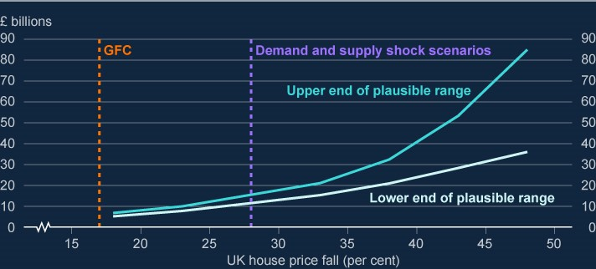

Sources: ONS, STDF, Bank analysis and calculations.

Sensitivity analysis also considered the impact of larger declines in UK CRE prices.

Increasing the size of the decline in UK CRE prices would also likely have a non-linear impact on impairments. However, because UK CRE makes up a relatively small component of banks’ exposures compared to UK mortgages, the marginal impact on overall impairments would be substantially lower than for UK mortgages.

## 6.4: Net interest income

**Net interest income is an important driver of results in both scenarios.**

NII is the difference between the interest banks earn on their assets and what they pay on their funding. It is an important source of income for banks, and a means through which they can rebuild capital and their capacity to support households and businesses through a stress.

The loan margin, calculated as NII divided by total lending, is affected by both the asset spread and the deposit spread to risk-free reference rates. It is also driven by banks’ ability to invest non-interest bearing liabilities and equity in fixed-interest bearing assets referred to as structural hedge portfolios. These structural hedge portfolios – which often include interest rate swaps – stabilise income through the interest rate cycle, slowing the costs of falling interest rates and the benefits from rising interest rates.

Banks’ balance sheets have evolved since the 2022/23 ACS. Loan margins have recovered from historically low levels to levels in line with historical averages as interest rates have increased. As such, the starting level of NII is higher than it was for the 2022/23 ACS. Those banks represented in the stress test generated £84 billion in the year before the scenario began compared to £64 billion in the year before the start of the 2022/23 ACS.

**Banks are assumed to pass through increases in Bank Rate to depositors and decreases in Bank Rate to borrowers in the stress scenarios**

It is assumed in the stress scenarios that banks pass through increases in Bank Rate to depositors in full, while decreases in Bank Rate lead to a compression in the deposit spreads that banks earn. It is also assumed reductions in Bank Rate are passed through to borrowers with spreads on lending to UK households increasing only by a limited amount that reflects higher expected credit losses on new loans. Lending volumes are held fixed. In both scenarios, quantitative tightening is assumed to affect deposit growth, and repayments continue of the Term Funding Scheme with additional incentives for SMEs.

In the supply shock scenario, it is further assumed that customers move deposits from accounts that pay zero interest to deposit accounts that do pay interest, and from instant access sight deposit accounts to higher yielding time deposits. The share of deposit balances that are non-interest bearing is assumed to decline by 15 percentage points over the five years of the supply shock scenario. And the share of time deposit balances is assumed to increase by 10 percentage points.

**Chart 6.4: Loan margins in the scenarios are sensitive to assumptions around deposit**

**pass-through rates, swap rates and lending spreads**

Loan margin in the desk-based stress test scenarios

(

**a**

)

(

**b**

)

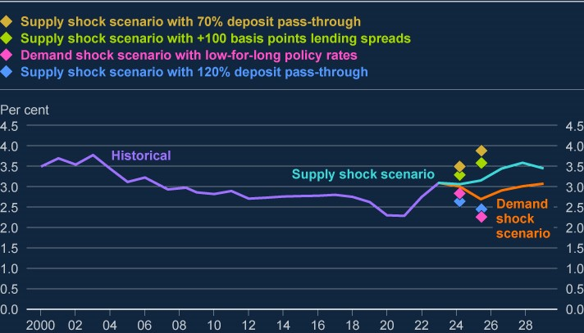

Sources: STDF, Bank analysis and calculations.

1. Loan margin is calculated as net interest income divided by total lending. Loan margins in this chart are calculated acrossall currencies. Net interest income is interest income minus interest expense.
2. Figures between 2000 and 2019 exclude Virgin Money UK, and figures before 2006 exclude Standard Chartered.

**In the supply shock scenario, full pass-through of increases in Bank Rate to deposit rates means NII is broadly flat in the first two years of the stress.**

In the supply shock scenario, the full pass-through of Bank Rate increases to deposit rates means that banks do not immediately benefit from the increases in Bank Rate. While banks earn income from interest rate swaps in their structural hedge portfolios being reinvested at higher interest rates, this happens slowly and is initially offset by increased costs on their deposits, including deposits that had to this point been insensitive to interest rates. From year three of the supply shock scenario, rising income from structural hedge reinvestments leads to increasing NII and a wider loan margin (Chart 6.4).

**In the demand shock scenario, narrowing deposit spreads, coupled with the passthrough of lower Bank Rate to borrowers, leads to lower NII in the first two years of the stress.**

In the demand shock scenario, banks pass through reductions in Bank Rate to borrowers with only a limited increase in lending spreads to reflect increased credit risk on new lending. But they are constrained by the zero lower bound on deposit rates, and deposit spreads narrow to around zero in the middle of the stress. As a result, NII falls over the first two years of the scenario.

As the reduction in Bank Rate is temporary, medium-term swap rates fall by less than the fall in Bank Rate. This means banks continue to earn increasing income from their structural hedge portfolios as interest rate swaps written at lower rates in past years are reinvested at higher rates throughout the scenario, albeit to a lesser extent than in the supply shock scenario. From year three onwards, this causes NII to increase and the loan margin to widen.

**These results suggest that the UK banking system could continue to support households and businesses in the stress scenarios.**

The assumptions made on NII combined with the aggregate CET1 capital ratios remaining above the hurdle rate in both scenarios suggests that the UK banking system could continue to support households and businesses in the stress scenarios by passing on changes in Bank Rate to borrowers and lenders, with lending spreads increasing by only an amount that reflects higher expected losses on new lending, and meeting the borrowing demand of creditworthy households and businesses.

**Sensitivity analysis shows that greater pass through of higher interest rates to depositors, or a low-for-longer Bank Rate path, could motivate banks to increase lending rates to offset lower NII.**

Given uncertainty around the behavioural assumptions underpinning NII, sensitivity analysis has also explored the impact of varying some of the key assumptions (Chart 6.4).

Lower competition for deposits in the supply shock scenario could lead banks to increase deposit rates by less than the increases in Bank Rate. Assuming a 70% deposit pass-through rate on both sterling and non-sterling deposits – comparable to the recent historical experience, but leading to deposit spreads rising above historical averages – would increase NII by around £30 billion over the first two years of the supply shock scenario. This would reduce the overall capital drawdown by 150 basis points.

Higher competition for deposits in the supply shock scenario could lead banks to increase deposit rates by more than increases in Bank Rate. This would narrow deposit spreads and reduce NII in the first two years of the stress. Assuming a deposit pass-through rate of 120% on both sterling and non-sterling deposits would have the opposite effect to the lower deposit pass-through rate sensitivity, reducing NII by around £30 billion over the first two years of the supply shock scenario. This would increase the overall capital drawdown by 150 basis points.

In the demand shock scenario, if the reduction in policy rates was no longer temporary and they stayed low for longer, this would lead swap rates to fall further towards zero. Banks would no longer benefit from reinvesting parts of their structural hedge portfolio at higher swap rates. This would lead to a £16 billion reduction in NII over the first two years of the demand shock scenario. This would increase the overall capital drawdown by 80 basis points.

In the higher pass-through and low-for-longer sensitivities, banks may be motivated to increase lending spreads further to offset the reductions in NII. The extent to which banks could do this would reflect the level of competition for lending. If banks widened spreads on household mortgages and PNFC lending by an additional 100 basis points, assuming for illustration that higher lending spreads did not further impact impairments or lending volumes, this would increase NII by £18 billion over the first two years of each scenario. This would reduce the overall capital drawdown by 90 basis points in both scenarios.

## 6.5: Other drivers

Due to the desk-based nature of the exercise, the Bank has taken a simplified approach to modelling the impact of various other factors driving the results of the stress test.

### Risk-weighted assets

Banks’ exposures become riskier in stress and average risk weights for credit exposures increase in both the supply shock and the demand shock scenarios. In both scenarios the aggregate CET1 capital ratio – defined as CET1 capital as a percentage of total RWAs – falls as RWAs increase, up until the low-point year.

### Traded risk

Traded risk is affected by a number of different factors in both scenarios. Fair value tradeable assets are affected by movements in asset prices, with higher interest rates in the supply shock scenario resulting in larger impacts. Declines in equity prices and rises in corporate bond spreads result in trading book stress losses and valuation adjustments. There is also a reduction in investment banking income, as the macroeconomic downturn leads to reduced risk-taking activity in financial markets.

### Operating expenses

Banks enter the stress with higher operating expenses than at the start of the 2022/23 ACS. The impact of inflation on operating expenses in the stress is informed by the relationship between expenses and inflation in the 2022/23 ACS – which included consideration of the relevance for banks’ direct costs of some of the factors driving inflation, and the role of fixedterm contracts and pay deals. High inflation in the supply shock scenario means that operating expenses increase by more relative to the demand shock scenario.

### Misconduct costs

As was set out in the publication of the scenarios, the test also incorporates a stressed level of misconduct costs in addition to the impact of the macroeconomic and financial scenarios. Over the stress horizon, for simplicity and in the absence of submissions from banks, the aggregate level of misconduct costs in each year is assumed to be fixed at a constant level equal to the average of years one and two in the last three stress tests for which banks provided estimates of stressed misconduct costs. As misconduct costs in past stress tests have typically fallen in the later years of the stress, this approach allows for larger stressed misconduct costs over the scenario horizon than in the 2022/23 ACS. Total misconduct costs are £25 billion over the stress horizon.

### Strategic management actions

As in previous stress tests, banks’ resilience relies in part on their ability in a stress to take management actions, such as cost reductions, in response to the stress. Although they weren’t tailored to the specific scenarios in the desk-based stress test, the Bank has considered the management actions that were submitted by banks in their 2022/23 ACS results and whether they could appropriately be applied in the desk-based stress test. Where they were considered credible and appropriate to either the supply shock or demand shock scenario, they have been reflected in the respective aggregate results for that scenario.

## 6.6: How the exercise is used

**The results of the desk-based stress test have been used, along with other relevant information, to help inform the setting of the UK countercyclical capital buffer rate, and to support the Prudential Regulation Authority’s ongoing supervisory work.**

In setting the UK countercyclical capital buffer (CCyB) rate, the FPC takes into account the extent of economic and financial vulnerabilities, and the risk that the banking system could experience losses on its UK exposures arising from those vulnerabilities that may result in a restriction in credit supply that is unwarranted by the macroeconomic outlook.

As set out in the [**record of the Financial Policy Committee meeting held on 15 November**](https://www.bankofengland.co.uk/financial-policy-summary-and-record/2024/november-2024)

[**2024**](https://www.bankofengland.co.uk/financial-policy-summary-and-record/2024/november-2024), in making its decision the Committee noted that the results of the desk-based stress

test suggested that the UK banking system could continue to support households and businesses even if economic, financial and business conditions turned out to be substantively worse than expected. They also noted that the greater level of UK impairments in the supply shock scenario implied a higher CCyB rate would be required to absorb the set of shocks in that scenario relative to in the demand shock scenario.

Insights from the desk-based stress test will continue to be used to support the PRA’s ongoing supervisory work.

As part of the Bank’s [**updated approach to stress testing the UK banking system from**](https://www.bankofengland.co.uk/stress-testing/2024/boes-approach-to-stress-testing-the-uk-banking-system)

[**2025 onwards**,](https://www.bankofengland.co.uk/stress-testing/2024/boes-approach-to-stress-testing-the-uk-banking-system) in 2025 the Bank will carry out a Bank Capital Stress Test which will include

submissions of stressed projections from participating banks.

# 7: The resilience of market-based finance

## Key developments since the June 2024 FSR

Core markets have broadly functioned well since the June FSR, through significant news in Q4 and short-lived volatility in financial markets in August, although the latter episode illustrated again the potential for vulnerabilities in market-based finance (MBF) to amplify shocks. Long-standing vulnerabilities in MBF have been at the centre of a number of stress events in recent years. Vulnerabilities associated with hedge fund leverage are still elevated. For example, deleveraging of US Treasury cash-futures basis positions could amplify market corrections.

Several market stress episodes, such as the stress in the UK’s liability-driven investment (LDI) sector in September 2022 caused by rapid and large moves in UK government bond yields, and the commodity market disruption following Russia’s invasion of Ukraine in 2022, have highlighted the challenges that can arise from a combination of leverage, concentration, and pro cyclical margin practices. Domestic and international work is underway to reduce the risks posed by high leverage, under-margining, and margin procyclicality in some core markets.

It is important that this policy work progresses to its conclusion swiftly, given the ongoing vulnerabilities and the currently heightened level of global risks.

## 7.1: The FPC’s approach to assessing risks from market-based finance and building resilience

**Market-based finance (MBF) plays a central role in the channelling of credit to the real economy. Since the global financial crisis, nearly the entire growth of the stock of UK corporate debt has been driven by an increase in MBF. But it is a diverse ecosystem with numerous interconnections and interdependencies with significant data gaps. The FPC has therefore established an approach to identifying, assessing, monitoring, and responding to financial stability risks associated with MBF.**

MBF is a complex and interconnected system of markets (eg equity, debt, and derivatives markets), non-bank financial institutions (NBFIs) such as insurers, hedge funds and private finance firms and market infrastructure (eg central counterparties and payment providers). MBF, alongside banks, supports the real economy by supplying finance and other financial services to many UK businesses. The share of outstanding market-based debt is around 56% of total £1.4 trillion stock of UK corporate debt (Chart 7.1).

It is vital that domestic and international regulators continue to develop and implement policies that mitigate vulnerabilities in MBF, to ensure that it can absorb rather than amplify severe but plausible shocks.

**Chart 7.1: Market-based finance is an important source of funding for UK businesses**

Composition of current stock of UK corporate debt

(

**a**

)

(

**b**

)

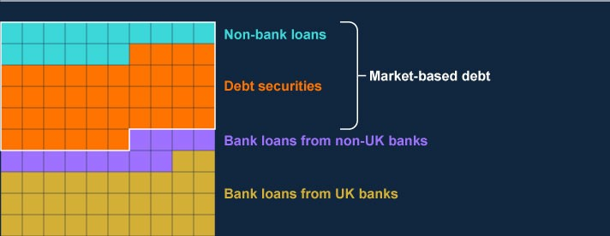

Sources: Bank of England, Bayes CRE Lending Report (Bayes Business School, City University of London), Deloitte, Eikon from Refinitiv, Financing & Leasing Association, firm public disclosures, LCD a part of PitchBook Data Inc., ONS, Peer-toPeer Finance Association and Bank calculations.

1. One square represents approximately £14 billion. There are 100 squares, each representing 1% of the total current stockof UK corporate debt, rounded to the nearest 1%. Debt securities include bonds, private placements, and commercial paper. Non-bank loans to large corporates includes lending by securities dealers and insurers, non-monetary financial institution syndicated loans, asset finance provided by the non-bank sector, and direct lending funds. These data are for private nonfinancial corporates using ONS consistent national accounts definitions, and excludes public, financial, and unincorporated businesses.
2. Data as of 2024 Q2.

## 7.2: Developments in vulnerabilities in market-based finance

The FPC has previously identified several vulnerabilities in the system of MBF (see [**Financial Stability in Focus: The FPC’s approach to assessing risks in market-based finance**)](https://www.bankofengland.co.uk/financial-stability-in-focus/2023/october-2023), which remain significant. These include:

instances of concentrated and correlated leverage in NBFIs, for example in hedge funds’ activity in core markets, and in liability-driven investment (LDI) funds (where stress crystallised in late 2022);

liquidity demands from margin calls in times of stress – as seen in the ‘dash for cash’ in

March 2020 and the 2022 commodity stress;

liquidity mismatch in money market funds (MMFs) and open-ended funds (OEFs) – as seen in the dash for cash; and

insufficient capacity of markets to intermediate in stress, so-called jump-to-illiquidity risk, as also seen in the dash for cash.

These vulnerabilities, many of which are opaque, could crystallise and cascade through markets, amplifying market volatility across institutions in the event of shocks, given the level of interconnectedness.

**Vulnerabilities associated with hedge fund leverage remain elevated.**

Leverage can take the form of ‘financial leverage’ (borrowing through loans, bonds, repo, and other securities financing transactions) or ‘synthetic leverage’ (using derivatives that create exposures whose value depends on the value of an underlying asset). Prime brokers are the main providers of leverage to hedge funds via cash or synthetic financing. Total borrowing by hedge funds via prime brokerage as a share of net asset value (NAV) is broadly in line with the levels at the time of FSR (Section 5.3).

Hedge funds obtain ‘financial leverage’ from their broker-dealers in the form of securities lending, margin lending and repo. Hedge funds have continued to employ large amounts of leverage in relative-value trading strategies, such as the US Treasury cash-futures basis trade, where leverage is used to enable hedge funds to profit from arbitraging very small price differentials.

In the gilt repo market, hedge fund net borrowing has risen since the June FSR, further exceeding pre-Covid peak levels. In November, hedge funds’ net borrowing in gilt repo was around £45 billion which is within the 5th percentile of the historical distribution of hedge fund net positioning, albeit around 25% lower than its peak earlier in Q4. More broadly, hedge funds’ net repo borrowing backed by different types of collateral, including US Treasuries, stood close to US$1 trillion (almost twice the size as at the time of the dash for cash in March 2020) at the end of 2024 Q2 (Chart 7.2 and Chart 7.3); and hedge funds’ net short positioning in US Treasuries futures continued to rise since the June FSR, reaching a new peak of just over US$1 trillion. Relative to the size of the US Treasury market, this is larger than the previous high reached in 2019. The rise in hedge fund positioning is a function of asset managers continuing to build long positions in Treasuries futures, and hedge funds taking the other side of these positions. Structural drivers of asset manager buying include higher yields, increased Treasury issuance, and the fact that credit issuance is often shorter duration than liabilities (eg for insurers). This shortfall means that asset managers who buy credit bonds often also need to buy futures to increase duration to match their liabilities.

Given the degree of global uncertainty, and the compressed levels of risk premia, the potential for sharp moves in market interest rates and other financial market prices is high. Hedge funds could potentially face significant losses if those sharp moves crystallised. In particular, leveraged hedge funds are exposed to the risk that initial margin requirements on derivative positions increase unexpectedly, creating sudden liquidity demands, which may deplete their cash buffers. In addition, as demonstrated by the results of the Bank’s system-wide exploratory scenario (SWES) exercise, banks’ counterparty risk concerns, and balance sheet constraints would likely hinder the extension of additional bilateral repo financing in stress, which would limit leveraged funds’ ability to borrow to fulfil these liquidity demands (Box A). In such cases, some leveraged funds may be forced to liquidate large and concentrated positions to meet margin calls or deleverage to avoid losses or breaching risk limits during periods of stress. This may place further downward pressure on prices, and if margin calls are not met, could spread losses to their counterparties (banks and prime brokers).

Deleveraging of leveraged positions under stressed market conditions continues to have the potential to amplify the transmission of a future stress, for example by leading to liquidity demands if significant volatility triggers rapid increases in margin calls. This would increase firms’ demand for liquidity, which could lead to asset sales, putting downward pressure on asset prices ([**With leverage comes responsibility – speech by Jonathan Hall**)](https://www.bankofengland.co.uk/speech/2023/june/jonathan-hall-speech-at-niesr). Any

turbulence in the US Treasury market, potentially amplified by deleveraging of the US Treasury cash-futures basis, would have repercussions globally including in UK funding markets. Fire-sale dynamics could disrupt the functioning of markets that are systemically important, such as the government bond market, which in turn could have implications for the pricing of household and business credit linked to these markets.

**Chart 7.2: Hedge funds’ net repo borrowing stands close to US$1 trillion**

Change in hedge fund repo positioning

(

**a**

)

(

**b**

)

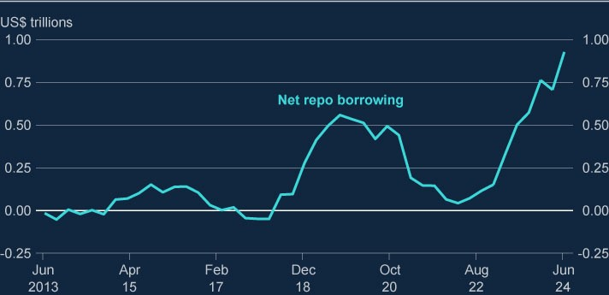

Sources: Office of Financial Research and Bank calculations.

1. The data are aggregated responses to SEC Form PF.
2. Latest data are as of 30 June 2024.

**Chart 7.3: Hedge fund net gilt repo borrowing has continued to rise since the June**

**FSR**

Hedge fund gilt repo positioning

(

**a**

)

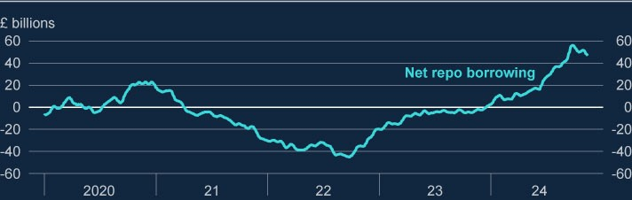

Sources: Sterling Money Market Data and Bank calculations.

(a) Latest data are as of 14 November 2024.

**Core markets have broadly functioned well since the June FSR, through significant news in Q4 and short-lived volatility in financial markets in August, although the latter episode illustrated again the potential for vulnerabilities in market-based finance to amplify shocks.**

In Q4, UK and US government bond repo market conditions largely remained stable through the periods around the UK budget and the US election, despite an increase in implied rate market volatility (Section 1).

In Q3, during the episode of short-lived volatility spikes across global financial markets that occurred in early August, core markets remained insulated from this shock for two main reasons. First, the size and limited persistence of the shock, and the subsequent positive economic news was such that core market functioning was not affected; firms had sufficient liquidity resilience to meet the increases in margins that occurred in certain markets such as equities and foreign exchange. Second, there were no counterparty credit risk concerns, which otherwise may have increased funding pressures, and led to broader contagion.

Nevertheless, the episode illustrated again the potential for vulnerabilities in market-based finance to amplify shocks, most notably through procyclical deleveraging. The evidence of deleveraging behaviour amplifying sharp moves in some non-core markets support the FPC’s previously communicated view that vulnerabilities in MBF continued to have the potential to amplify market corrections significantly, which could impact the price and availability of credit for households and businesses.

## 7.3: Improving the resilience of market-based finance

**Given the potential for vulnerabilities in market-based finance to pose risks to UK financial stability, the FPC is committed to the development and implementation of robust domestic and international standards on MBF.**

The FPC continues to support the Financial Stability Board’s (FSB’s) international work programme on leverage in NBFIs, in collaboration with standard-setting bodies, and encourages authorities globally to take action to reduce the vulnerabilities through internationally co-ordinated policy reforms. Absent sufficient international co-ordination and co-operation, there is the potential for cross-border spillovers of risks and regulatory arbitrage.

Some progress is being made in addressing key vulnerabilities in the system of MBF, including since the June FSR (Table 7.1 provides an overview of progress), however further progress is needed for such standards to be fully designed, and then implemented. For example, work is currently underway to enhance margin and haircut practices and improve liquidity preparedness of NBFIs. Results from the SWES strengthen the evidence base for current NBFI policy programmes, including international work on NBFI leverage.

**Previous market stress episodes have highlighted the challenges that can arise from a combination of leverage and pro-cyclical margin practices across different market segments.**

Margin – collateral placed as security against a trade – plays a key role in managing counterparty credit risk and disincentivising excessive risk-taking in both cleared and bilateral markets. Margin is collected in two forms: initial margin (IM) is sized to cover the potential future losses if either counterparty defaults; and variation margin (VM) is exchanged to cover the current exposure of the trade based on its mark-to-market value. In cleared derivatives markets IM is collected by central counterparties (CCPs), while in bilateral markets banks collect it or require their counterparties to place collateral in the form of ‘haircuts’ for securities financing transactions like repo.

Key challenges that margining practices pose across different markets include: (i) procyclicality, which leads to increased liquidity demands in periods of stress (ii) lack of predictability of changes in cleared initial margin; and (iii) under-margining and commensurately higher leverage in bilateral repo markets. The FPC has previously [**highlighted**](https://www.bankofengland.co.uk/-/media/boe/files/financial-stability-report/2024/financial-stability-report-june-2024.pdf) the need for further policy work to address risks arising from procyclicality in

cleared margin requirements.

Unexpected procyclical increases in IM requirements during times of wider market stress have contributed to previous liquidity stresses and triggered deleveraging, which resulted in destabilising rapid asset sales. For example, these dynamics were observed during the March

2020 dash for cash, and the commodities and LDI stresses in 2022. Enhancing the transparency of margin requirements in centrally cleared markets is a key step towards improving market participants’ liquidity preparedness and reducing procyclical behaviours in response to sudden changes in margin requirements. International work at the FSB is proposing [**measures to enhance the liquidity resilience**](https://www.fsb.org/uploads/P170424.pdf) of non-bank market participants,

such that they are better prepared to face spikes in margin and collateral calls during times of market-wide stress.

Bank analysis suggests that more than half of the outstanding stock in the uncleared bilateral dealer-to-client segment of the gilt repo market has zero haircuts, potentially resulting in under-collateralisation and procyclical increases in margins (Chart 7.4). In the SWES, some banks also reported charging zero haircuts on gilt repo to clients. For Treasury repo in the non-centrally cleared bilateral repo market, over 70% of all volume is transacted at zero haircuts. Zero haircuts on repo allow leveraged investors to take positions without using their capital, facilitating the build-up of leverage in the financial system. In the event of a large shock, leverage amplifies losses and increases the likelihood of position liquidations and counterparty defaults, with adverse implications for market functioning.

In July 2024, the [**G20 Finance Ministers and Central Bank Governors issued its**](https://www.gov.br/fazenda/pt-br/assuntos/g20/declaracoes/2-3rd-fmcbg-communique.pdf)

[**statement**](https://www.gov.br/fazenda/pt-br/assuntos/g20/declaracoes/2-3rd-fmcbg-communique.pdf) calling for the development of robust recommendations to address the risk from

NBFI leverage. The FSB is developing recommendations to enhance authorities’ ability to identify, monitor and mitigate the risks associated with non-bank leverage. This policy work directly addresses many of the vulnerabilities that have amplified the shocks which occurred in the past few years in capital markets. A consultation paper on policy proposals will be published by the FSB in a few months.

**Chart 7.4: Haircuts in the bilateral gilt repo market are very low**

Outstanding stock in the uncleared bilateral segment of the gilt repo market

(

**a**

)

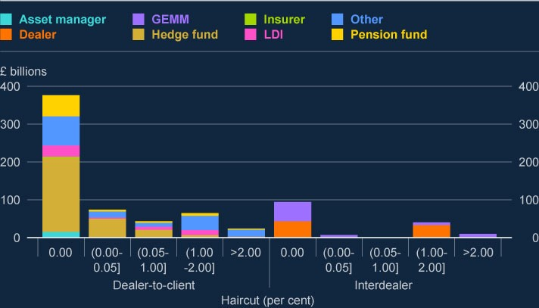

Sources: UK Securities Financing Transactions Regulation data and Bank calculations.

(a) Data as of 14 November 2024.

**Domestic and international work is underway to reduce the risks posed by undermargining and margin procyclicality in some core markets.**

In cleared markets, international proposals to improve margin transparency and promote market participant preparedness can help alleviate the trade-off between margin reactivity, coverage of credit risk and average margin cost.

Reflecting its commitment to robust international standards, the Bank has continued to take an active role in driving forward international work on centrally cleared margining practices as part of the FSB’s wider programme on non-bank financial intermediation. This will promote market participants’ preparedness by improving transparency on IM practices and the evaluation of procyclicality in centrally cleared markets.

Alongside transparency, the FSB’s recommendations on liquidity preparedness for margin and collateral calls are expected to be published by the end of the year. By enhancing the liquidity preparedness of non-bank market participants to face spikes in margin and collateral calls, these recommendations will help reduce procyclical behaviours of market participants during times of market-wide stress.

**Given the crucial role of CCPs in the financial system, the FPC welcomes the publication of the Bank's third public supervisory stress test of UK CCPs. The results confirm that CCPs maintain appropriate levels of resilience and have the resources in place to manage the default of two or more of their clearing members and other losses.**

UK CCPs play an important role in the functioning of financial markets, safeguarding financial stability through the critical services they provide. CCPs interpose themselves between the counterparties to contracts traded on financial markets – becoming the buyer to every seller and the seller to every buyer. This ensures that the obligations of a trade can be fulfilled even if one counterparty fails, thus reducing counterparty credit risk in financial markets.

The Bank’s third public supervisory stress test of UK CCPs has played an important role in the Bank’s supervision and regulation of CCPs. The stress test of UK CCPs is an exploratory tool intended to identify potential risks and vulnerabilities. This year, it focused on CCPs’ credit resilience – and introduced exploratory analysis such as desk-based stress testing. While this year’s scenario was equivalent to the historic worst in expected profit and loss impact, it included shocks to some products that go beyond the historic worst in order to identify pockets of vulnerability, complemented by a large number of ‘decorrelated’ scenarios.

The results confirm that all UK CCPs are resilient to a stress scenario similar to the worst-ever historical stresses, combined with the default of the Cover-2 population (ie the two members whose default generates the largest losses in excess of the defaulters’ own resources). When considering alternative decorrelated scenarios and the cost of liquidating highly concentrated positions, this exploratory exercise identified some potential pockets of vulnerability, which the Bank will investigate further with relevant CCPs as part of its continuing supervision and report back to the Financial Market Infrastructure Committee.

**Table 7.1: Overview of progress on building resilience against key vulnerabilities in**

**MBF domestically and internationally (a) (b)**

|  |  |  |
| --- | --- | --- |
| **Vulnerability** | **Financial stability implications** | **Policy recommendations and next steps** |
| **Liquidity mismatch in money market funds (MMFs)** | MMFs are used by UK corporates, investment funds, and other NBFIs as a way of managing cash balances. Investors hold around £230 billion in sterling denominated  MMFs.  Liquidity mismatch between the redemption terms and the liquidity of some of their assets makes MMFs vulnerable to sharp redemptions from investors in stress and so risk of both runs and contagion across the sector. This could amplify shocks, impact financial stability if investors cannot access cash, and lead to tighter financial conditions for the economy. | The Financial Conduct Authority (FCA) launched a consultation paper on enhancing MMF resilience measures, in December 2023. This work is part of broader international efforts to address vulnerabilities and increase the resilience of MMFs, ensuring consistently high standards in the international financial system.  In July 2023, the US Securities and Exchange Commission adopted amendments to rules relating to MMFs to address identified MMF vulnerabilities. These include the introduction of a mandatory liquidity fee framework, as well as stronger liquidity ratio requirements. The final stage of the SEC’s MMFs reform took effect in October 2024, marking the most substantial shift since the 2016 reforms.  In February 2024, the FSB published a [**Thematic review on money market fund**](https://www.fsb.org/uploads/P270224.pdf)  [**reforms**](https://www.fsb.org/uploads/P270224.pdf) in national authorities, taking stock of measures adopted or planed by FSB members in response to their 2021 proposal. Separate follow-up work is planned by the FSB in 2026 to assess the effectiveness of those policy measures. The FSB has also recently [**published a report**](https://www.fsb.org/2024/05/enhancing-the-functioning-and-resilience-of-commercial-paper-and-negotiable-certificates-of-deposit-markets/) (May 2024)  assessing the functioning and vulnerabilities of commercial paper and commercial deposit markets. |

|  |  |  |
| --- | --- | --- |
| **Vulnerability** | **Financial stability implications** | **Policy recommendations and next steps** |
| **Liquidity mismatch in open-ended funds (OEFs)** | Globally, the assets under management of OEFs primarily investing in UK equities, sterling government bonds, sterling corporate bonds, and UK property totalled around £224 billion, £37 billion, £67 billion, and £10 billion respectively as of October 2024.  Some OEFs offer daily redemptions while holding less liquid assets. This means in stress, there is an incentive for investors to redeem ahead of others. Funds may struggle to meet [**redemption demands without rapid sales of assets, which could lead to contagion across markets.**](https://www.bankofengland.co.uk/report/2021/assessing-the-resilience-of-market-based-finance) | In December 2023, the FSB published a set of revised policy recommendations to address structural vulnerabilities from liquidity  mismatch in OEFs, complemented by new  International Organization of Securities  Commissions (IOSCO) guidance on anti dilution liquidity management tools.  The Bank is co leading the FSB’s OEF Data Pilot Project, which is considering the availability of data to monitor vulnerabilities arising from liquidity mismatch in OEFs.  The FSB and IOSCO will undertake a stock take, to be completed in 2026, of the measures that have been adopted and planned, with a further effectiveness review by 2028 to see whether financial stability risks have been sufficiently addressed. |
| **Non-bank leverage** | Leverage creates counterparty risks and can lead to sudden spikes in demand for liquidity – either to support the financing of leveraged positions, or as deleveraging leads to forced sales, which in turn could amplify shocks and lead to market dysfunction and a potential tightening in financial conditions for households and businesses. The notional amount of non-bank investors’ over-the-counter derivatives in 2022 has been estimated at almost US$90 trillion. Global NBFI financial debt in 2022 has been estimated at approximately US$48 trillion, or 50% of global GDP. | The FSB is developing recommendations to enhance authorities’ ability to identify, monitor and mitigate the risks associated with nonbank leverage. A consultation report on policy proposals will be published in a few months.  In the US, the SEC’s clearing rule – effective in 2026 – mandates central clearing for most US Treasury bond repo transactions. By requiring widespread use of central clearing, it aims to improve transparency and mitigate financial stability risks through centralised default management processes. |

|  |  |  |
| --- | --- | --- |
| **Vulnerability** | **Financial stability implications** | **Policy recommendations and next steps** |
| **Liquidity demands from margin calls in stress** | Margin can increase rapidly in stress to match the increase in expected potential losses and risks. This ensures that counterparty risk is properly mitigated but requires counterparties to find additional liquid assets at a time when it is more difficult for them to do so.  Increases in margin that are unpredictable or unexpectedly large can cause liquidity strains on market participants and the financial system. For example, during the March 2020 dash for cash, initial margin requirements at UK CCPs increased by around 31% to £58 billion, with a maximum daily increase of £10 billion, and average daily variation margin calls were five times higher than in January and February 2020. | International work on CCP margin procyclicality has focused on transparency of margin calls in centrally and non-centrally cleared markets, and the preparedness of participants, as a way of improving the tradeoffs between reducing margin cost, reactivity and coverage, without seeking to impose a ‘one size fits all’ policy solution.  The Bank has continued to co-chair the Basel Committee on Banking Supervision, the Bank for International Settlements' Committee on Payments and Market Infrastructures and the  International Organization of Securities Commissions Margin Group responsible for work to improve the transparency and evaluate the responsiveness of initial margin practices in centrally cleared markets. The Margin Group is due to publish its final set of policy proposals later this year, which are expected to culminate in updates to international standards and guidance in 2025. The Bank will look to enhance its domestic CCPs margin framework in line with these proposals.  The FSB is proposing measures to enhance the liquidity resilience of non-bank market participants such that they are better prepared to face spikes in margin and collateral calls during times of market-wide stress.  The FPC welcomed the FCA policy statement on [**Improving transparency for bond and derivatives markets**](https://www.fca.org.uk/publications/policy-statements/ps24-14-improving-transparency-bond-and-derivatives-markets) published on 5  November 2024, containing rules to revise the transparency framework through changes to scope and calibration as well as through improved information content. |
| **Vulnerability** | **Financial stability implications** | **Policy recommendations and next steps** |
| **Capacity of markets to intermediate in stress without compromising on the resilience of dealers** | Past episodes of market turbulence, such as the 2020 dash for cash and the 2022 LDI stress have shown that vulnerabilities in NBFIs can propagate liquidity stresses in the gilt market, via investor deleveraging, liquidity mismatches in funds, liquidity demands from margin calls and insufficient market participant preparedness to meet rising margins. Exacerbated by limited dealer intermediation capacity, these events have led to periods of forced selling of gilts by NBFIs and self-reinforcing price spirals, threatening UK financial stability. | The FPC had previously noted that there would be value in exploring ways to enhance market intermediation capacity in a stress, without compromising dealer resilience, including through potential changes to market structure.  The FPC also welcomed the progress the Bank had made in developing a new lending facility, the Contingent NBFI Repo Facility (CNRF), to address severe market dysfunction in the gilt market that threatens UK financial stability arising from shocks that temporarily increase NBFIs’ demand for liquidity. **The CNRF eligibility will be limited initially to insurance companies, defined benefit pension schemes, and LDI funds**  **(set out in detail in the** [**July 2024 provisional Market Notice**](https://www.bankofengland.co.uk/markets/market-notices/2024/july/contingent-nbfi-repo-facility-provisional-market-notice)**). The development of the tool is largely complete. The Bank now expects to open for applications from eligible firms at the start of next year.** |

Note: New policy developments are in **bold**.

1. Managing the demand for liquidity in stress.
2. Increasing the resilience of the supply of liquidity in stress.

|  |
| --- |
| **Box A: The results of the system-wide exploratory exercise**  **The Bank has published the conclusions of its system-wide exploratory scenario (SWES) exercise. The exercise, which is the first of its kind, has improved the FPC’s understanding of the behaviours of banks and non-bank financial institutions during stressed financial market conditions in core UK markets and revealed a number of mismatches in expectations among market participants. The headline results illustrate that actions taken by authorities and market participants following recent stresses, for example on LDI funds, have helped to increase gilt market resilience. Nonetheless, the exercise highlighted how outcomes in the gilt market were very sensitive to initial conditions, the nature of the shock and outcomes in other markets. They also highlight a number of remaining risks and vulnerabilities that will be important to address, including the importance of enhancing the resilience of the repo and corporate bond markets.**  System-wide stress testing has proved to be an effective tool for improving the understanding by the Bank and participating firms of system-level vulnerabilities in core UK markets (Figure A). The FPC welcomes the Bank’s commitment, alongside the FCA, to continue to invest in their capabilities in this area for surveillance and risk assessment, and to update periodically these findings, in a proportionate way with market participants, as the financial system and risk-taking change. The FPC also supports staff plans to explore how further SWES-style exercises could be used over time to explore risks in different markets.  **It is important for all financial market participants to factor in system-wide dynamics and the lessons from the SWES exercise into their internal risk management and stress testing.** There are also several potential benefits to the broader international regulatory community and financial sector of running such [**system-wide exercises**](http://www.bankofengland.co.uk/financial-stability/boe-system-wide-exploratory-scenario-exercise/boe-swes-exercise-final-report). |

**Figure A: Key risk transmission channels under investigation in the SWES**

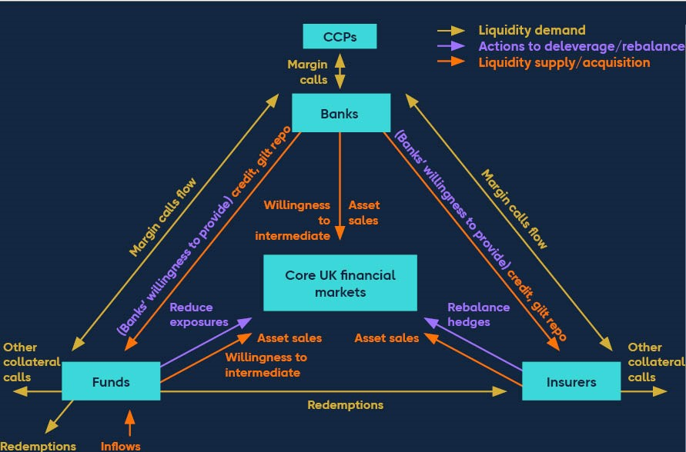

# 8: In focus – Emerging vulnerabilities at the intersection of the private equity and the life insurance sectors

## Summary

The June 2024 Financial Stability Report highlighted the vulnerabilities associated with highly leveraged portfolio companies connected with the private equity (PE) sector. This In focus section builds on that analysis, focusing on the links between the PE and life insurance sectors.

In the US, a growing number of PE firms have acquired life insurers and reinsurers (or have entered strategic partnerships with them), some of which are based overseas. In the UK, insurers have increased their use of funded reinsurance (FundedRe), where risks are transferred to reinsurers, including reinsurers owned by PE firms.

PE firms’ ownership of insurers has grown significantly in the US in the past decade. The increased use of funded reinsurance in the UK is a more recent trend and is currently small relative to the industry’s annuity liabilities. However, it could grow rapidly due to the high volume of bulk purchase annuities (BPA) UK insurers are expected to write in the coming decade.

This business model is associated with higher target returns via greater risk-taking, as shown by the growth of PE-backed insurers and reinsurers (collectively known as (re)insurers) investments in private assets, which tend to be riskier, less liquid and harder to value. There is also a growing reliance on exploiting differences in regulatory regimes, through cross-border reinsurance.

The level of complexity and opacity associated with these activities makes it difficult for regulators and market participants alike to assess risks holistically, including to insurers. These developments therefore have the potential to increase the fragility of parts of the global insurance sector and to pose systemic risks if underlying vulnerabilities are not addressed.

A sharp deterioration in PE-sponsored corporate asset performance, or reassessment of their credit risk, combined with high leverage, could result in defaults of assets held by PE-backed life (re)insurers. Given the potentially correlated nature of exposures, this could lead to a simultaneous failure of reinsurance risk-transfer arrangements if contractual termination clauses are hit. This would trigger a ‘recapture event’, requiring the insurers to assume the liabilities and the assets backing the liabilities, from reinsurers back onto their balance

|  |
| --- |
| sheets, and to take actions to mitigate the associated risks. This could also lead to increases in their capital requirements.  A large-scale recapture could amplify risks to other insurers globally, including UK life insurers engaged in FundedRe, triggering corrective actions, such as asset fire sales, that could disrupt corporate funding markets.  Loss of policyholder confidence could also create a liquidity stress for PE-backed life (re)insurers in some jurisdictions and pressure to sell large volumes of less liquid corporate financial assets could disrupt market functioning. Banks and institutional investors with significant private equity or credit exposures could also see losses.  The FPC supports the regulatory actions taken by the PRA to mitigate risks to UK life insurers from FundedRe, and international work to address the build-up of these risks more broadly.  The global response needs to consider developments across the broader ecosystem and regulators may need enhanced disclosure to appropriately monitor these activities. |

**The June 2024 Financial Stability Report highlighted the vulnerabilities associated with highly leveraged portfolio companies connected with the private equity (PE) sector.**

**The PE sector has grown rapidly over the past decade, including during the period of low interest rates,** with assets under management (AUM) reaching around US$10 trillion in 2023.[35] **It now plays a significant role in financing UK businesses**. The long-term nature of capital investments into PE allows and incentivises fund managers to act less cyclically, which can reduce the volatility of financing flows in macroeconomic downturns. **However, the widespread use of leverage within PE firms and their portfolio companies makes them particularly exposed to tighter financing conditions.**[36]Vulnerabilities from high leverage, opacity around valuations, and interconnections with riskier credit markets mean the sector has the potential to generate losses for banks and institutional investors, and cause market spillovers to highly correlated and interconnected markets such as leveraged loans and private credit – all of which could reduce investor confidence, further tightening financing conditions for businesses.

**The rapid growth in the global PE sector has been accompanied by the acquisition of insurance liabilities as a low-cost source of long-dated funding for PE firm lending activities.**

The June 2024 FSR discussed the PE ecosystem, including the link between banks, insurers, private credit funds and PE firms. This Section considers the growing interlinkages between PE firms and life insurers. While these developments can create potential benefits for the PE firms and insurers concerned, policyholders and the economy, they also have the potential to increase the fragility of parts of the global insurance industry and to pose systemic risks if the underlying vulnerabilities are not addressed.

Traditional PE firms, including those that are publicly listed, have been taking control of life insurance liabilities as a key source of funding for more than a decade. This has enabled them to diversify away from traditional fundraising sources like limited partners. Life insurance liabilities come with an associated insurance premium that needs to be invested to achieve the guaranteed income promised to the policyholders.

Globally, PE control of life insurance assets has increased by more than US$1 trillion from very low levels since 2009. To date, this has almost entirely been driven by the US market where PE-backed insurers now control nearly US$900 billion of US insurance liabilities, up from US$67 billion in 2012. Control of life insurers also provides PE firms with a stable AUM inflow from sales of new life insurance policies, supporting their AUM growth. For example, PE firms’ AUM grew by more than US$200 billion in 2023, driven by US insurance inflows, and 35% of new US annuity sales went to PE-backed insurers in 2023.

This trend is also growing in other jurisdictions, with PE-backed insurers and reinsurers (collectively known as (re)insurers) taking control of insurance liabilities via asset intensive reinsurance (AIR), also known as funded reinsurance (FundedRe). These are collateralised risk-transfer arrangements where the investment and insurance risks associated with a block of long-dated insurance cash flows (such as pension payments) are transferred to a counterparty, often a PE-backed (re)insurer. Figure 8.1 illustrates how FundedRe impacts a UK insurer’s balance sheet.

In Asia, insurance liabilities transferred through FundedRe are expected to grow rapidly from $25 billion in 2023, into a potential market of $2 trillion. In the UK, liabilities transferred through FundedRe are currently small relative to the annuity liabilities of UK life insurers but are projected to grow rapidly. Drivers of this growth are anticipated to be the improved funding positions of corporate sponsored pension schemes, which makes pension risk transfer to insurers more attractive, together with the strategic use of FundedRe by individual insurers to improve their competitive position in this market. Industry estimates suggest that around £600 billion of corporate pension assets could be transferred to UK insurers over the next decade via bulk purchase annuities (BPA).

**Figure 8.1: Illustrative impact of funded reinsurance on the insurance balance sheet**

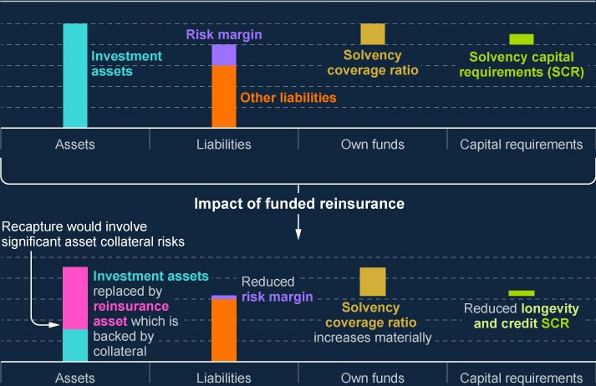

Source: Bank of England.

**This business model, while promising benefits, has the potential to increase the fragility of parts of the global insurance sector and to pose systemic risks if vulnerabilities are not addressed.**

Historically, PE business models have relied on PE firms or financial sponsors (general partners) raising funding at arm’s length from investors (limited partners) such as insurers, pension schemes, and family offices. Funds raised would then be used to lend to PEsponsored corporates. The PE firm itself would retain limited risk on the underlying assets (eg high-yield bonds, leveraged loans), which they mostly originated to distribute to investors.

By acquiring life insurance liabilities, PE firms take control of how insurance premiums are invested and use these to, among other things, provide credit lines to PE-sponsored corporates. These investments, in the form of private credit debt and other debt instruments, become assets of the PE-backed (re)insurers. The (re)insurance subsidiaries are therefore increasingly exposed to the performance of assets linked to PE portfolio companies. Figure

8.2 illustrates, for a selection of large PE firms, how funds from insurance policyholder

### Bank of England

premiums are being accumulated in PE-backed (re)insurers and deployed into risky credit assets originated by the PE firm. These are often structured to achieve investment-grade ratings through internal securitisation structures.

**Figure 8.2: Growing vertical integration of PE firm activities in the insurance sector as**

**illustrated by the activities of a sample of seven large PE firms**

**(**

**a) (**

**b) (**

**c)**

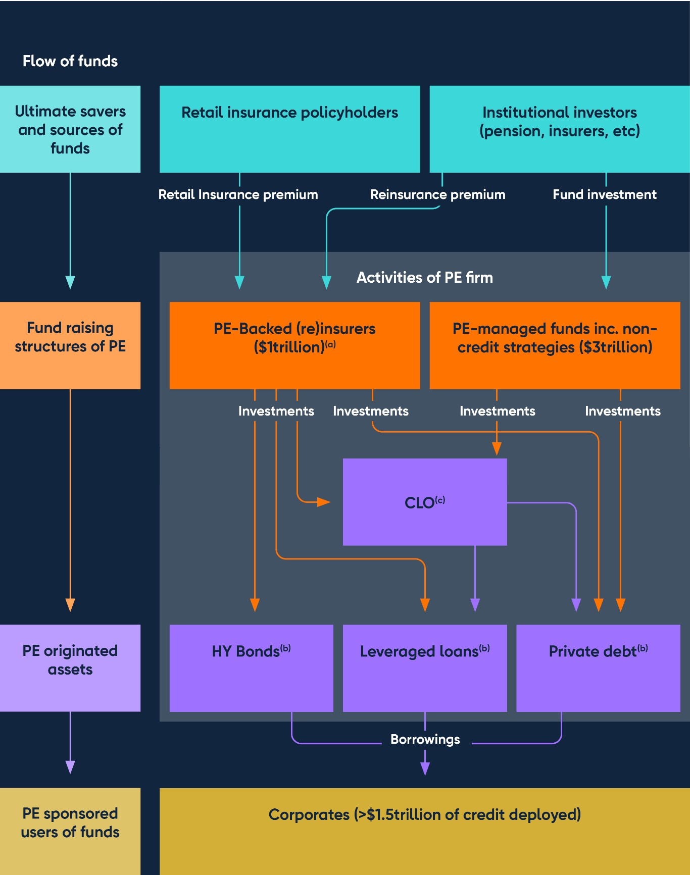

Notes: The schematic above represents the activities of a sample of seven large global PE firms and alternative asset managers with control of life (re)insurers. These PE firms, receiving around $200 billion of inflows from their insurance activities in 2023, are major originators of private assets in the credit markets, with aggregate credit strategies of over $1.5 trillion at financial year 2023. In relation to FundedRe the diagram only reflects the investment side of the reinsurance process, illustrating the flow of reinsurance premiums received by PE-backed (re)insurers and their allocation into various asset classes. The transfer of assets and liabilities in FundedRe arrangements is not represented.

Sources: Company filings and Bank calculations.

1. PE firms raise funding in their insurance entities as an alternative to funds.
2. PE firms arrange and originate lending to PE-sponsored risky corporates.
3. PE firms securitise their originated assets in collateralised loan obligations (CLO)s and asset-backed securities (ABS) toallow insurers to hold assets efficiently.

This business model creates potential benefits as well as risks. Industry estimates suggest that PE firms have injected fresh capital of around $30 billion into the (re)insurers they control, allowing for a higher supply of life insurance products in the market and reducing the pressures on publicly funded retirement pensions. PE-backed (re)insurers obtain costeffective access to a pipeline of high-yield assets, allowing them to price their insurance products more competitively and so achieve higher returns.

PE firms may benefit from access to long-term, generally stable, and relatively low-cost funding, which allows them to grow their corporate financing activities. This is likely beneficial to some corporate borrowers in need of finance. The growing interconnection between the PE and life insurance sectors may be introducing new risks, however, and as it continues to grow could present systemic risks if underlying vulnerabilities are not addressed.

**The greater risk appetite of PE owners of (re)insurers is driving a shift towards riskier, non-publicly traded credit…**

Vulnerabilities at the intersection of life insurance and PE firms are driven by the activities carried out at scale by PE owners of life insurers. PE-controlled life insurance subsidiaries are increasingly holding PE-sponsored corporate debt including that of corporates sponsored by the same PE firm that owns the insurer. This is creating concentrated and potentially correlated exposures to non-traditional asset classes (from a life-insurance perspective). These holdings often include a mix of investment-grade (IG) and non-investment grade (non-

IG) private credit instruments, and structured products such as collateralised loan obligations (CLOs) and asset-backed securities (ABS). While IG assets are typically lower risk, private credit generally involves less transparency and liquidity compared to publicly traded instruments. Credit quality in private credit can also vary; while restructuring through securitisation can create IG tranches, the underlying assets may still have higher default rates or be of lower quality, leading to risks of contagion or credit rating misestimation. The level of transparency and complexity of structured products, combined with their reliance on less liquid markets, increases challenges for counterparties and regulators to assess and mitigate risks effectively compared to publicly traded corporate bonds. Globally, PE-backed insurers have higher exposure to structured and non-traditional credit instruments compared to publicly listed insurers.[37] Industry estimates indicate private credit now accounts for around 45% of the bonds held in the US insurance industry.

To enable their insurance entities to hold these investments efficiently, some PE firms adopting this business model are internally securitising credit assets that they have originated in CLOs with different risk tranches. This structuring allows (re)insurance firms to hold notes with higher credit ratings, while distributing the lower-rated tranches to investors including via PE-owned credit funds. This activity has some risks common to those that crystallised in mortgage finance and securitisation during the global financial crisis, where banks played a central role. In this case, this activity is driven by PE firms, which have not been subject to the same increase in regulatory requirements as the banking sector.

US insurers are significant participants in the US CLO market, especially in senior and mezzanine tranches.[38] Global reinsurers are also increasing allocations to CLOs due to the regulatory capital efficiency these assets provide under certain solvency regimes. The growth of this business model is leading to more competitive lending markets, driving non-PE (re)insurers to adopt similar strategies to PE-backed (re)insurers to compete in the retirement markets. Analysis shows US PE-backed (re)insurers allocate around 30% of their bond investments to ABS and other structured securities like CLOs, compared to the US insurance industry average of just over 10%. This is consistent with increased issuance of CLOs by PE firms with a high level of retention of the residual tranche in PE-backed (re)insurers. Over a third of this CLO issuance relates to private credit CLOs.

This business model also has the potential for conflicts of interest that need to be managed, given PE firms can control both the borrower (the corporate) and the lender (the (re)insurer). In addition, there may be a mismatch between the shorter investment time horizon for a PE firm and the time horizon that insurers and prudential regulators need to consider for safety and soundness, given insurers’ long-term liabilities. These incentives and related remuneration structures can affect asset quality and introduce principal-agent risks akin to those seen in previous stresses.

**…and there is increasing reliance on exploiting differences in regulatory regimes.**

The risks associated with the assets and liabilities of US PE-backed (re)insurers are increasingly being transferred to or held in offshore jurisdictions such as Bermuda and the Cayman Islands. Bermuda’s life insurance sector assets have grown to more than $1.1 trillion in 2022, from $0.2 trillion in 2015.[39] There is also a growing trend of non-US PE firms setting up reinsurers in offshore jurisdictions, replicating the same business model.

Economic valuation of long-dated life insurance liabilities is complex and requires robust assumptions about returns and the likelihood of default or downgrade of invested assets. Significant undervaluation of liabilities can occur if these assumptions are inadequately calibrated. Furthermore, differences in regulatory treatments across jurisdictions – such as variations in capital requirements, asset valuations, credit default assumptions, or asset eligibility for insurance portfolios – may influence the economic incentives for parties involved in these transactions.

**A sharp deterioration in PE-backed corporate performance could trigger significant losses on debt instruments if they default on their loans…**

As highlighted in the June 2024 FSR, PE-backed corporates are often more levered, have riskier forms of borrowing, and are more exposed to refinancing risks. An economic downturn or more restrictive funding environment could therefore have a disproportionate impact on PEbacked corporates, triggering defaults or forced restructuring.

**…which may impact PE-backed life (re)insurers simultaneously…**

A deterioration in the resilience of corporates could impair the cash flows promised in lending agreements. This could lead to significant losses for investors, including PE-backed (re)insurers, which tend to have lower surplus capital compared to other life (re)insurers.[40] Given the concentrated exposures of PE-backed (re)insurers to the same underlying markets, losses may crystallise for multiple PE-backed (re)insurers simultaneously, potentially leading to a rapid deterioration in their solvency positions.

**…and, if significant enough, could lead to a simultaneous and potentially large-scale failure of reinsurance risk-transfer arrangements through contractual termination clauses in reinsurance arrangements.**

A significant fall in solvency ratios of PE-backed (re)insurers could lead to the triggering of AIR and FundedRe contractual clauses. This would require the original insurers to assume liabilities and the assets backing the liabilities from reinsurers back onto their balance sheets (known as a recapture event). It would also require them to take actions to mitigate the risks associated with such an event. This could lead to increases in capital requirements for these insurers.

Insurers that have not set adequate limits around the volume and nature of the FundedRe they execute would be forced to recapture large portfolios of deteriorating assets they might not have expertise in, at a time of market and economic stress (including downgrades), and to put aside additional capital for risks previously transferred. They may be forced to rebalance their portfolio rapidly to meet capital or regulatory demands and internal risk limits. This could involve selling assets, potentially at steep discounts, further exacerbating market stress and corporate funding conditions, and impacting valuations across the insurance and PE sectors.

Large scale recapture could amplify risks to other (re)insurers, including UK life insurers, exposed using FundedRe.

**Loss of policyholder confidence could also create a liquidity stress for PE-backed life (re)insurers in some jurisdictions. Pressure to sell large volumes of assets would impact financial market pricing and further disrupt market functioning.**

Annuity policyholders in the UK cannot typically exit their contracts early but in other jurisdictions, some products provide options to exit. These sometimes (but not always) come with a surrender charge, although it is uncertain how far such charges might mitigate liquidity risk. It is plausible that the perceived failure of PE-sponsored corporates may cause retail policyholders of PE-backed insurers to seek to exit products, requiring these insurers to source liquid funds to return to the policyholders. A rapid liquidity stress may impact PEbacked (re)insurers disproportionately given their higher relative allocation to illiquid assets.

As described above, if private credit assets need to be sold rapidly to meet liquidity demands, this could have a market-wide impact on prices. Given the illiquidity of these assets, and the fact that they are typically not marked to market, they can have uncertain valuations, which can lead to large discounts in times of stress. Significant uncertainty about, or reductions in, the perceived valuation of private assets could exacerbate solvency and liquidity pressures across the sector.

These global dynamics could trigger spillovers to the UK financial system via the transmission channels described in the June 2024 FSR, including by affecting risk-appetite in financial markets, the supply of financing to corporates, through the impact on banks with significant private equity and credit exposures, and through losses to institutional investors including pension schemes and insurers.

**The FPC supports the regulatory actions taken by the PRA to mitigate risks to UK life insurers from FundedRe.**

Although UK life insurers’ exposures to FundedRe currently remain modest, the actual and potential growth in this activity has motivated the PRA to set out in July 2024 [**expectations of**](https://www.bankofengland.co.uk/prudential-regulation/publication/2024/july/funded-reinsurance-implementation-approach)

[**how UK life insurers should manage this risk**](https://www.bankofengland.co.uk/prudential-regulation/publication/2024/july/funded-reinsurance-implementation-approach). The PRA expects UK insurers engaging in

FundedRe transactions to be able to demonstrate with a high level of confidence that they can withstand either a single recapture event, or multiple recapture events involving highly correlated counterparties. For this to be possible, the size and structure of transactions should be limited in such a way that the financial and non-financial impact of recapture are capable of being reliably estimated and managed, including in stress. The PRA’s inclusion of a FundedRe recapture event in the [**forthcoming UK life insurers stress test exercise**](https://www.bankofengland.co.uk/prudential-regulation/publication/2024/july/list-2025) will

also provide a useful insight into potential channels of disruption and the resilience of UK insurers.

**The FPC also supports international work to address the build-up of these risks more broadly, which is beginning.**

International recognition of the risks associated with PE ownership of insurers has been increasing, including by the IMF, the International Association of Insurance Supervisors (IAIS) and the Bank of International Settlements (BIS)[41] with authorities and standard-setting bodies also considering and, in some cases, seeking to mitigate the vulnerabilities associated with FundedRe. The FPC supports this work. In the US, the National Association of Insurance Commissioners has been reviewing the risks posed by PE-backed insurers and reinsurers, focusing on their use of complex offshore reinsurance and exposure to privately structured securities. Several mitigating actions have been taken, including to address capital requirements for CLOs, the conflicts of interest that arise between PE owners and PE-backed

(re)insurers, and the adequacy of reinsurance recoverables. The US Financial Stability Oversight Council has recently [**updated its approach to addressing potential and emerging financial stability risks**.](https://www.occ.gov/news-issuances/speeches/2024/pub-speech-2024-17.pdf) The Bermudan Monetary Authority (BMA) has also been monitoring the activities of PE backed (re)insurers and implemented reforms in 2024.[42]

**The global regulatory response needs to consider the broader PE ecosystem and regulators may need enhanced disclosure to monitor high-risk activities.**

The interconnectedness of PE with insurers could create potential systemic risks that can transmit across borders if vulnerabilities are not addressed. The transmission across borders can be via several channels including the cross-border provision of financing by PE entities, and the potential for losses for policyholders in other jurisdictions. These dynamics underscore the importance of a globally co-ordinated, system-wide approach to monitor and address these vulnerabilities, ensuring that the activities of PE firms do not amplify instability during periods of stress.

Some level of public transparency exists in the insurance sector, including through solvency regulatory returns. However, this can vary between countries, and regulatory returns often do not address the increased use of FundedRe or capture the nature and extent of the influence of the PE firm on the (re)insurer. Enhanced disclosure of related party arrangements and asset holdings would allow for a clearer understanding of the exposure of PE-backed (re)insurers to assets originated by PE firms. Improving transparency, including through more granular public or regulatory reporting on asset composition, valuation methods, and the resilience of solvency ratios under stress scenarios such as through insurance stress-testing exercises, would help to address these data gaps. Cross-border stress testing covering multiple sectors within the financial system could also provide valuable behavioural insights (Section 7, Box A). Similarly, disclosure at the PE owner level is hampered by significant data gaps, which limits understanding of risks and dependencies.

It is vital that domestic and international regulators continue to develop and implement policies that mitigate vulnerabilities at the intersection of insurance and PE. The FPC encourages consideration of these issues by the relevant international authorities when

### Bank of England

designing additional disclosures. This information is essential to allow authorities to judge whether there is a build-up of the systemic risks, and whether the entities involved can absorb losses without amplifying severe but plausible shocks.

# Annex: Macroprudential policy decisions

|  |
| --- |
| This annex lists any FPC Recommendations and Directions from previous periods that have been implemented or withdrawn since the [**June 2024 Report**](https://www.bankofengland.co.uk/financial-stability-report/2024/june-2024), as well as  Recommendations and Directions that are currently outstanding. It also includes those FPC policy decisions that have been implemented by rule changes and are therefore still in force. |

Each Recommendation or Direction has been given an identifier to ensure consistent referencing over time. For example, the identifier 17/Q2/1 refers to the first Recommendation made at the 2017 Q2 Committee meeting.

## Outstanding FPC Recommendations and Directions (as at the date of the FPC’s meeting on 15 November 2024)

On 23 March 2023, the FPC made the Recommendation (23/Q1/2) that:

The Pensions Regulator (TPR) should have the remit to take into account financial stability considerations on a continuing basis. This might be achieved, for example, by including a requirement to have regard to financial stability in its objectives, which should be given equal weight alongside other factors to which TPR is required to have regard. The FPC noted that in order to achieve this, TPR would need appropriate capacity and capability.

On 15 November 2024, the FPC made the Recommendation (24/Q4/1) that:

The Prudential Regulation Authority (PRA) and the Financial Conduct Authority (FCA) should ensure that mortgage lenders do not extend more than 15% of their total number of new residential mortgages at loan to income ratios at or greater than 4.5. This Recommendation applies to all lenders which extend residential mortgage lending in excess of £150 million per annum. The Recommendation should be implemented as soon as is practicable.

The explanation of the Recommendation is set out in the Record of the meeting on 15 November 2024.

## FPC Recommendations withdrawn since the 19 September 2024 Policy meeting

In June 2014, the FPC made the following Recommendation (14/Q2/2): The Prudential Regulation Authority (PRA) and the Financial Conduct Authority (FCA) should ensure that mortgage lenders do not extend more than 15% of their total number of new residential mortgages at loan to income ratios at or greater than 4.5. This Recommendation applies to all lenders which extend residential mortgage lending in excess of £100 million per annum. The Recommendation should be implemented as soon as is practicable.

(On 15 November 2024, the FPC updated the de minimis threshold contained in this

Recommendation from £100 million to £150 million. The updated Recommendation (24/Q4/1) is detailed in full above.)

## Other FPC policy decisions which remain in place

The following text sets out previous FPC decisions, which remain in force, on the setting of its policy tools. The calibration of these tools is kept under review.

### Countercyclical capital bu er rate

The FPC agreed to maintain the UK CCyB rate at 2% on 15 November 2024, unchanged from its 19 September 2024 meeting. This rate is reviewed on a quarterly basis. The UK has also reciprocated a number of foreign CCyB rate decisions – for more details see [**The**](https://www.bankofengland.co.uk/financial-stability/the-countercyclical-capital-buffer)

[**countercyclical capital buffer**](https://www.bankofengland.co.uk/financial-stability/the-countercyclical-capital-buffer). Under PRA rules, foreign CCyB rates applying from 2016

onwards will be automatically reciprocated up to 2.5%.

### Leverage ratio

In September 2021, the FPC finalised its review of the UK leverage ratio framework, and issued a Direction and Recommendation to implement the outcome of the review as set out in its [**October 2021 Record**](https://www.bankofengland.co.uk/financial-policy-summary-and-record/2021/october-2021).

In October 2022, in line with its statutory obligations, the FPC completed its annual review of its Direction to PRA. The FPC revoked its existing Direction to the PRA in relation to the leverage ratio regime, and issued a new Direction on the same terms as in September 2021 with the addition of discretion for the PRA to set additional conditions to the central bank reserves exclusion.

The full text of the FPC’s Direction to the PRA on the leverage ratio is set out in the Annex of the [**October 2022 Record**,](https://www.bankofengland.co.uk/financial-policy-summary-and-record/2022/october-2022) together with the original Recommendation (now implemented).

The PRA has [**published its approach**](https://www.bankofengland.co.uk/prudential-regulation/publication/2021/june/changes-to-the-uk-leverage-ratio-framework) to implementing this Direction and Recommendation.

## Other FPC activities since the June 2024 Report

Other FPC activities since the June 2024 Report not included elsewhere in this Report are set out in full in the [**Financial Policy Committee Record – 2024 Q3**,](https://www.bankofengland.co.uk/financial-policy-summary-and-record/2024/october-2024) and [**Financial Policy**](https://www.bankofengland.co.uk/financial-policy-summary-and-record/2024/november-2024)

[**Committee Record – November 2024**](https://www.bankofengland.co.uk/financial-policy-summary-and-record/2024/november-2024). These include:

Confirming, as part of its annual review of the leverage ratio Direction, that the UK leverage ratio framework remained appropriate. The FPC welcomed the Bank and the PRA’s engagement with firms on the normalisation of central bank balance sheets and the financial stability role of central bank reserves, and noted that such discussions would inform future FPC annual reviews. It also noted a PRA announcement that the thresholds for application of the leverage ratio requirement were being reviewed.

Welcoming the 12 September publication of the PRA’s second near-final policy statement on the implementation of Basel 3.1 standards in the UK and the PRA’s consultation paper on the Strong and Simple Framework.

Welcoming the continued progress to maintain a credible resolution regime captured in the published findings of the Bank’s second assessment of the eight major UK banks’ resolvability under the Resolvability Assessment Framework. It also welcomed the introduction of the Bank Resolution (Recapitalisation) Bill to Parliament.

Receiving an update on the progress of firms and financial market infrastructures (FMIs) towards implementing the operational resilience policies set by the Bank, PRA and FCA. Despite progress, more work is needed to address vulnerabilities. As firms and FMIs seek to comply with the policies, the FPC noted that they must focus on their roles in the financial system and broader economy, and engage with other firms, other FMIs and the wider market on the potential impact of their own disruption and actions they might take.

Discussing the development of the Bank’s new tools for lending to non-bank financial institutions (NBFIs) in the event of severe gilt market disruption that threatened UK financial stability, and approved the scope and principles determining their design. The FPC encouraged potential counterparties, such as insurers, pension schemes and liabilitydriven investment funds, to familiarise themselves with the expected design and features of the Contingent NBFI Repo Facility and to assess what steps they would need to take to be ready to sign up to the facility when applications open.

Discussing the benefits and risks of the use of stablecoins for wholesale purposes. Given the potential benefits, the FPC supported monitoring developments, but considered that there were risks to the stability of the value of stablecoins and that this could have financial stability implications in wholesale markets. More broadly, the FPC had a low risk appetite for a significant shift away from central bank money as the primary settlement asset in the financial system.

Discussing tokenisation, including of money market funds (MMFs) and the impact this could have on how MMF shares are managed and utilised. The FPC noted that the Bank/FCA Digital Securities Sandbox would be an appropriate way to observe the potential benefits and risks of tokenisation to financial stability.

Discussing the main channels through which artificial intelligence (AI) could have financial stability implications. The FPC supported the Bank, in collaboration with other regulatory bodies, taking actions to enable the effective monitoring of the systemic risks from AI. The FPC also agreed to develop further its understanding of those channels and to publish an assessment of them, as well as its approach to monitoring financial stability risks from AI, in a report in the first half of 2025.

Welcoming the publication of the UK regulators’ final policy and rules for critical third parties (CTPs), as well as information on how the regulators will approach CTP oversight.

Welcoming the FCA’s policy statement on improving transparency for bond and derivatives markets and judging that the transparency regime would support UK financial stability.

Reviewing the current thresholds for other systemically important institutions buffer rates and decided it would consult on a proposal to index the thresholds based on the growth in nominal GDP since the Committee last updated the thresholds in 2019. The FPC proposed to assess the thresholds as part of its future regular reviews of the framework, and to update them in line with nominal GDP growth, where appropriate.

Judging that the loan to income flow limit, in combination with the FCA's responsible lending requirements, continued to ensure the appropriate level of resilience.

Receiving a Remit letter from the Chancellor setting out the economic policy of His

Majesty's Government and Treasury's Recommendations under Sections 9D–9E of the Bank of England Act 1998. The FPC noted the strong emphasis on economic growth, and agreed to publish its response in due course.